REG NO: 22TD0058 NAME: NASRIN J YEAR/SEM/SEC: Y3/S6/B

STUDY OF SQL COMMANDS

DDL COMMANDS

CREATE

SQL> create table database(S_no number(4), s_name varchar2(10), s_dob date, total number(8,2));

Table created.

SQL> desc database
Name Null? Type
----------------------------------------- -------- ----------------------------
S_NO NUMBER(4)
S_NAME VARCHAR2(10)
S_DOB DATE
TOTAL NUMBER(8,2)

SQL> create table db1 as select * from database; Table created.

SQL> desc db1
Name Null? Type
----------------------------------------- -------- ----------------------------
S_NO NUMBER(4)
S_NAME VARCHAR2(10)
S_DOB DATE
TOTAL NUMBER(8,2)

SQL> create table db2 as select s_name,s_dob from database; Table created.

SQL> desc db2
Name Null? Type
----------------------------------------- -------- ---------------------------- S_NAME VARCHAR2(10)
S_DOB DATE

ALTER

SQL> alter table database modify S_no number(6); Table altered.

SQL> desc database
Name Null? Type
----------------------------------------- -------- --------------------
S_NO NUMBER(6)
S_NAME VARCHAR2(10)
S_DOB DATE
TOTAL NUMBER(8,2)

SQL> alter table database modify (S_no number(8),s_name varchar2(12)); Table altered.

SQL> desc database
Name Null? Type
----------------------------------------- -------- ------------------------

S_NO NUMBER(8)
S_NAME VARCHAR2(12)
S_DOB DATE
TOTAL NUMBER(8,2)

SQL> alter table database add rank number(2); Table altered.

SQL> desc database
Name Null? Type
----------------------------------------- -------- -----------------

S_NO NUMBER(8)
S_NAME VARCHAR2(12)
S_DOB DATE
TOTAL NUMBER(8,2)
RANK NUMBER(2)

SQL> alter table database add(age number(2), grade char(1)); Table altered.

SQL> DESC DATABASE
Name Null? Type
----------------------------------------- -------- --------------------
S_NO NUMBER(8)
S_NAME VARCHAR2(12)
S_DOB DATE
TOTAL NUMBER(8,2)
RANK NUMBER(2) AGE NUMBER(2)
GRADE CHAR(1)

DROP

SQL> alter table database drop column age; Table altered.

SQL> DESC DATABASE
Name Null? Type
----------------------------------------- -------- --------------------

S_NO NUMBER(8)
S_NAME VARCHAR2(12)
S_DOB DATE
TOTAL NUMBER(8,2)
RANK NUMBER(2)
GRADE CHAR(1)

SQL> alter table database drop(grade,rank); Table altered.

SQL> DESC DATABASE
Name Null? Type
----------------------------------------- -------- -------------
S_NO NUMBER(8)
S_NAME VARCHAR2(12)
S_DOB DATE
TOTAL NUMBER(8,2)

RENAME

SQL> alter table database rename column s_name to sname; Table altered.

SQL> alter table database rename column s_no to sno;
Table altered.

SQL> DESC DATABASE
Name Null? Type
----------------------------------------- -------- -----------------
SNO NUMBER(8)
SNAME VARCHAR2(12)
S_DOB DATE
TOTAL NUMBER(8,2)

SQL> RENAME DATABASE TO RECORD;
Table renamed.

SQL> DESC RECORD

Name Null? Type
----------------------------------------- -------- --------------- SNO NUMBER(8)
SNAME VARCHAR2(12)
S_DOB DATE
TOTAL NUMBER(8,2)

NOT NULL

SQL> alter table record modify sno not null; Table altered.

SQL> DESC RECORD
Name Null? Type
----------------------------------------- -------- ------------------------ SNO NOT NULL NUMBER(8)
SNAME VARCHAR2(12)
S_DOB DATE
TOTAL NUMBER(8,2)

NULL

SQL> alter table record modify sno null; Table altered.

SQL> DESC RECORD
Name Null? Type
----------------------------------------- -------- ------------------------ SNO NUMBER(8)
SNAME VARCHAR2(12)
S_DOB DATE
TOTAL NUMBER(8,2)

PRIMARY KEY

SQL> create table data (d_no number(3)primary key,d_name char(12),mark number(4)); Table created.

SQL> desc data
Name Null? Type
----------------------------------------- -------- ------------------------ D_NO NOT NULL NUMBER(3)
D_NAME CHAR(12)
MARK NUMBER(4)

SQL> insert into data values(1,'abi',500); 1 row created.

SQL> insert into data values(2,'dhivya',501); 1 row created.

SQL> select * from data;
D_NO D_NAME MARK
---------- ------------ -------------------- 1 abi 500
2 dhivya 501

DQL COMMAND

SELECT

SQL>select mark from data where d_no=1
MARK
----------------
500

USING ALTER COMMAND

SQL> alter table dbs add primary key(dbsno); Table altered.
SQL> DESC DBS
Name Null? Type
----------------------------------------- -------- -----------------------
DBSNO NOT NULL NUMBER(3)
DBSNAME CHAR(8)
MARK NUMBER(3)

FOREIGN KEY

SQL> create table dept(dno number(3) primary key,
2 dname varchar2(20), 3 location varchar2(15)); Table created.

SQL> create table emp(eno number(3),dno number(3) references dept(dno), 2 design varchar2(20)); Table created.
SQL> desc emp
Name Null? Type
----------------------------------------- -------- ---------------------------- ENO NUMBER(3)
DNO NUMBER(3)
DESIGN VARCHAR2(20)

SQL> desc dept
Name Null? Type
----------------------------------------- -------- ----------------------------
DNO NOT NULL NUMBER(3)
DNAME VARCHAR2(20)
LOCATION VARCHAR2(15)

CHECK CONSTRAINTS
COLUMN LEVEL

SQL> create table database(dbno number(3),dbname char(8),mark number(3)constrai t database_mark_ck check(mark>50 and mark<100)); Table created.

SQL> desc database;
Name Null? Type
----------------------------------------- -------- ---------------------------
DBNO NUMBER(3)
DBNAME CHAR(8)
MARK NUMBER(3)

SQL> insert into database values(1,'dhivya',88); 1 row created.
TABLE LEVEL

SQL> create table dbs(dbsno number(3),dbsname char(8),mark number(3)); Table created.

SQL> alter table dbs add constraints dbs_mark_ck check(mark>50 and mark<100); Table altered.

SQL> desc dbs
Name Null? Type
----------------------------------------- -------- ---------------------------
DBSNO NUMBER(3)
DBSNAME CHAR(8)
MARK NUMBER(3)

SQL> insert into dbs values(1,'dhana',88); 1 row created.

UNIQUE CONSTRAINTS

SQL> create table dbs1(dbno number(3),dbname char(8),mark number(3)constraint dbs1_mark_uk unique); Table created.
SQL> desc dbs1
Name Null? Type
----------------------------------------- -------- ----------------------------
DBNO NUMBER(3)
DBNAME CHAR(8)
MARK NUMBER(3)
SQL> select * from dbs1;

DBNO DBNAME MARK
---------- -------- ------------------------------ 1 ABI 456
SQL> insert into dbs1 values(1,'dhivya',456);
insert into dbs1 values(1,'dhivya',456) *
ERROR at line 1:
ORA-00001: unique constraint (A212411104011.DBS1_MARK_UK) violated

CONSTRAINT ENABLE/DISABLE

SQL> alter table dbs disable constraint dbs_mark_ck; Table altered.

SQL> insert into dbs values(1,'dhivya',48); 1 row created.

DML COMMANDS
INSERT

SQL> insert into record values(001,'Abi','23nov93',999); 1 row created.

SQL> insert into record values(002,'Arthi','29jan93',999); 1 row created.

SQL> insert into record values(003,'Dhivya','24aug93',998); 1 row created.
SQL> select * from record;
SNO SNAME S_DOB TOTAL
---------- ------------ --------- ------------------------- 1 Abi 23-NOV-93 999
2 Arthi 29-JAN-94 999
3 Dhivya 24-AUG-93 998

SQL> insert into record values(&sno,'&sname','&s_dob',&total);
Enter value for sno: 002
Enter value for sname: Arthi
Enter value for s_dob: 29jan94 Enter value for total: 997 old 1: insert into record values(&sno,'&sname','&s_dob',&total) new 1: insert into record values(002,'Arthi','29jan94',997) 1 row created.

SQL> /
Enter value for sno: 003
Enter value for sname: Dhivya
Enter value for s_dob: 24aug93 Enter value for total: 998 old 1: insert into record values(&sno,'&sname','&s_dob',&total) new 1: insert into record values(003,'Dhivya','24aug93',998) 1 row created.

SQL> /
Enter value for sno: 004
Enter value for sname: saranya
Enter value for s_dob: 24nov1993 Enter value for total: 998 old 1: insert into record values(&sno,'&sname','&s_dob',&total) new 1: insert into record values(004,'saranya','24nov1993',998) 1 row created.

SQL> select * from record;
SNO SNAME S_DOB TOTAL
---------- ------------ --------- ------------------------ 1 Abhi 23-NOV-93 999
- Arthi 29-JAN-94 997
- Dhivya 24-AUG-94 998
- saranya 24-NOV-93 998

SAVEPOINT AND ROLLBACK

SQL> select * from record;
SNO SNAME S_DOB TOTAL
---------- ------------ --------- ------------------------
- Arthi 29-JAN-94 997
- Dhivya 24-AUG-93 1000
1 Abhi 23-NOV-93 999
4 saranya 24-NOV-93 998

SQL> savepoint r1; Savepoint created.

SQL> update record set total=1000 where sno=4; 1 row updated.
SQL> select * from record;
SNO SNAME S_DOB TOTAL
---------- ------------ --------- ------------------------
- Arthi 29-JAN-94 997
- Dhivya 24-AUG-93 1000
1 Abhi 23-NOV-93 999
4 saranya 24-NOV-93 1000

SQL> roll back r1;
Rollback complete.

SQL> select * from record;
SNO SNAME S_DOB TOTAL
---------- ------------ --------- ------------------------
- Arthi 29-JAN-94 997
- Dhivya 24-AUG-93 1000
1 Abhi 23-NOV-93 999
4 saranya 24-NOV-93 998

DCL COMMANDS
Oracle provides extensive feature in order to safeguard information stored in its tables from unauthoraised viewing and damage.The rights that allow the user of some or all oracle resources on the server are called privileges.

- Grant privileges using the GRANT statement
The grant statement provides various types of access to database objects such as tables, views and sequences and so on.
Syntax:
GRANT <object privileges>
ON <objectname>
TO<username>
[WITH GRANT OPTION];

- Revoke permissions using the REVOKE statement:
The REVOKE statement is used to deny the Grant given on an object.

Syntax:
REVOKE<object privilege>
ON
FROM<user name>;

REG NO: 22TD0058 NAME: NASRIN J YEAR/SEM/SEC: Y3/S6/B

CREATION OF DATABASE APPLICATION USING ORACLE

INTRODUCTION TO ORACLE APPLICATION EXPRESS:
Oracle Application Express(abbreviated APEX, previously named Oracle HTML DB) Is a web based software development environment that runs on an Oracle database. It is fully supported and comes standard (at no additional cost) with all Oracle Database edition and starting, with Oracle 11g, is installed by default as part of the core database install.

CREATION OF DATABASE APPLICATION:

Step 1:visit http://127.0.0.1:8080/apex/f?p=4950 and create workspace.
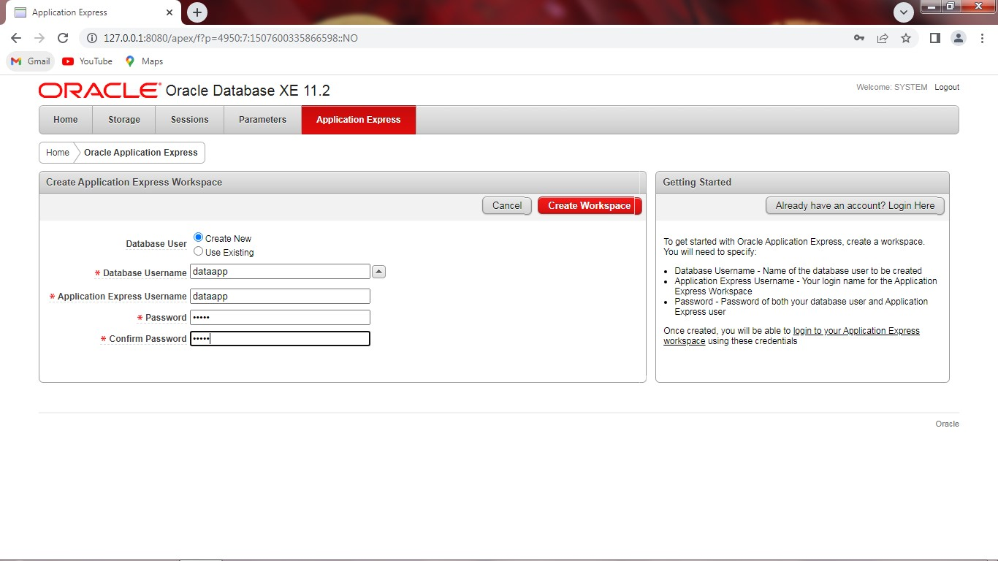

Step 2:Enter Application workspace, username and password.

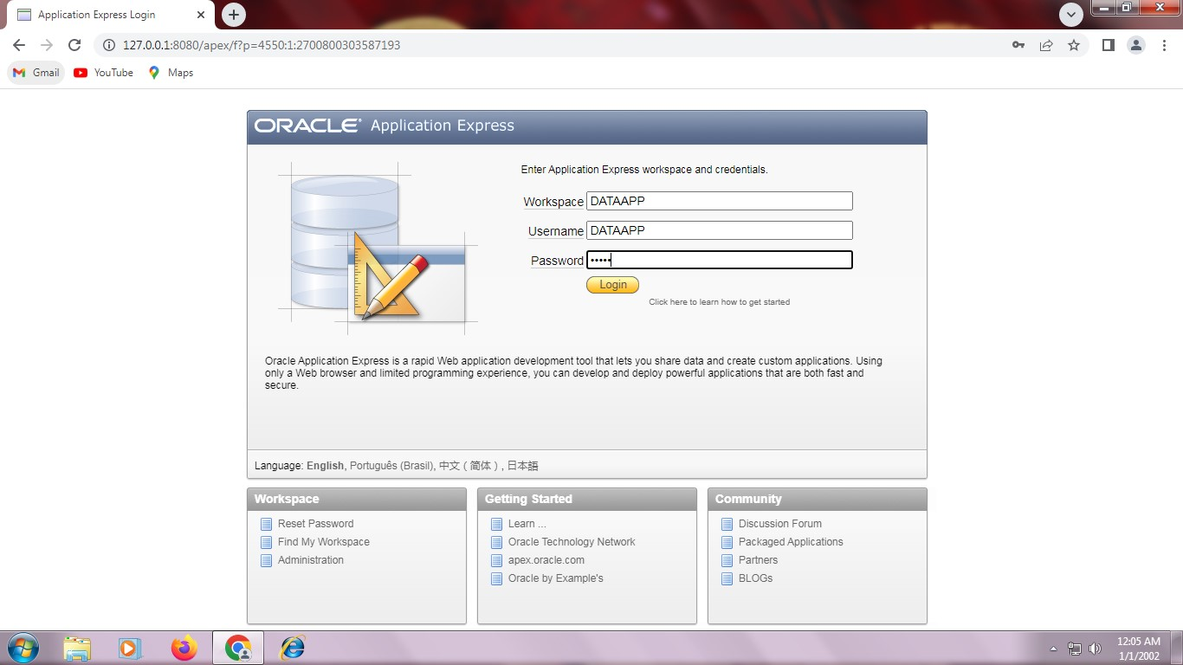

Step 3:Go to SQL Workshop. And click DATA Workshop
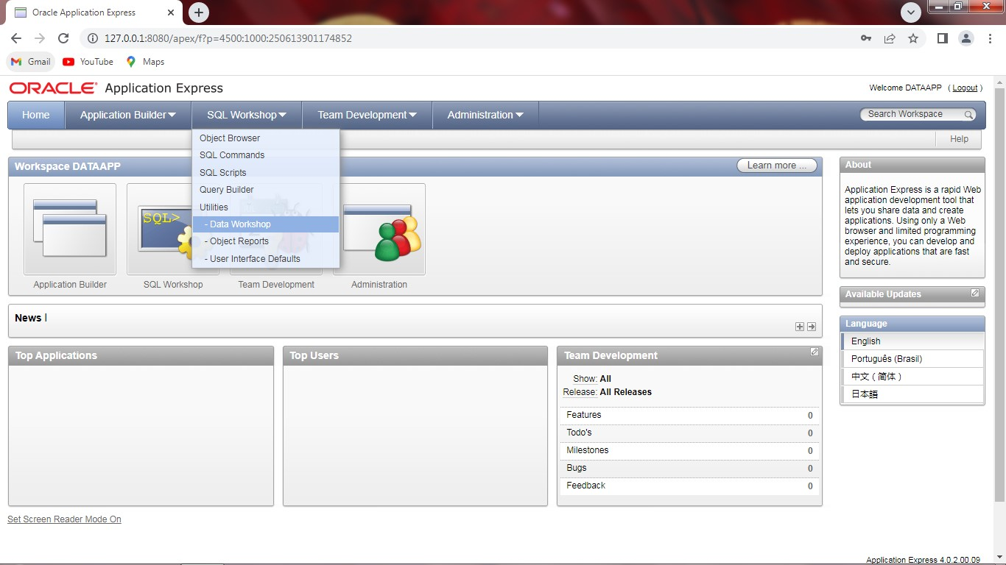

Step 4: Select Text Data.
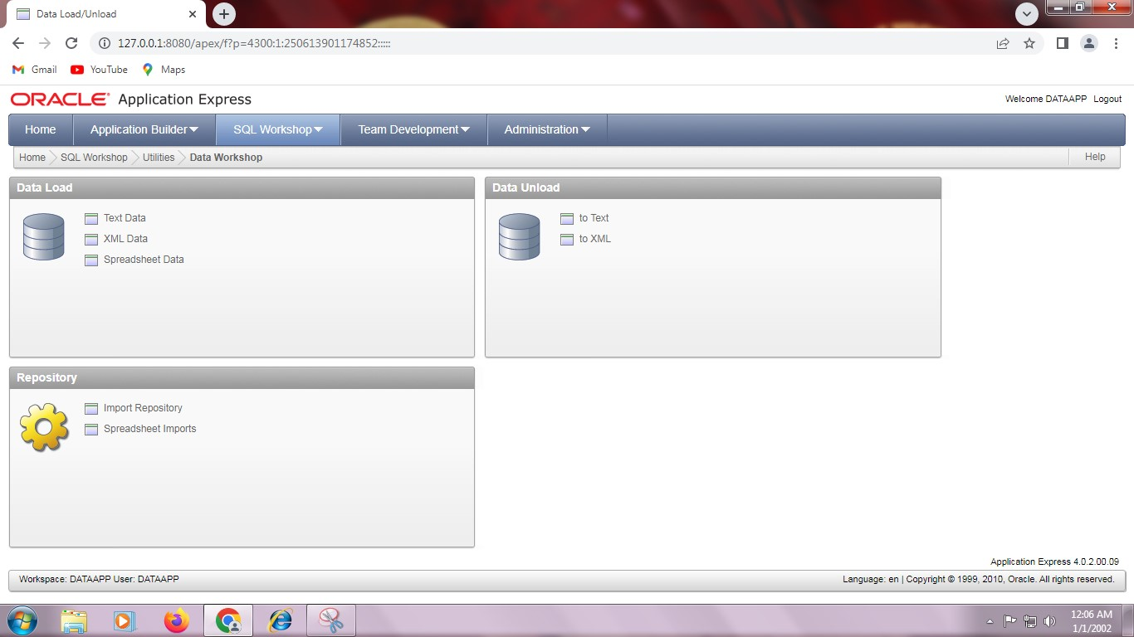

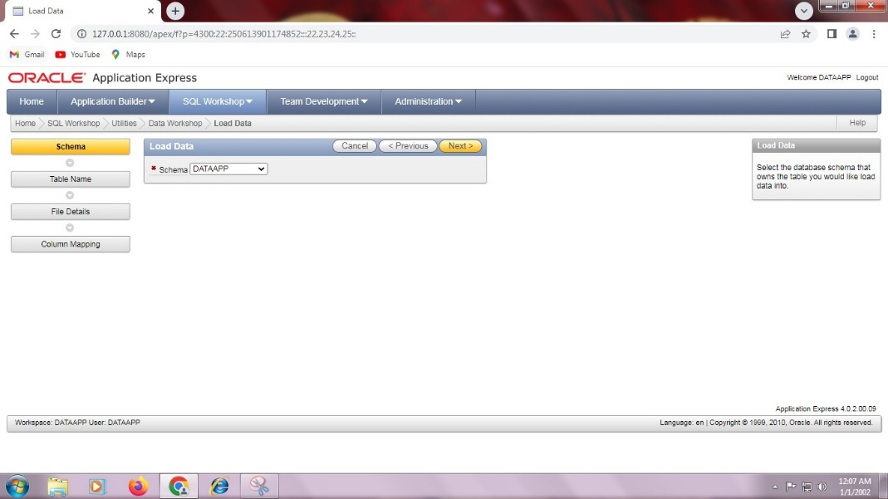
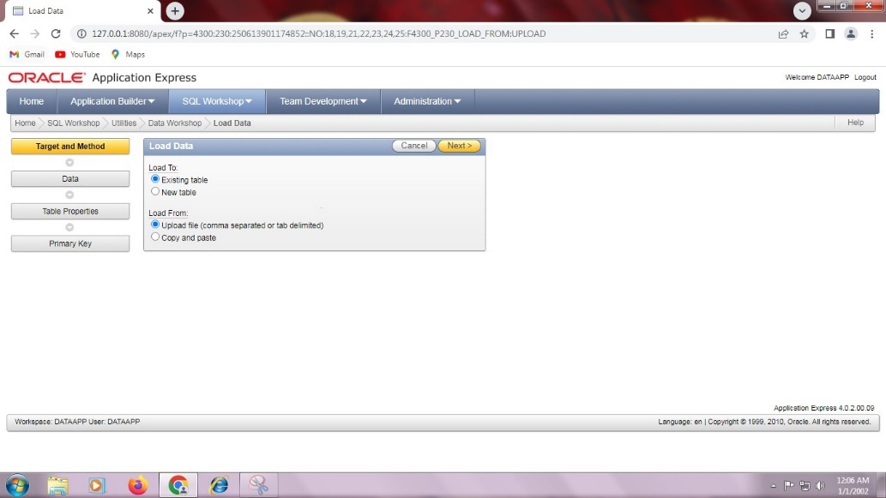
Step 5: Load Data from existing data.

Step 6: Load TableName as DEPT. 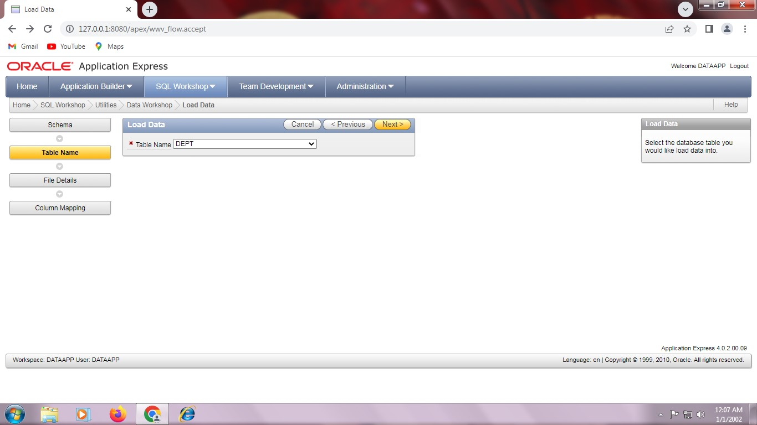
Step 7: Choose file from downloads and load it.
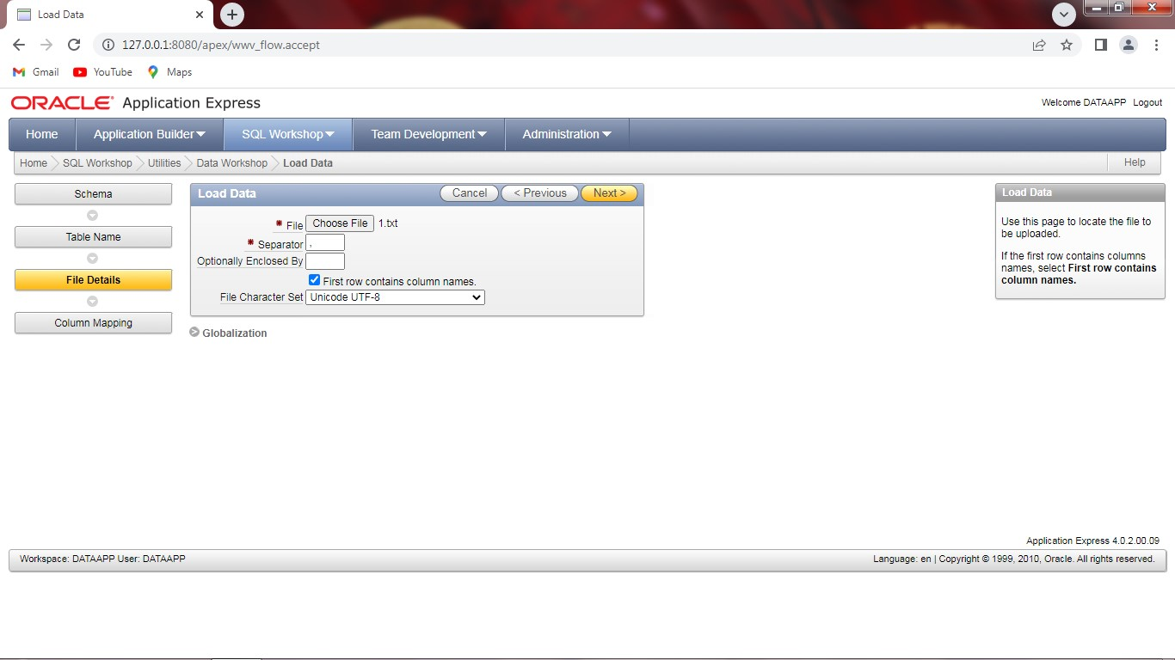

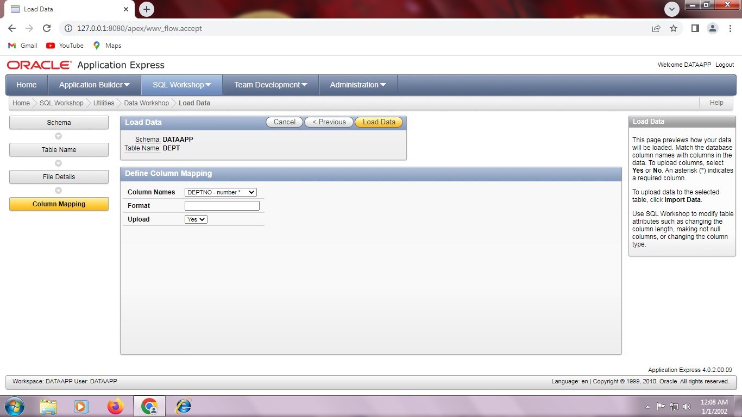

Step 8: File will be added.
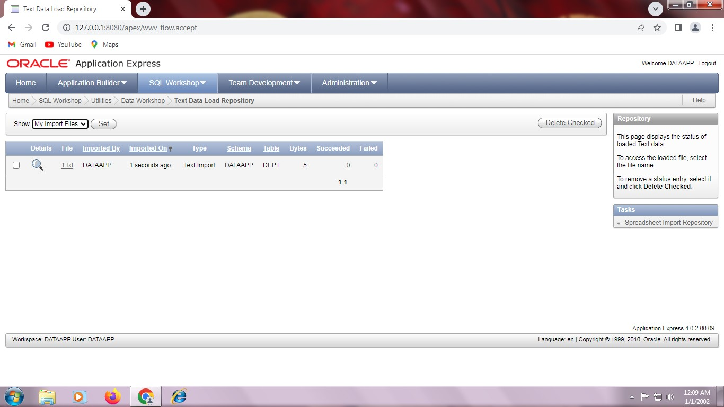

Step 9: Go to Database application and create database.
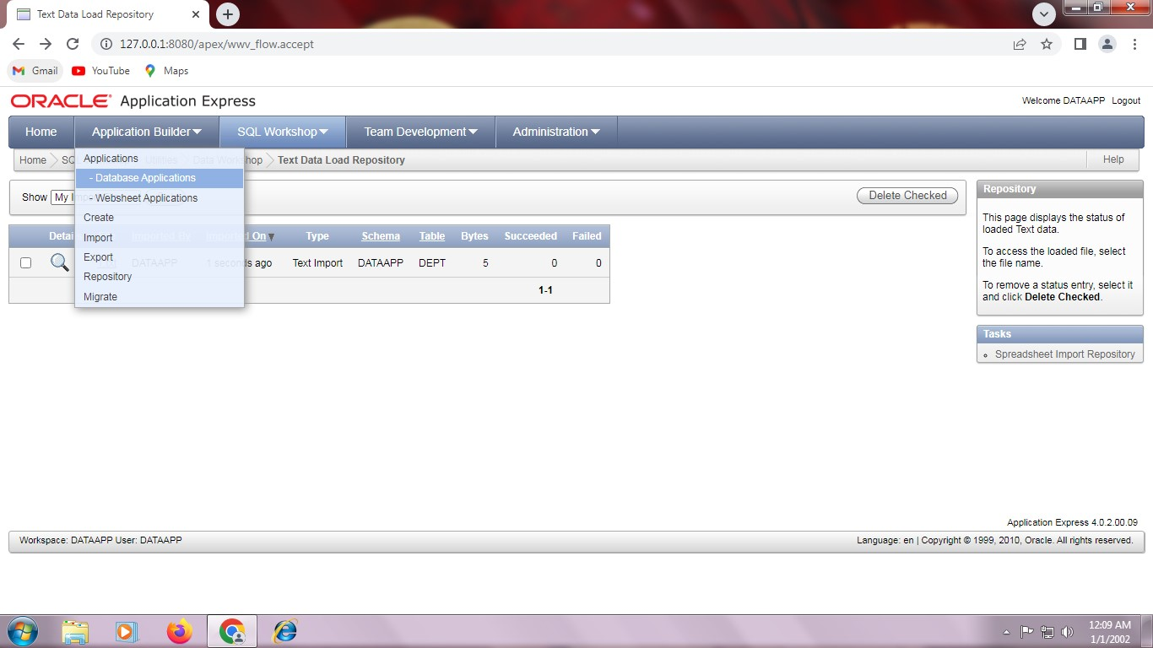
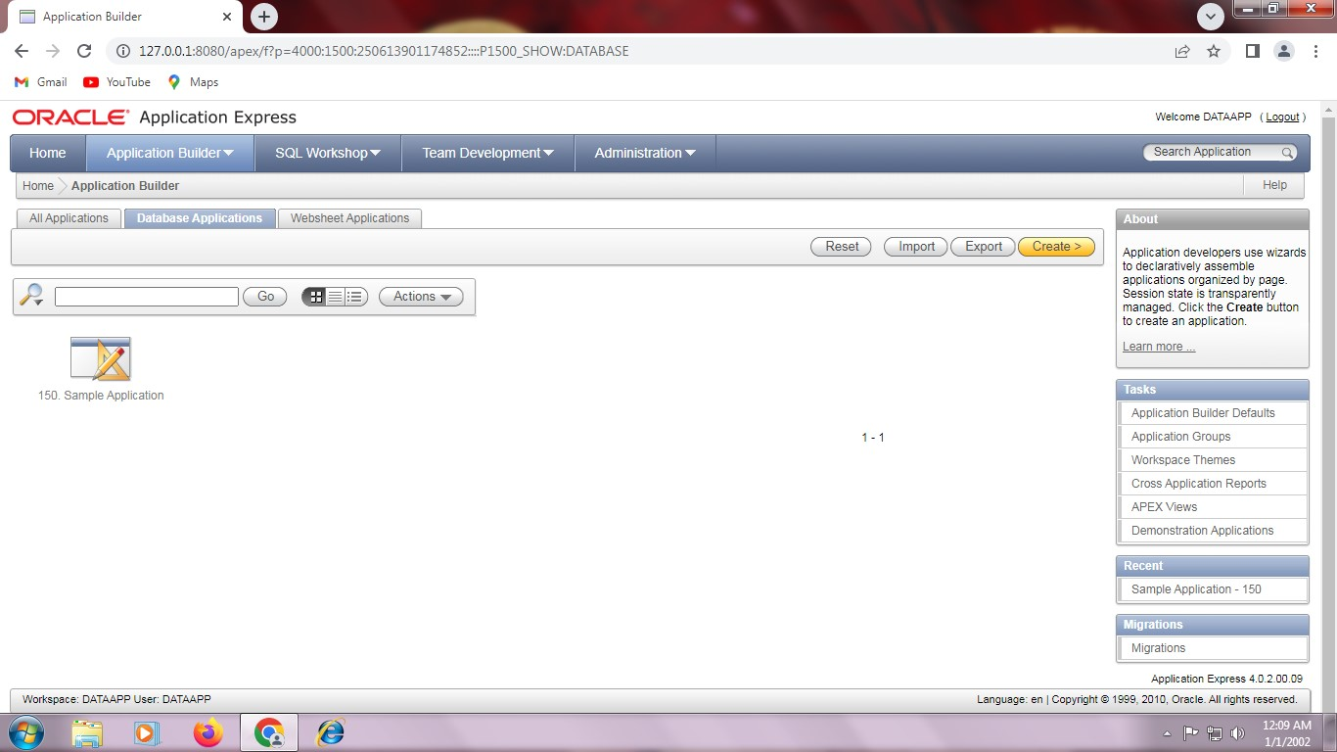

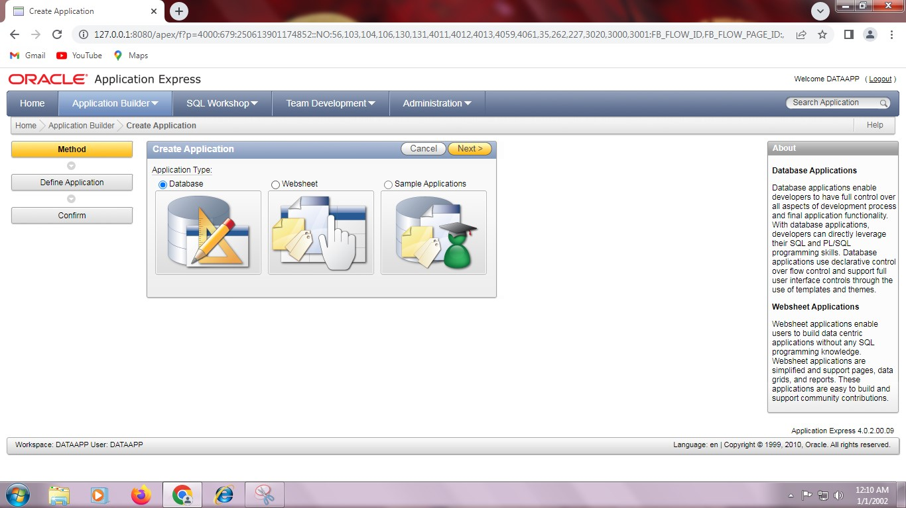

Step 10: Select from scratch and click next.
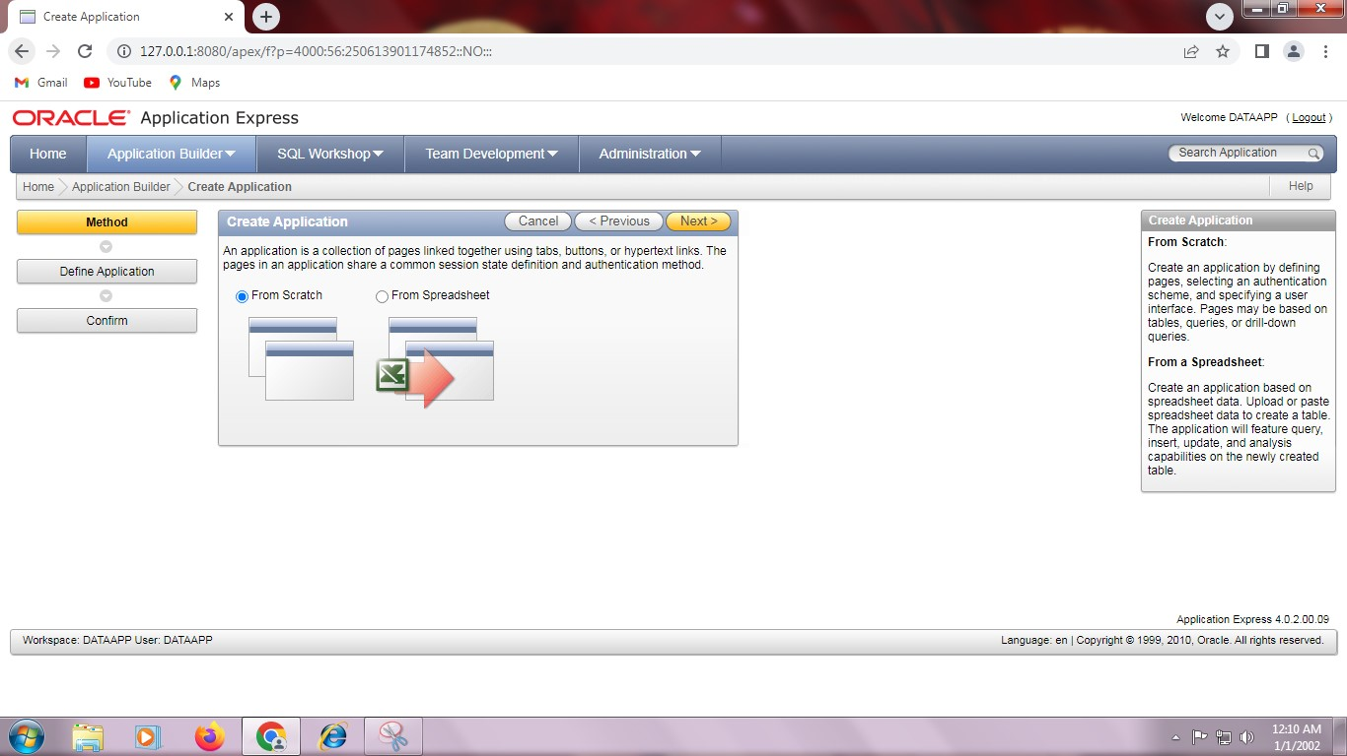

Step 11: Create Application and create next.
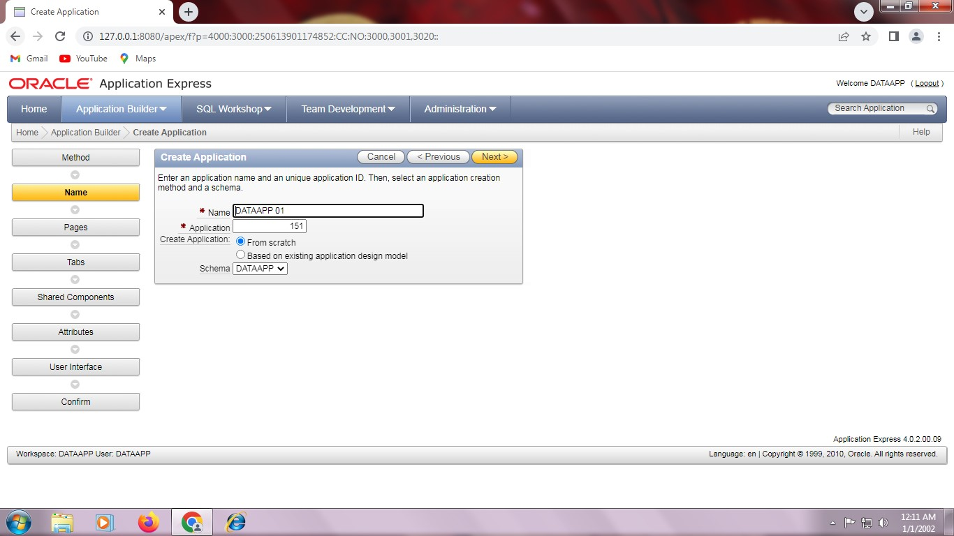

Step 12: Click report and Form.
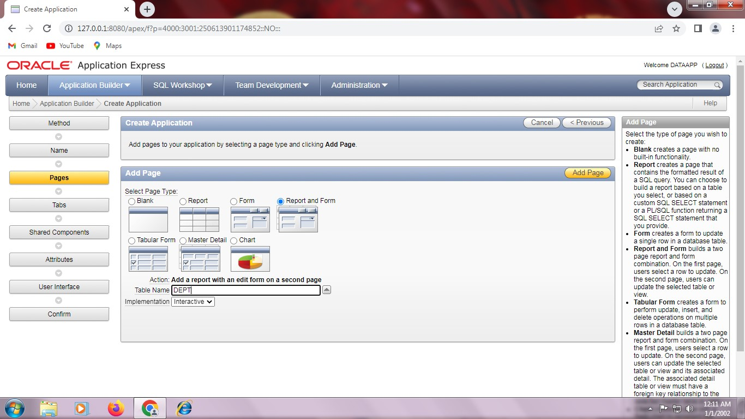
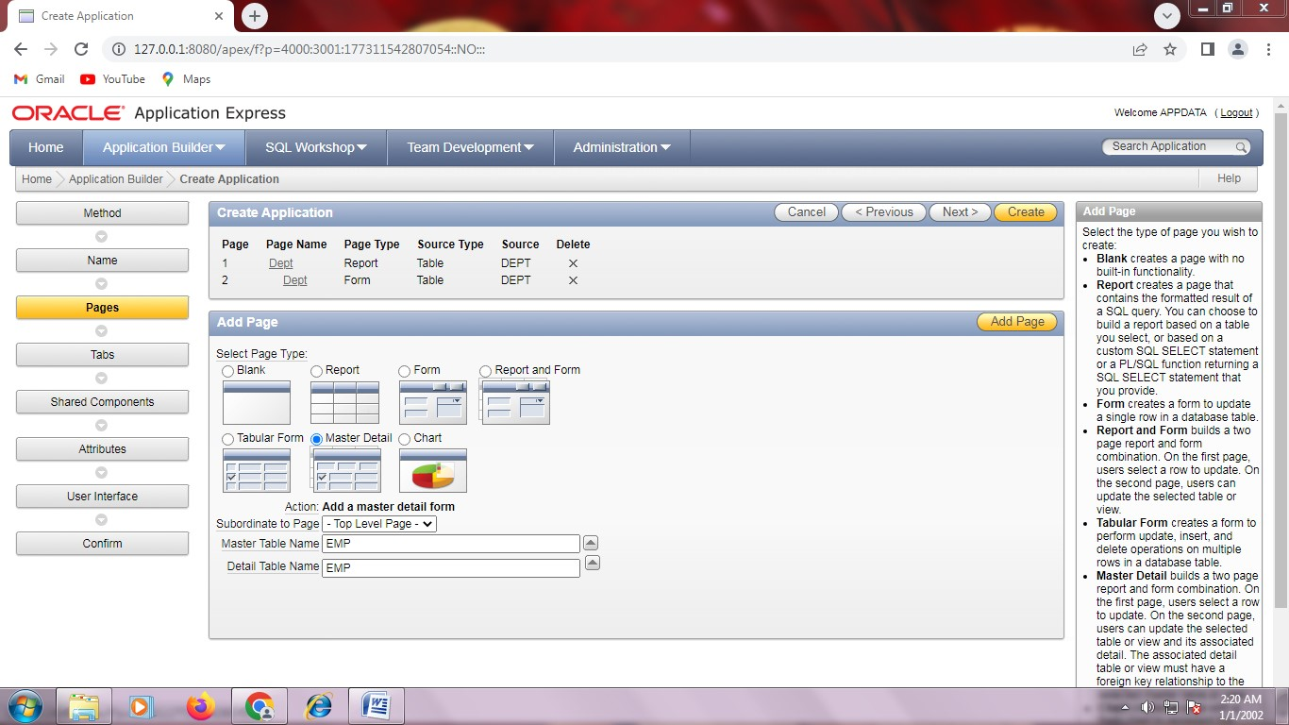

Step 13: Click Master detail.
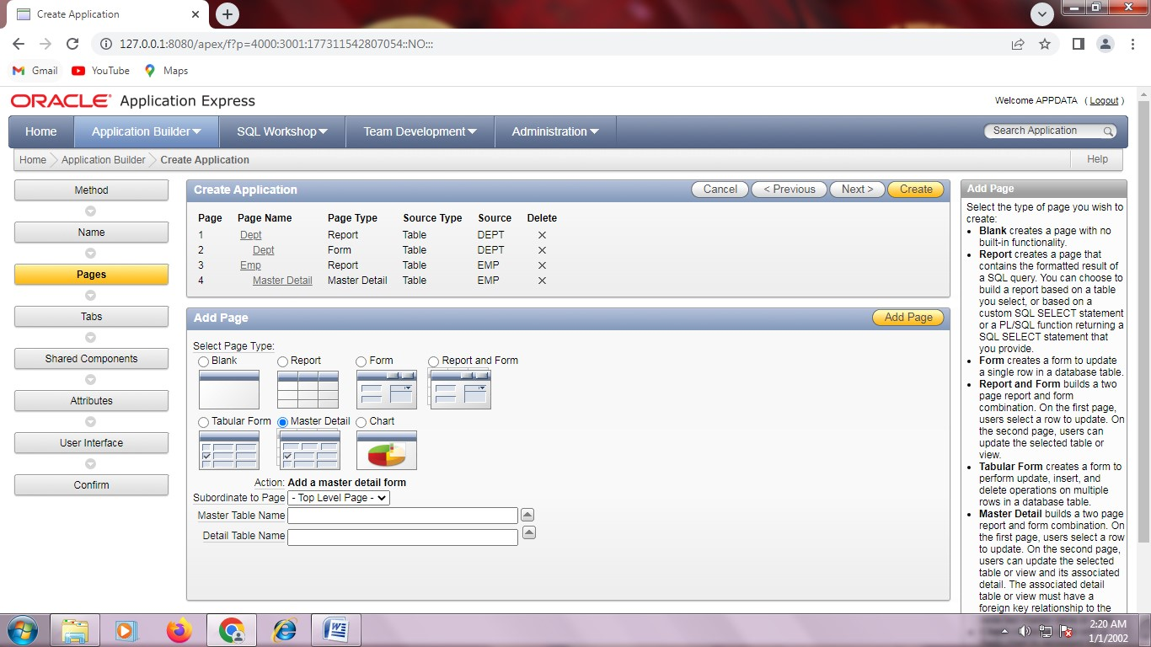

Step 14: Create Application with one level of tabs.
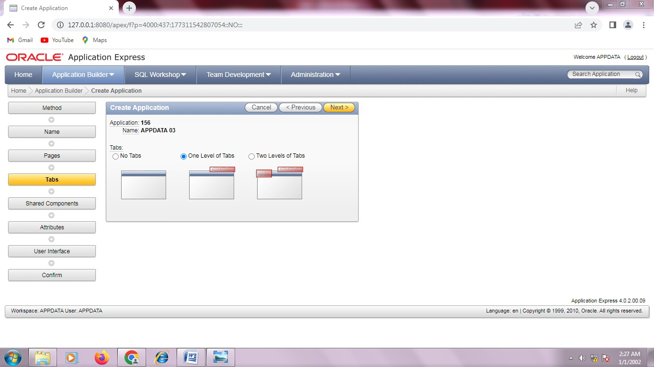

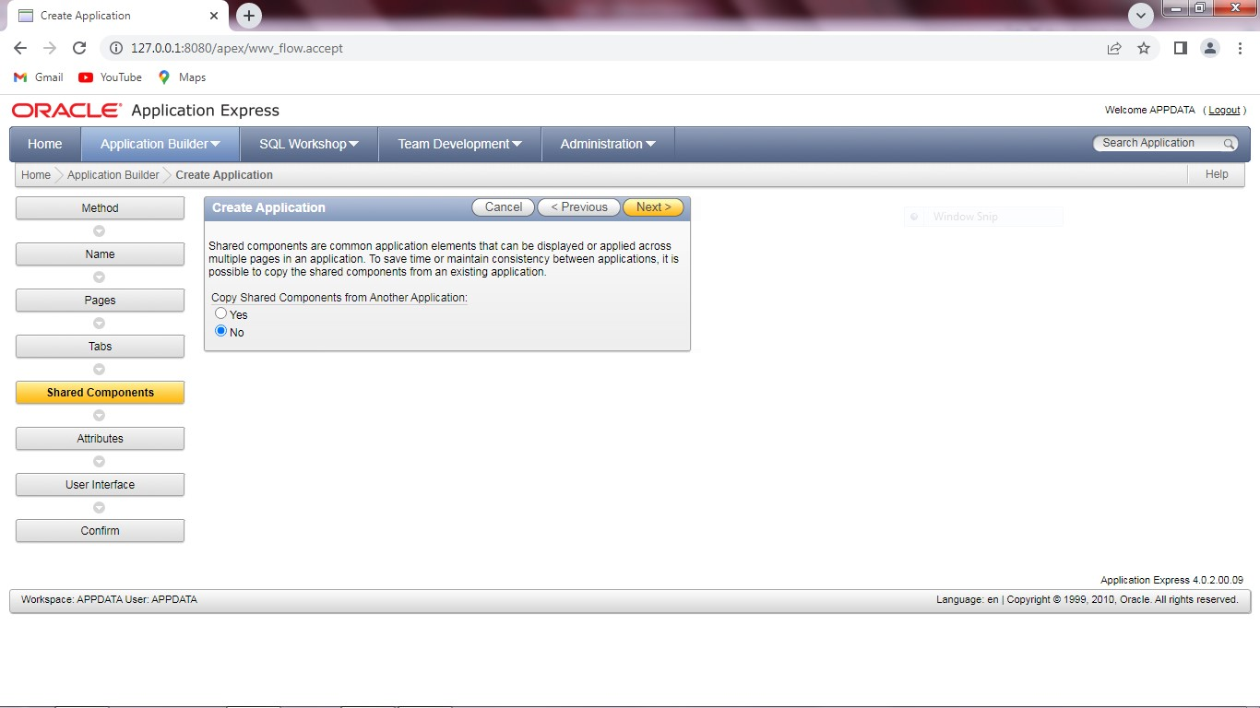

Step 15: Change the data format.
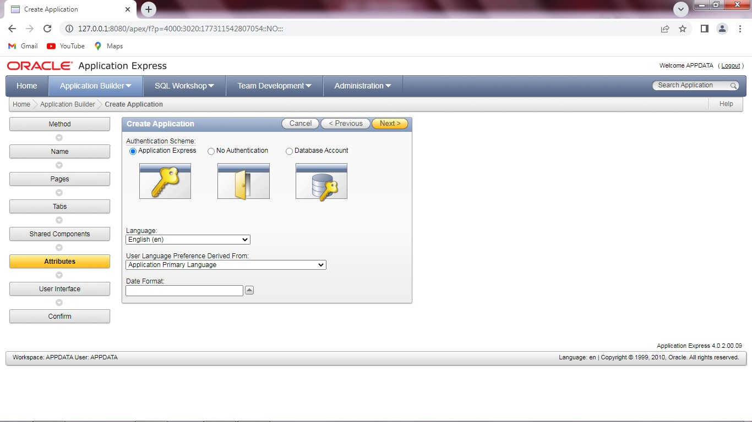

Step 16: Select theme12 and click next.
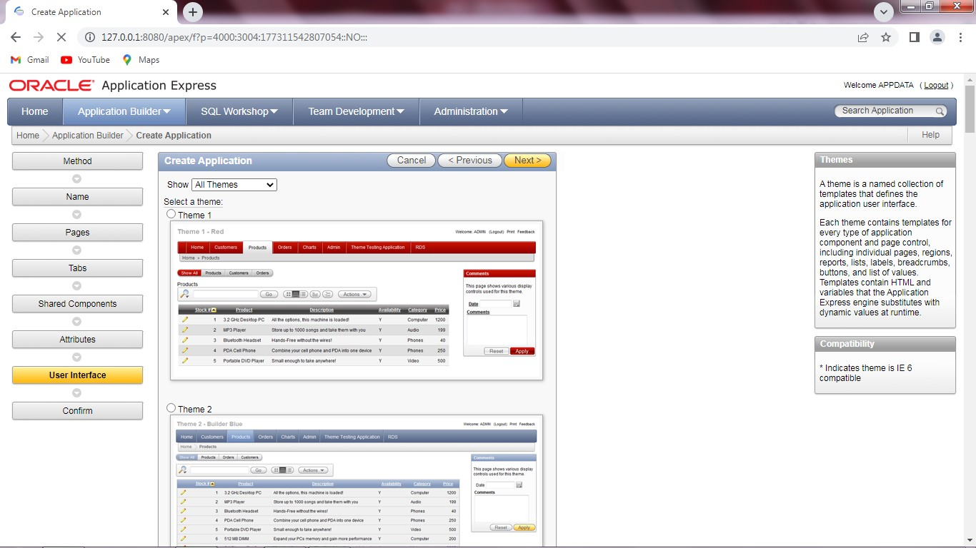
Step 17: Application successfully created.

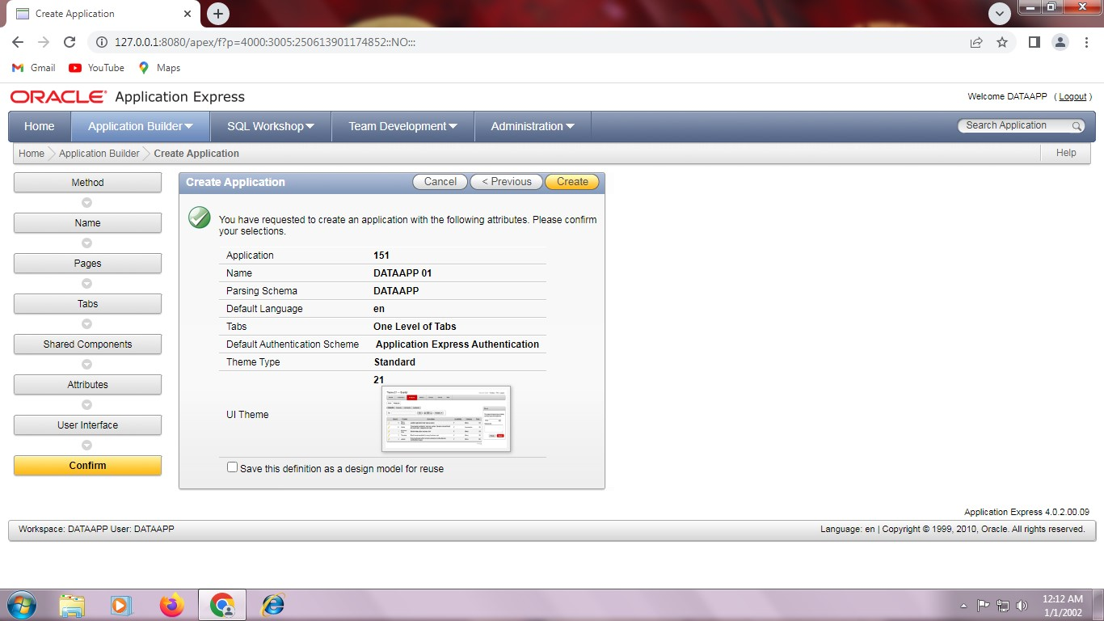

Step 18: Run application.
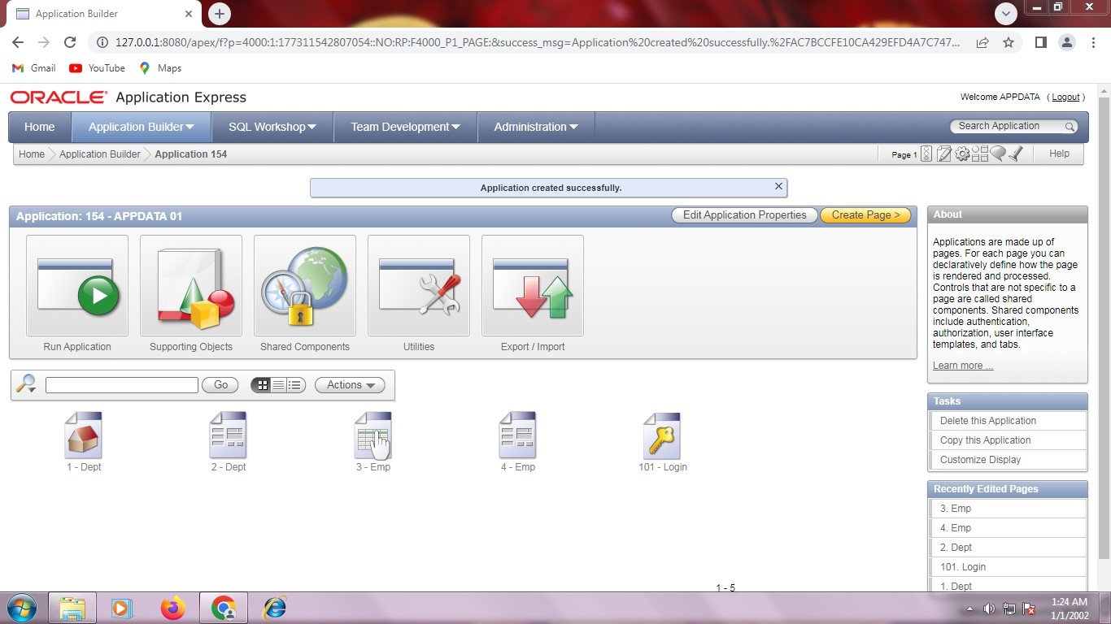

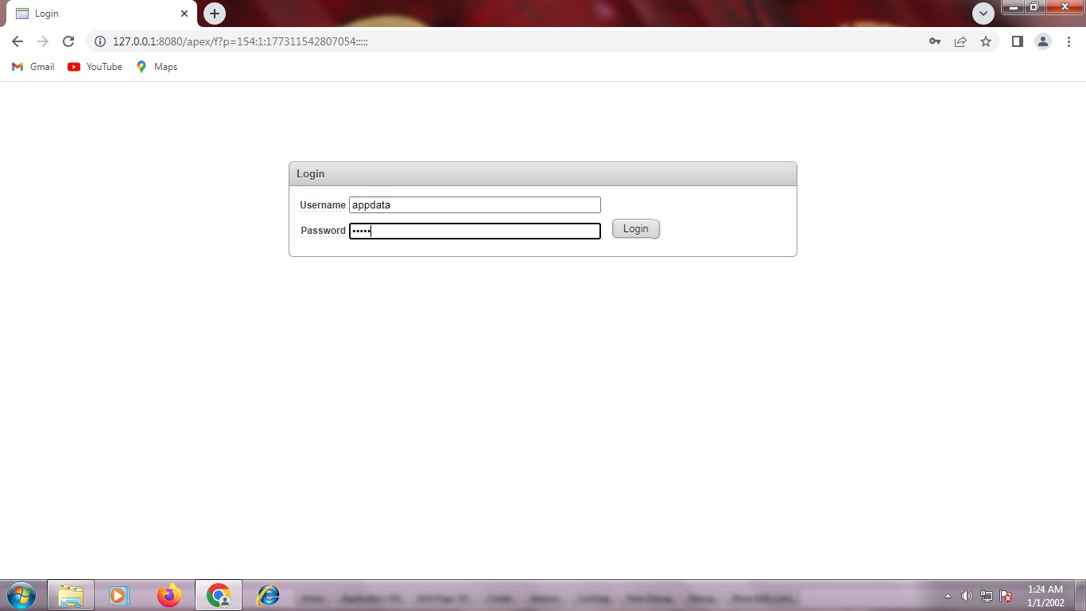
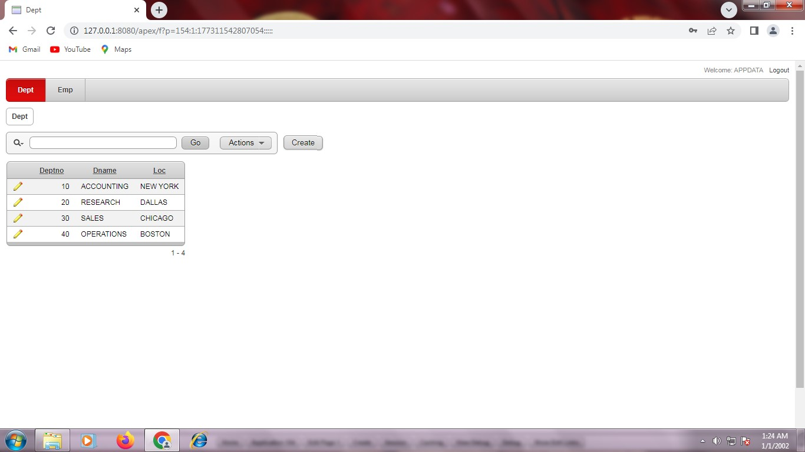
Step 19: Table will be displayed.

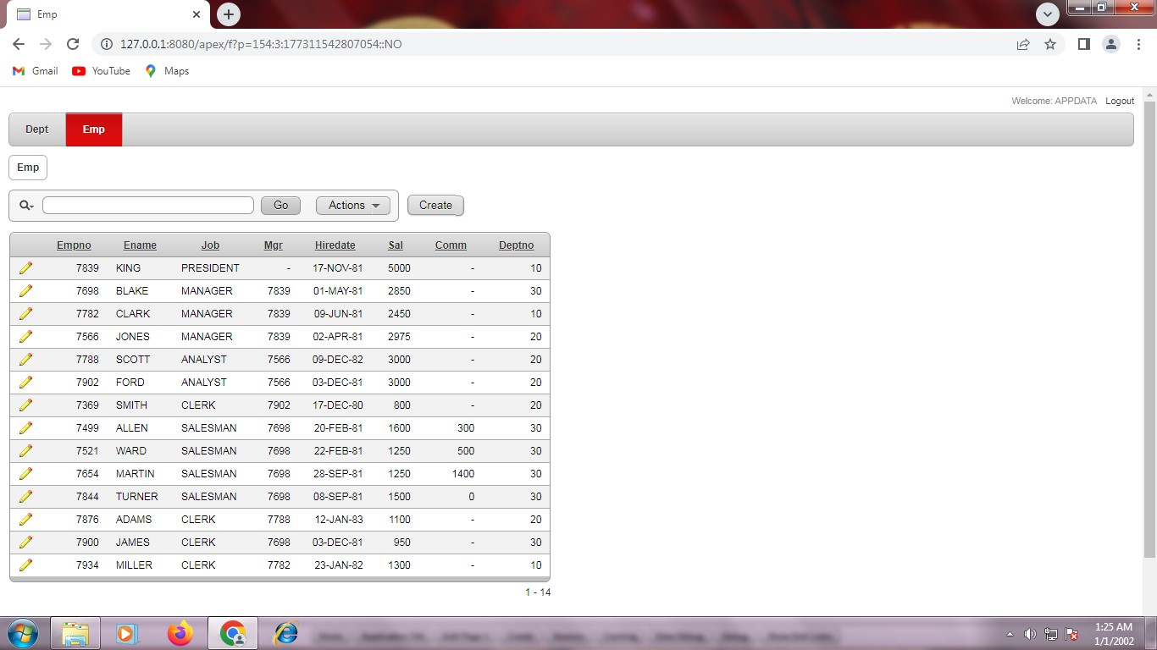

REG NO: 22TD0058 NAME: NASRIN J YEAR/SEM/SEC: Y3/S6/B

IMPLEMENTATION OF REPORT

INTRODUCTION TO ORACLE APPLICATION EXPRESS:
Oracle Application Express (abbreviated APEX, previously named Oracle HTML DB) is a web based software environment that runs on an Oracle database. It is fully supported and comes standard1
(at no additional cost) with all Oracle Database editions and starting with Oracle 11g, is installed by default as part of the core database install.

CREATION OF INTERACTIVE REPORT:

STEPS:

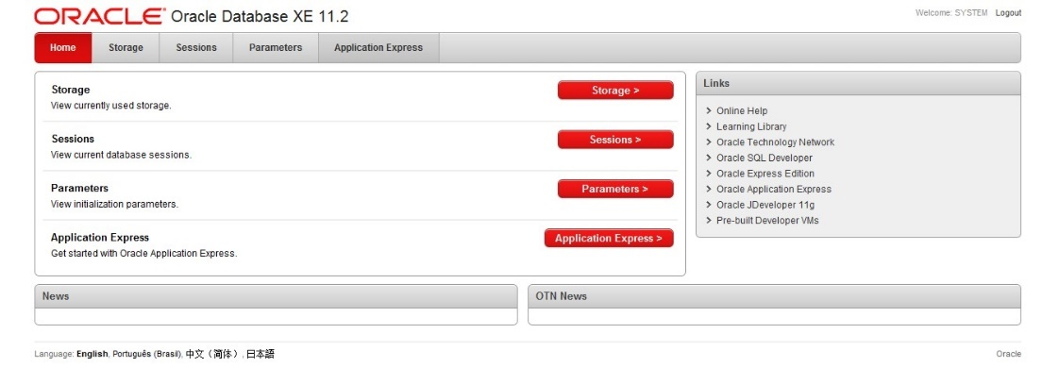
Step 1:Visit http://127.0.0.1:8080/apex/f?p=4950 and create workspace.

Step 2: Enter Application express workspace and credentials.
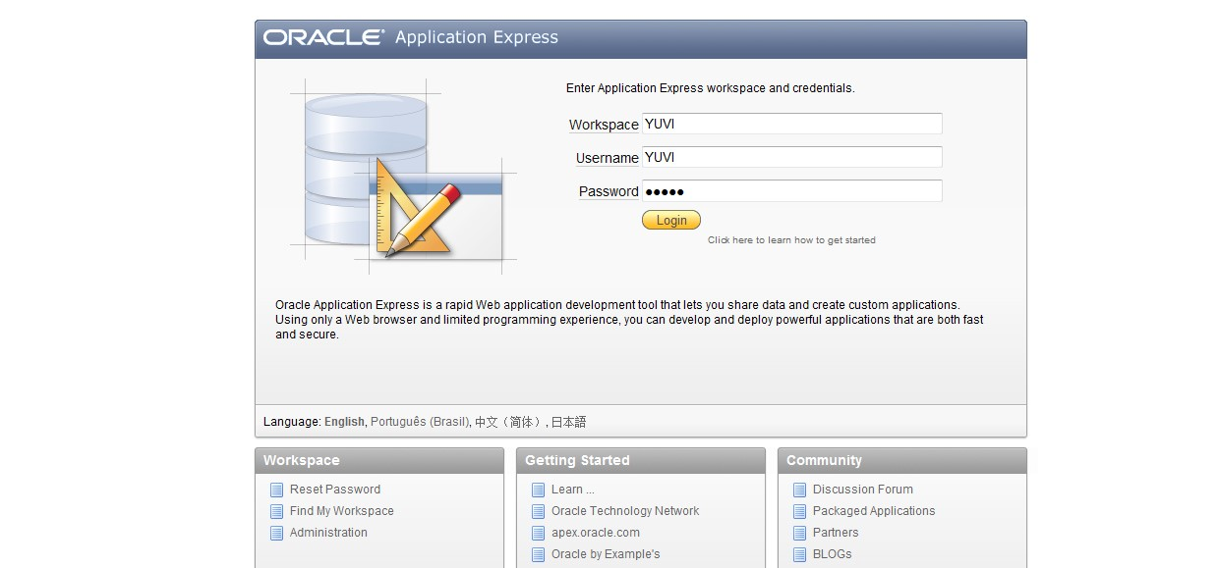
Step 3: Under Application builder click database application.

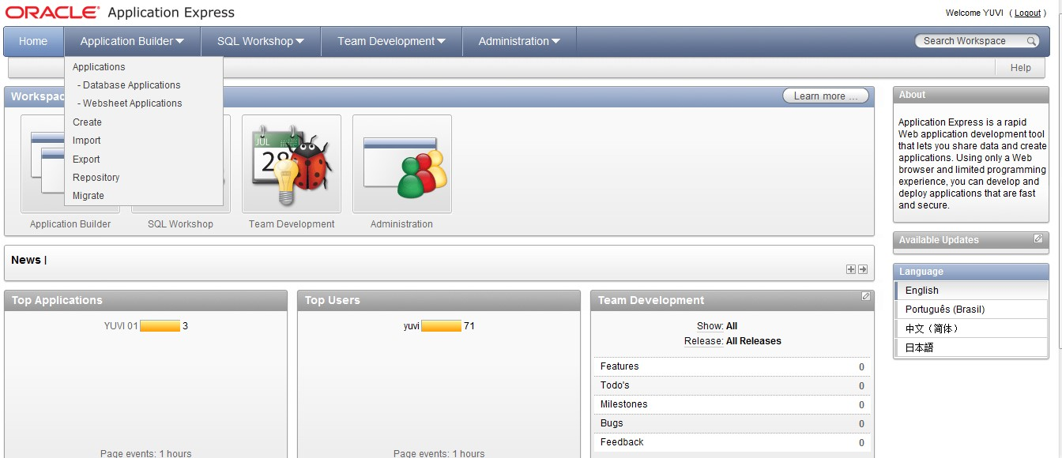

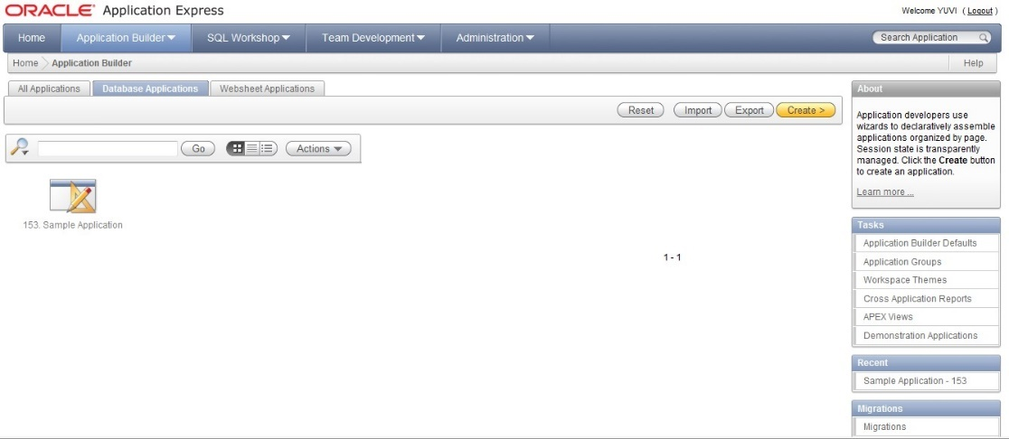
Step 4: Created Database application.

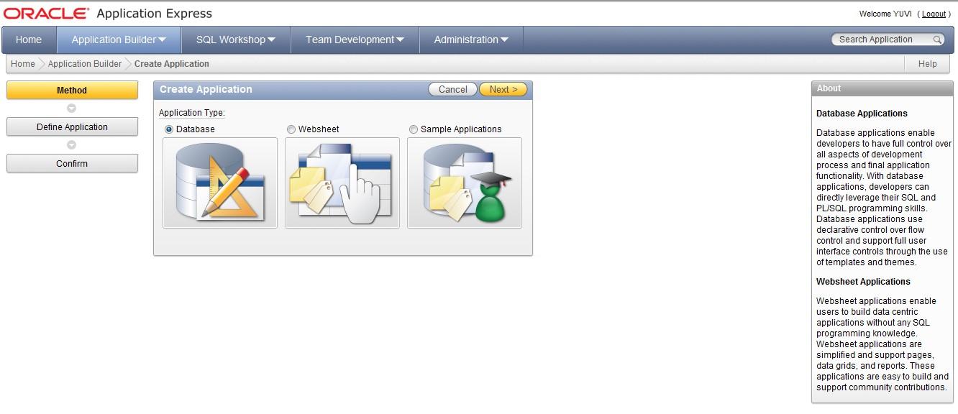

Step 5: Create application from scratch.
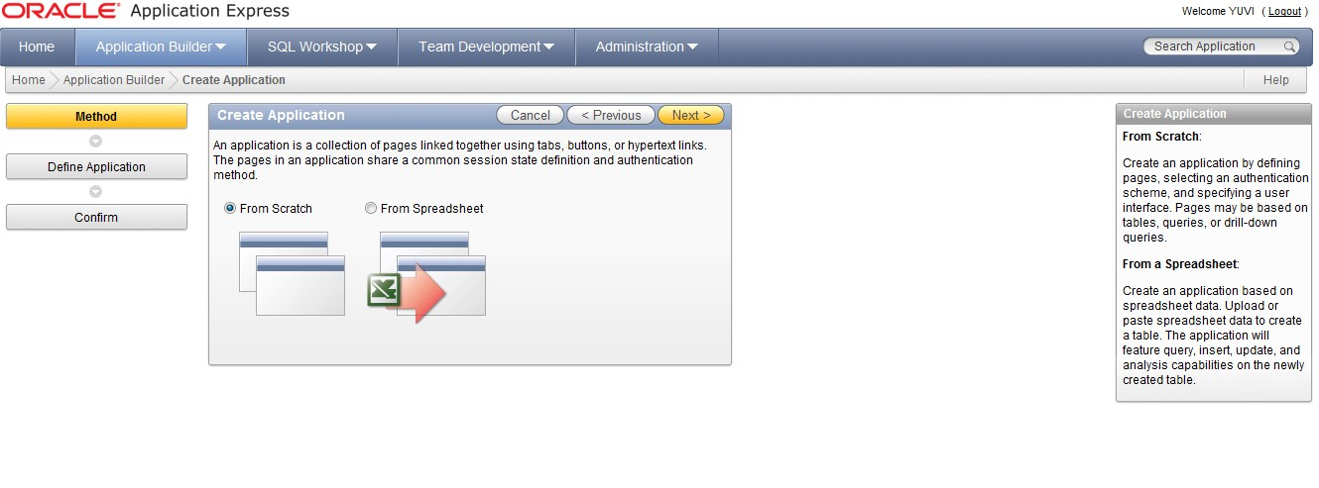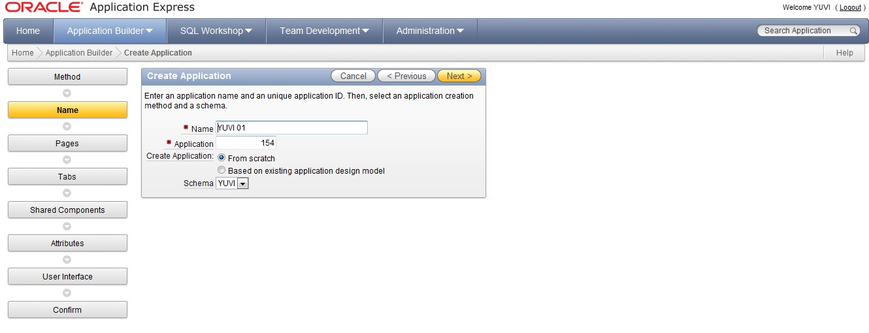

Step 6: Select blank application and enter page name and add page.
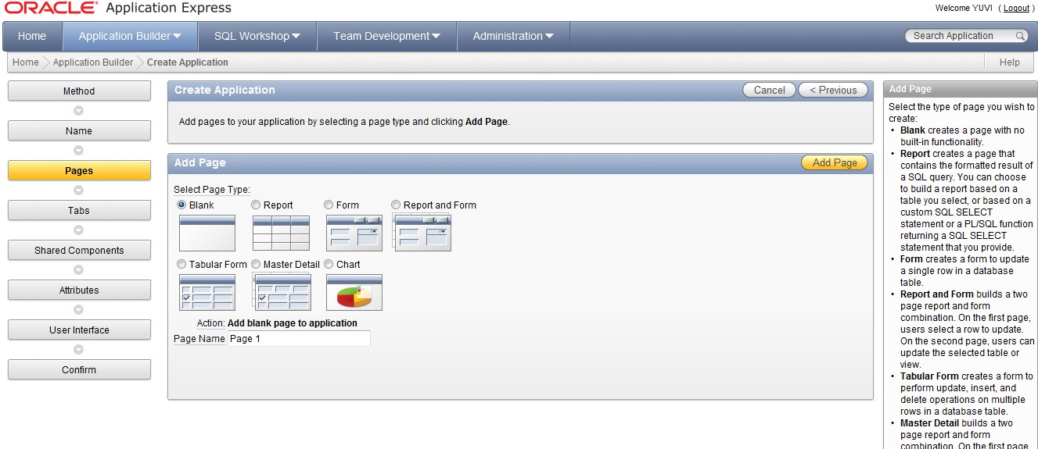

Step 7: Then select report and form and enter table name from list of values and add pages.

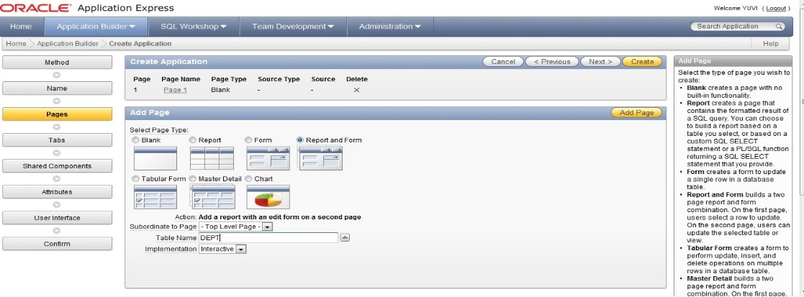

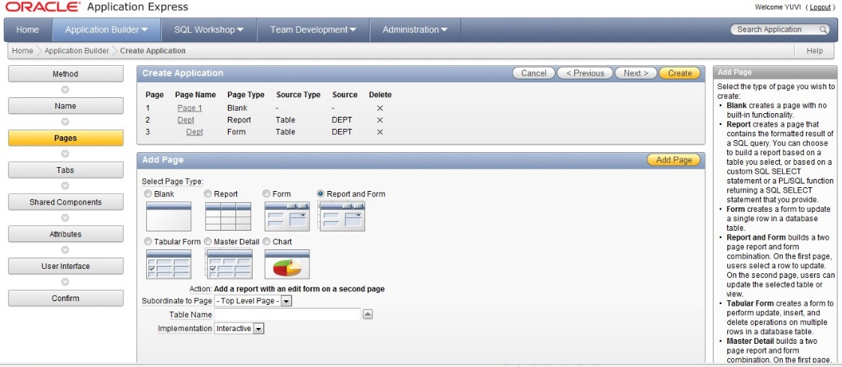
Step 8: Create application from one level of tabs.
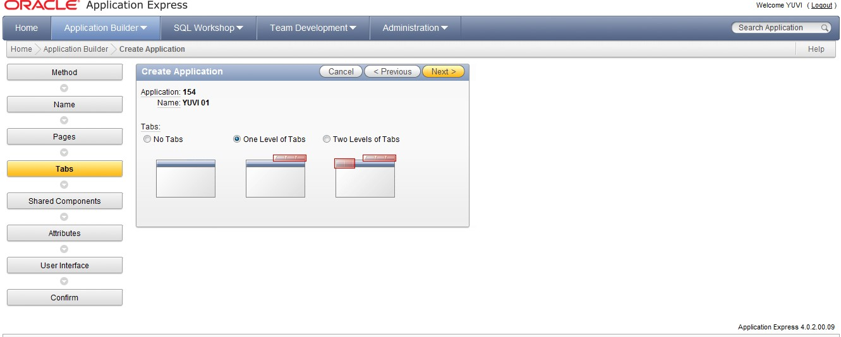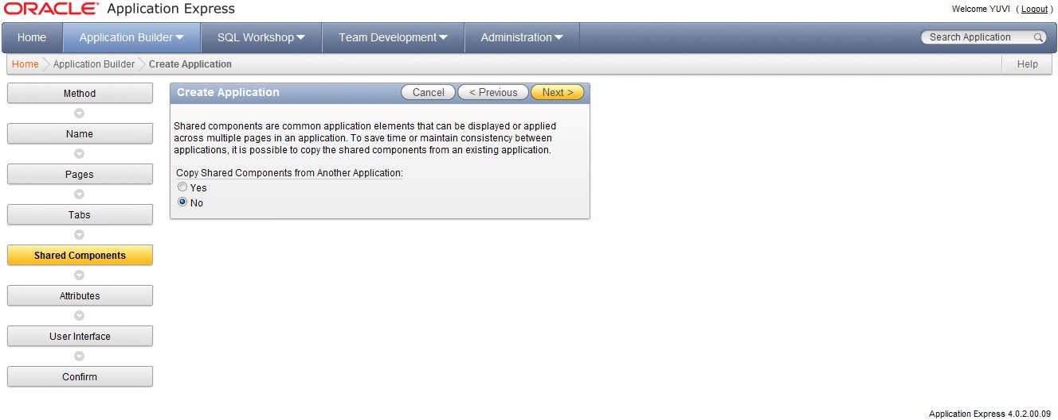

Step 9: Select application express and change date format.
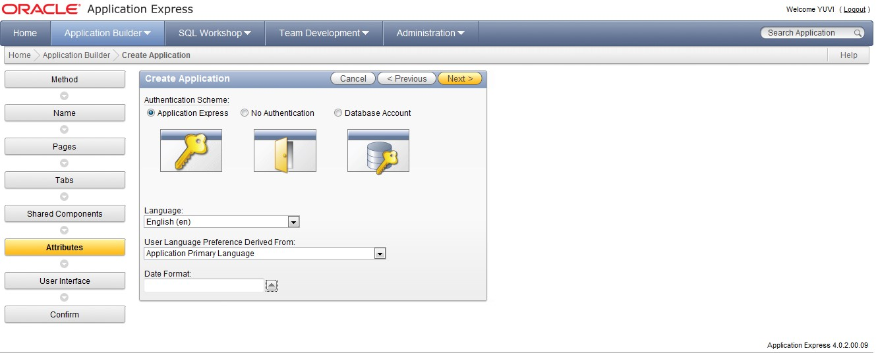

Step 10: Select theme1 and click next.

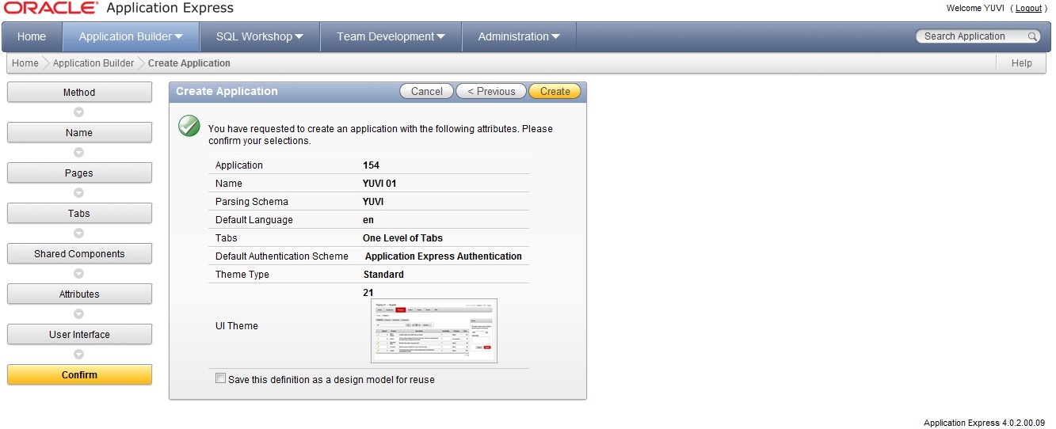
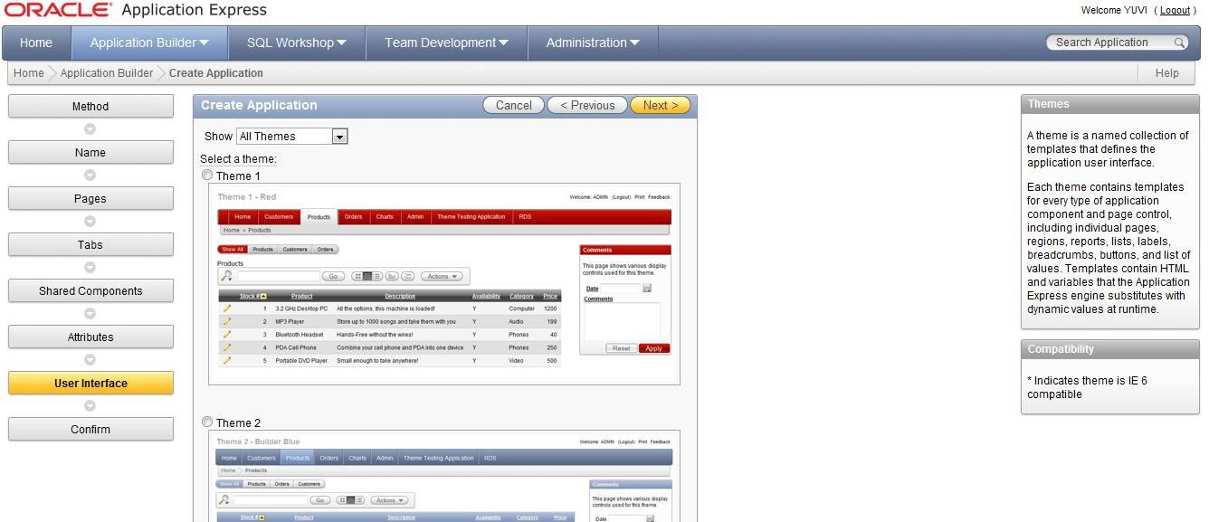
Step 11: Create and run application.
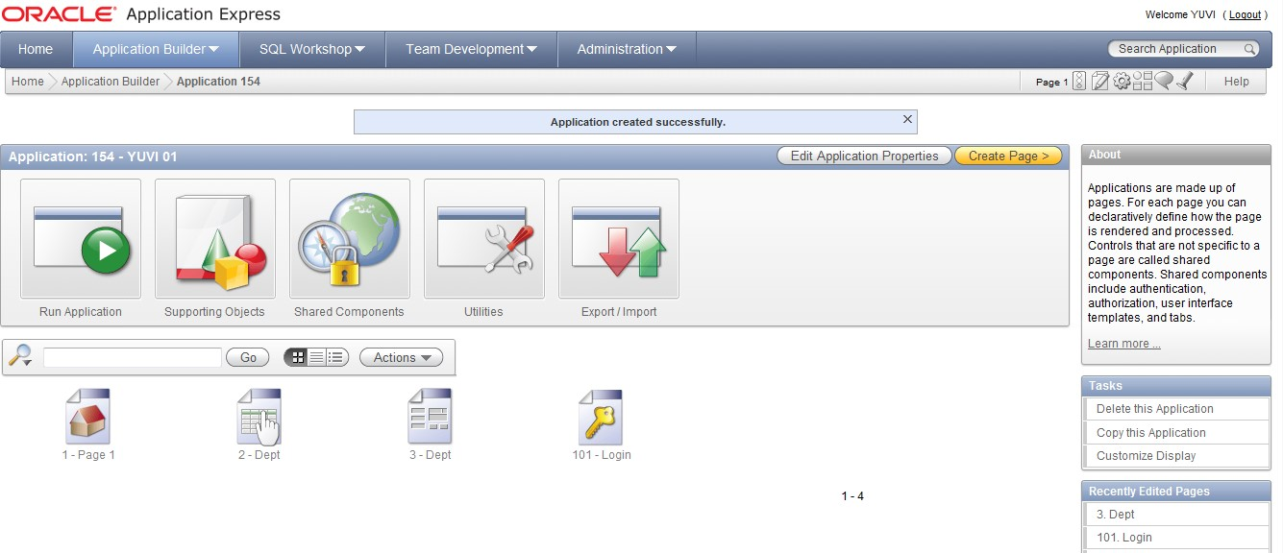

Step 12: Login with username and password.

Step 13: Report is generated.
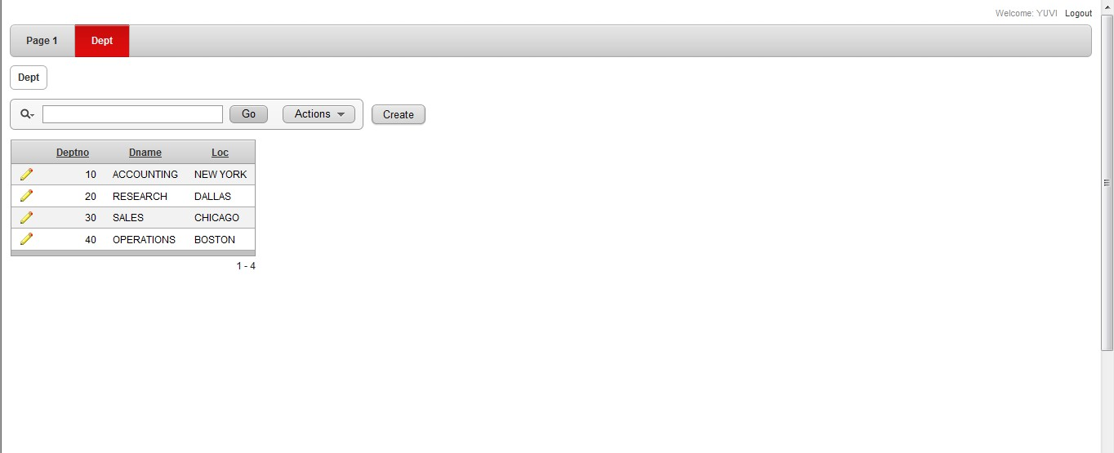

REG NO: 22TD0058 NAME: NASRIN J YEAR/SEM/SEC: Y3/S6/B

CREATION OF WEBSHEET APPLICATION

INTRODUCTION TO ORACLE APPLICATION EXPRESS:
Oracle Application express (abbreviated APEX, previously named Oracle HTML DB) is a well-based software development environment that runs on a Oracle database. It is fully supported and comes standard (at no additional cost) with all Oracle Database editions and, starting with Oracle 11g, is installed by default as part of the core database install.
CREATION OF WEBSHEET APPLICATION:
STEPS:
Step1: visit http://127.0.1:8080/apex/f?p=4950 and create workspace.
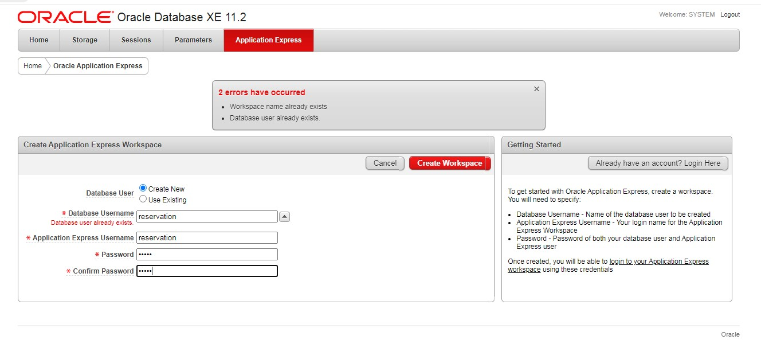

Step2: Enter application express and credentials.
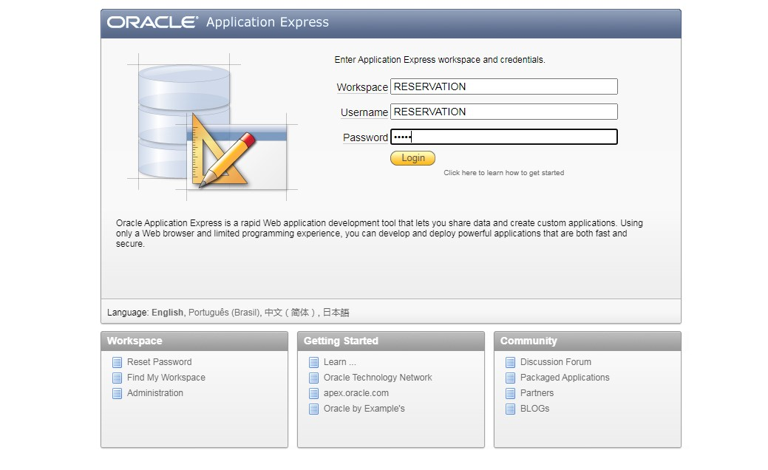
Step3: under application builder and select websheet application.
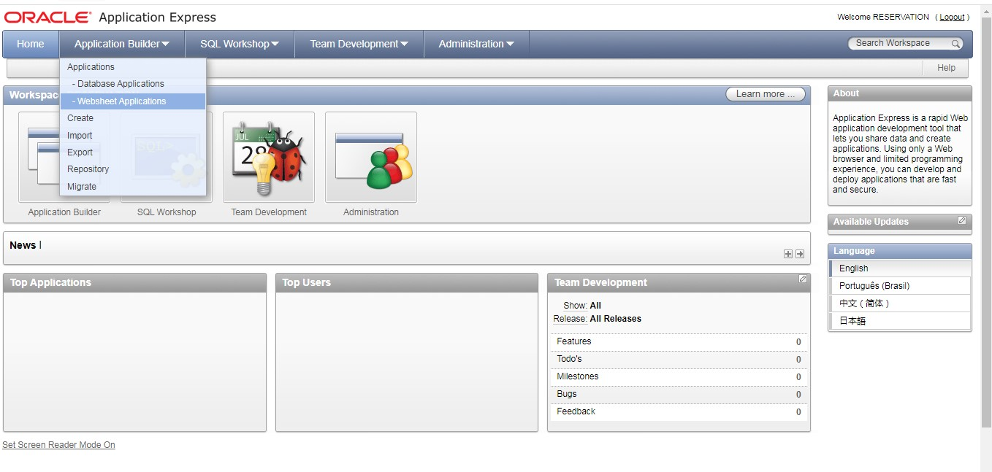
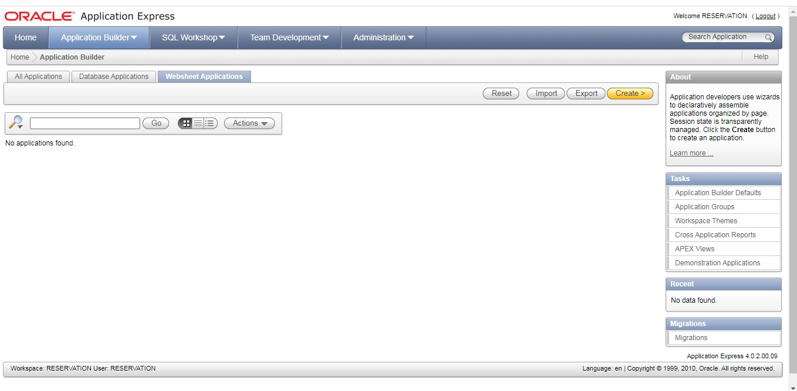
Step4: Select websheet application.
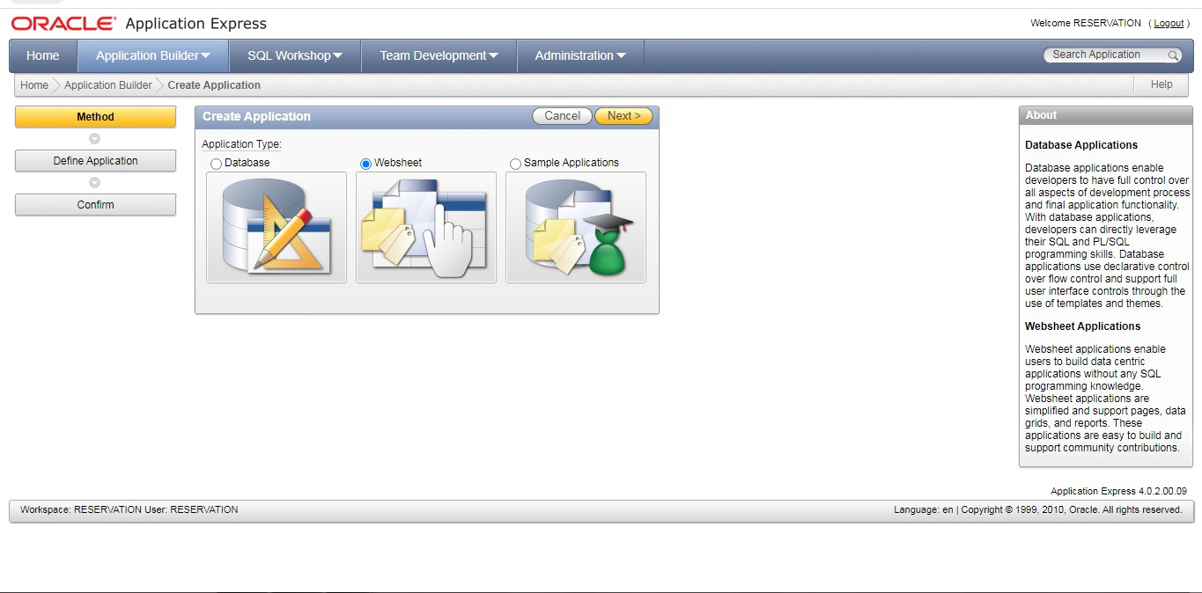
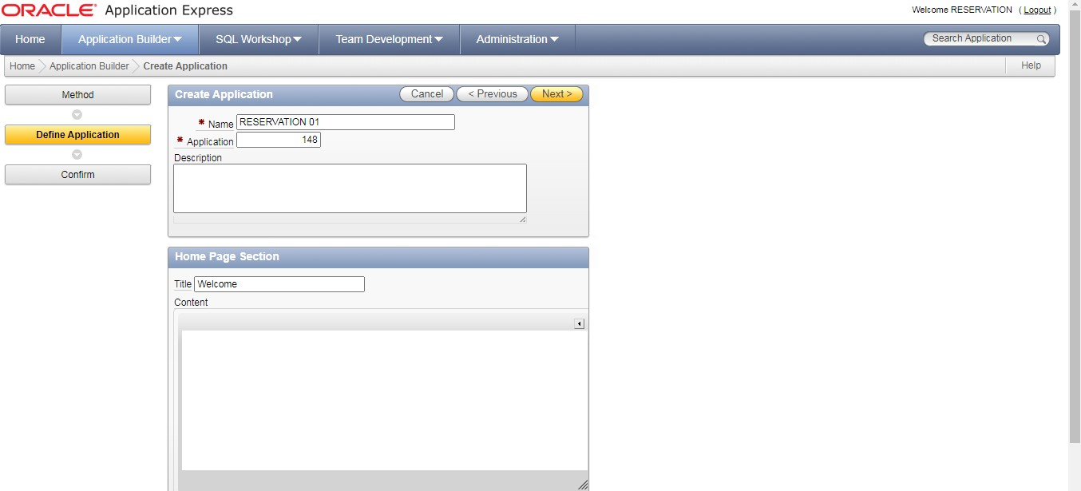

Step5: Confirm your application.
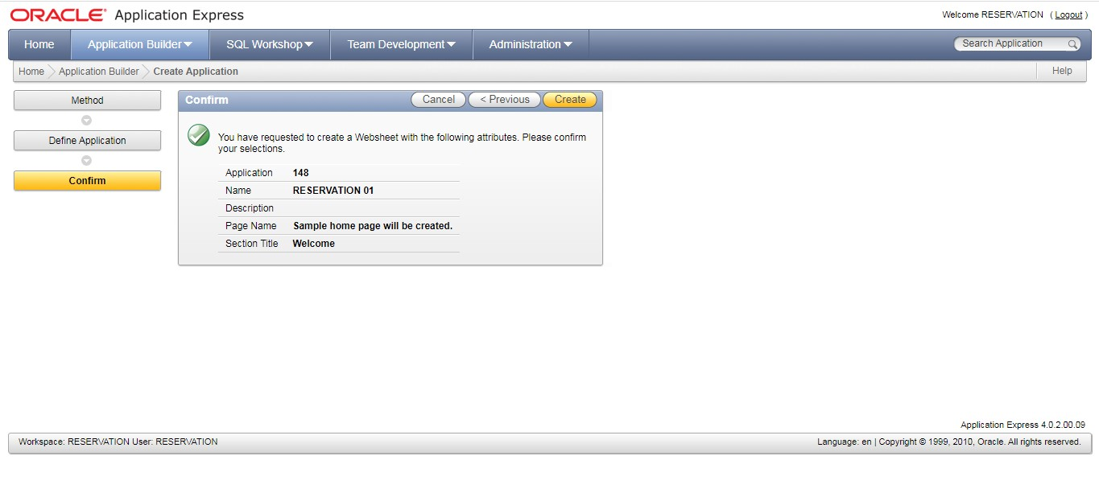

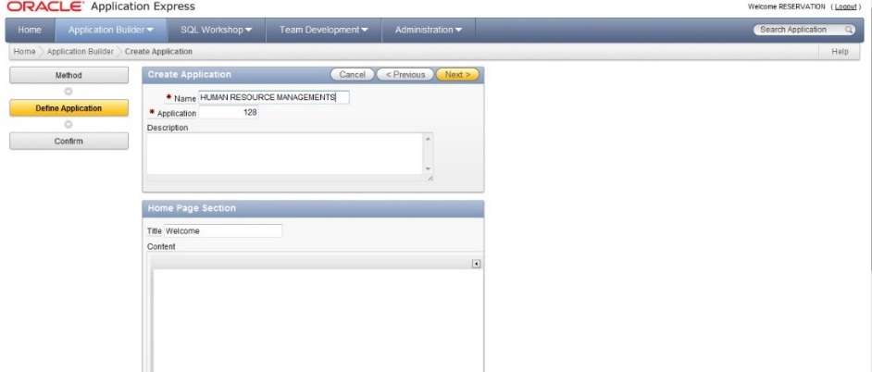
Step 6:
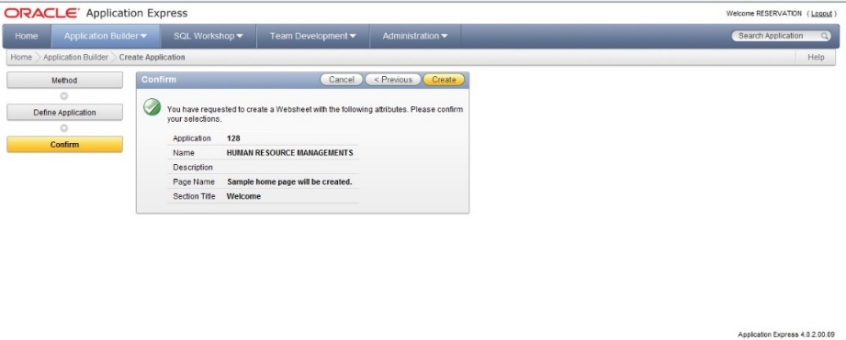

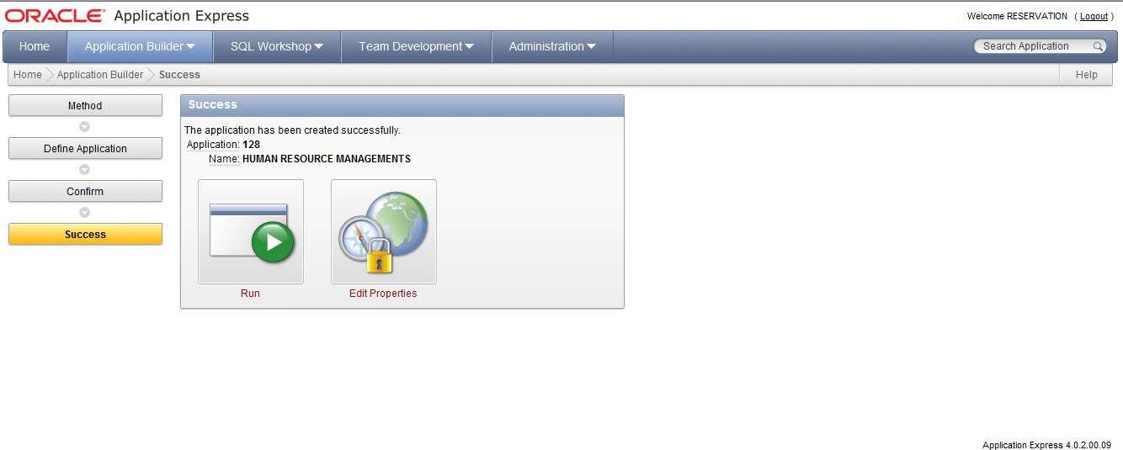
Step7: Run the application.

Step 8: Enter with username and password.
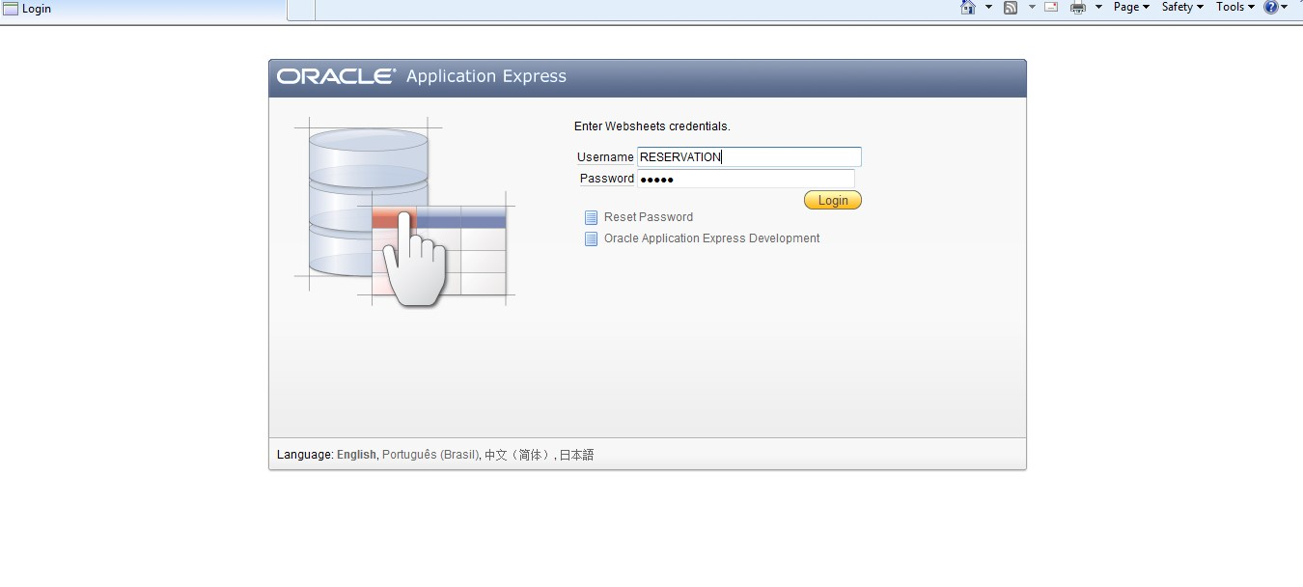
ADDING A TEXT SECTION TO A PAGE:
Step 9: under page option select new section.
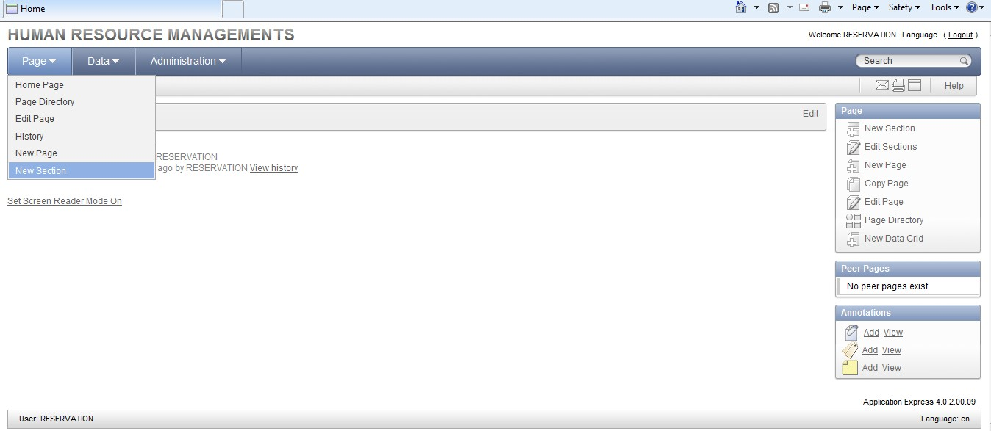

Step 10: Select text option.
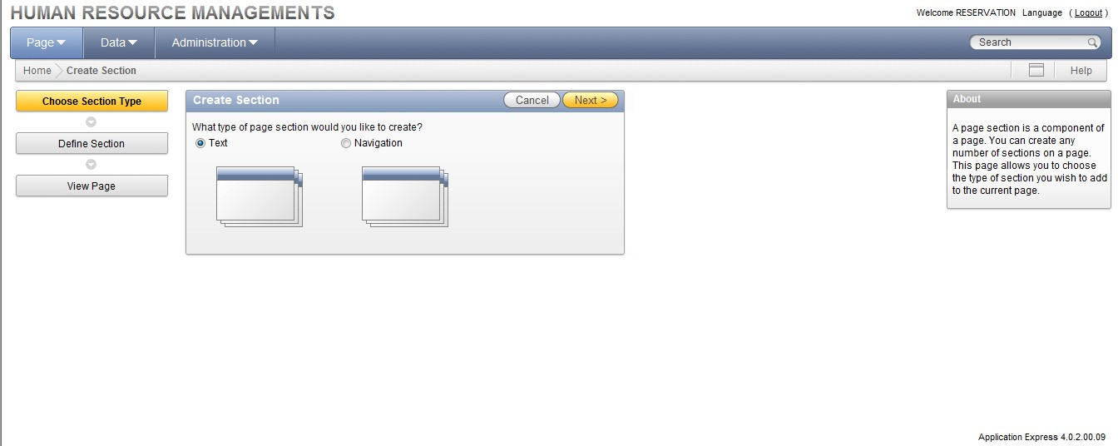
Step 11: Enter the content and create.
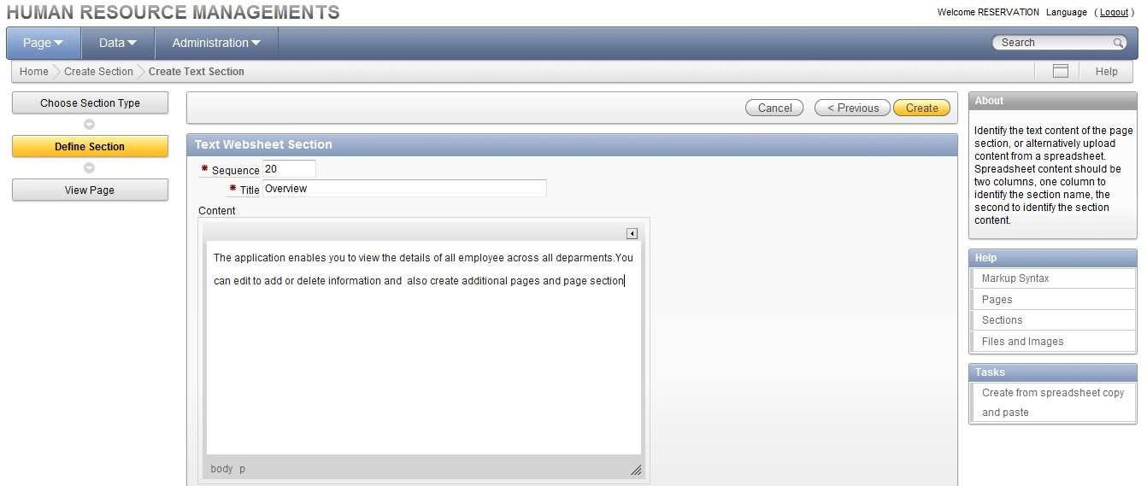

Step 12: New section created.

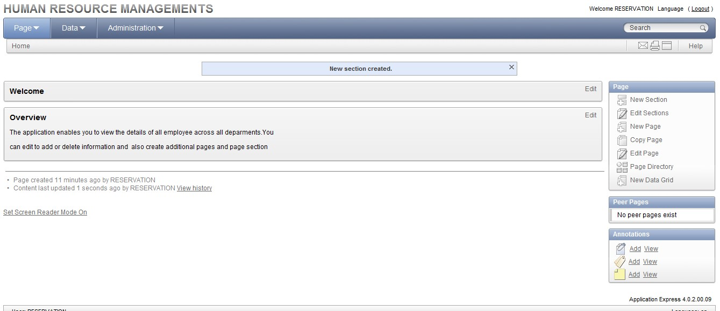
ADDING A FILE TO A PAGE:
Step 13: Browse the file.
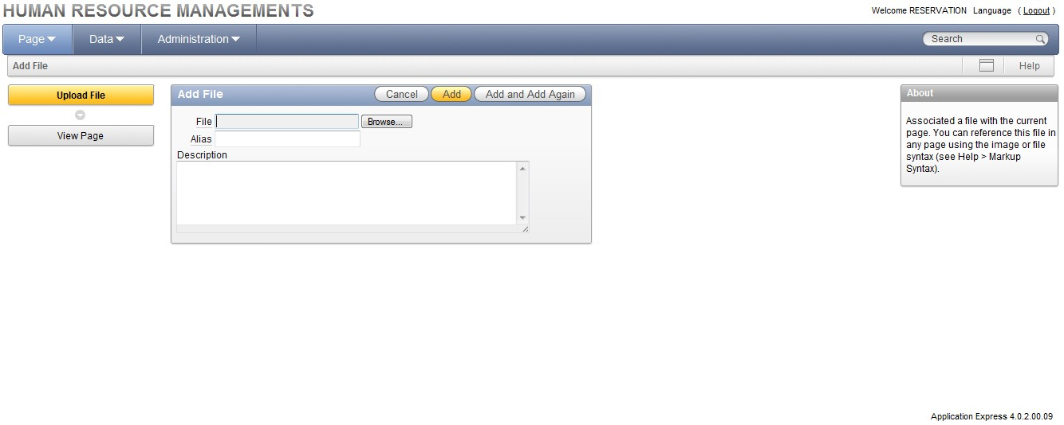
STEP 14: File will added to a page.
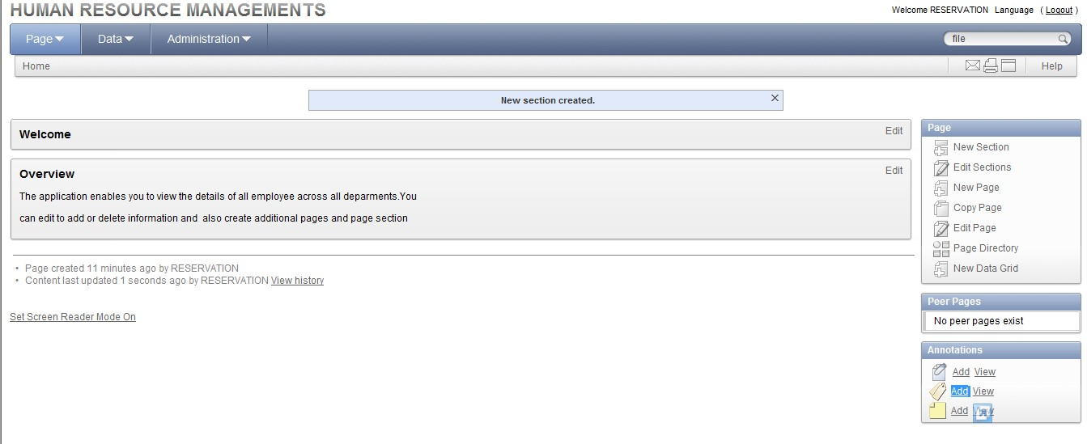
ADDING A TAG TO A PAGE:
Step 15: Enter sample in the tag filed and add tag. 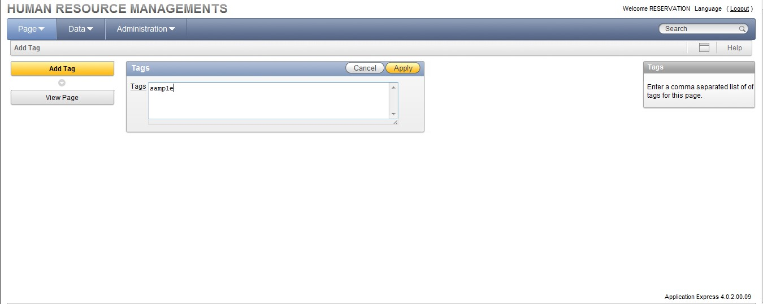
Step 16: Tag is added to a page.
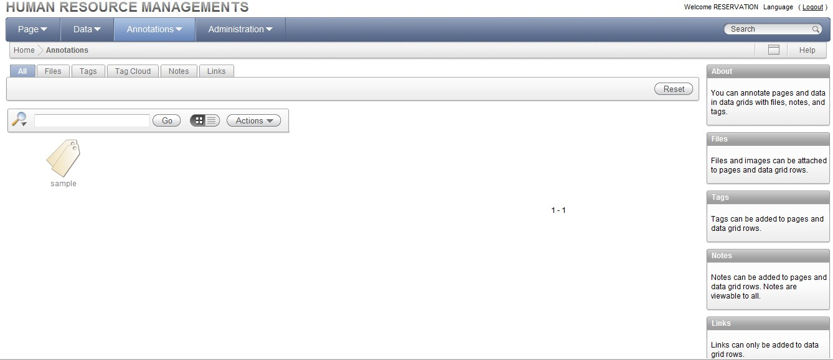
Step 17: Enter the note in the filed and add a note.
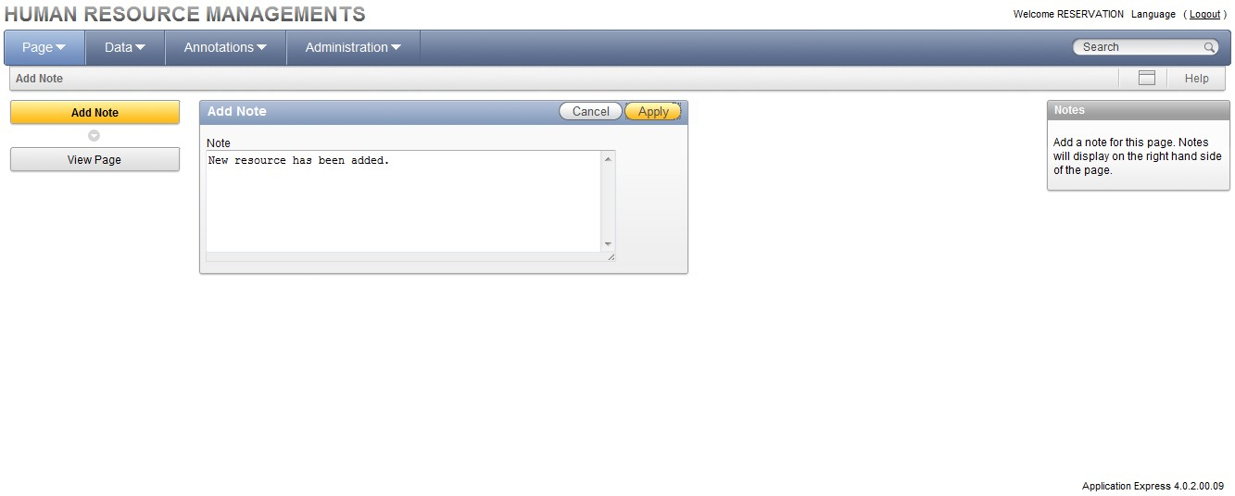
Step 18: New resource file will be added.
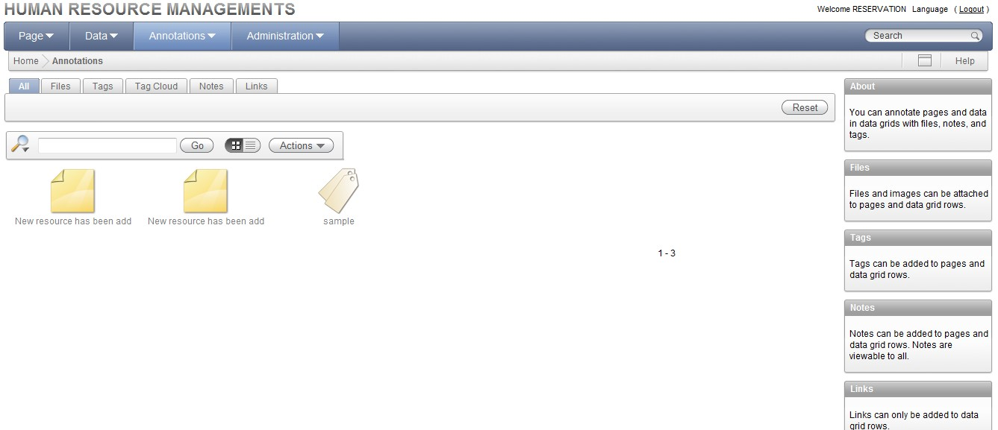
DISPLAYING AN IMAGE:
Step 19: Browse the image file.

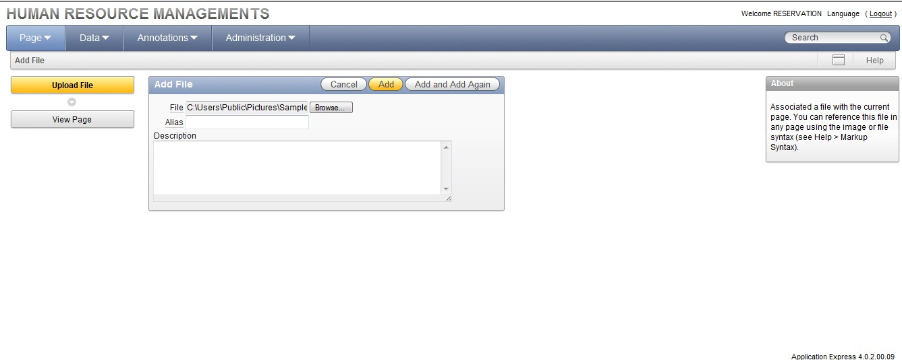
Step 20: File will be added.
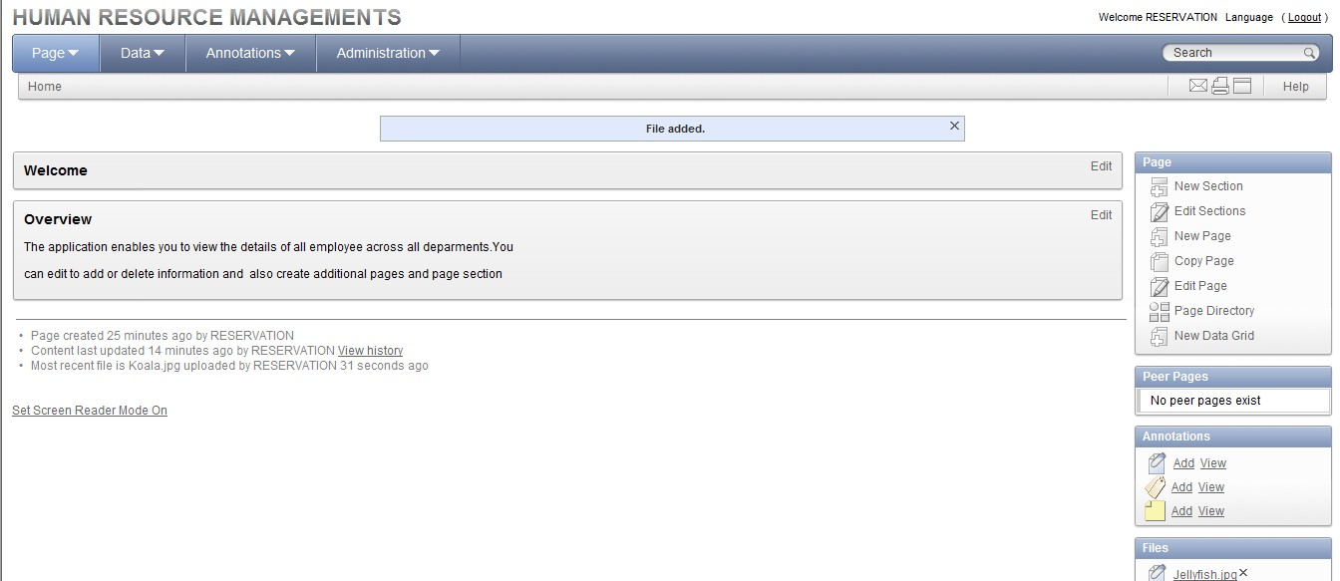



CREATING A DATA GRID:
Step 21: Create data grid from scratch.
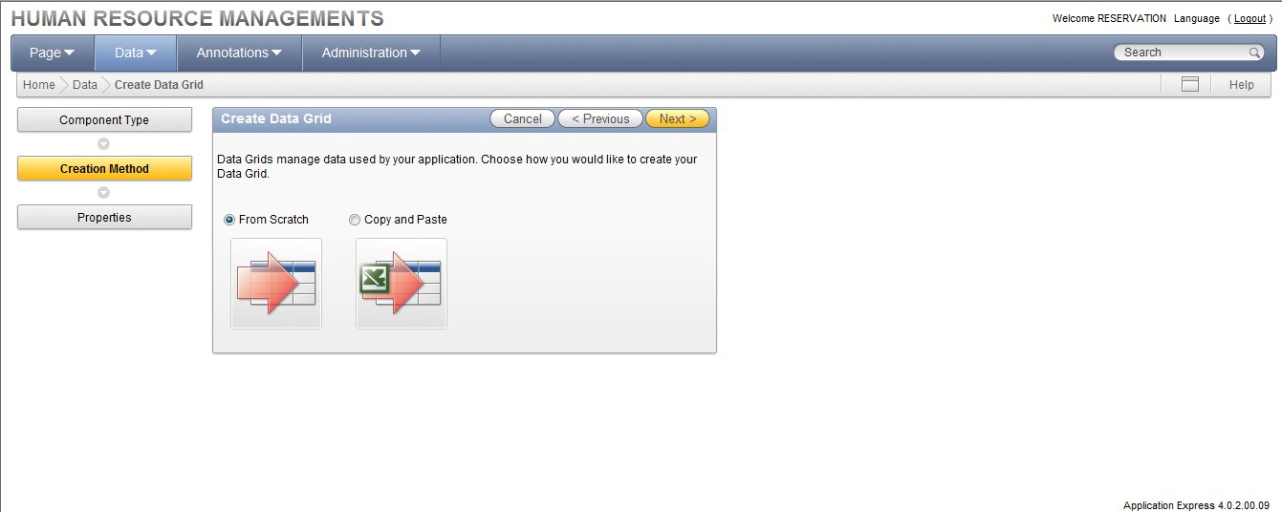

Step 22: Enter the table name to create data grid.
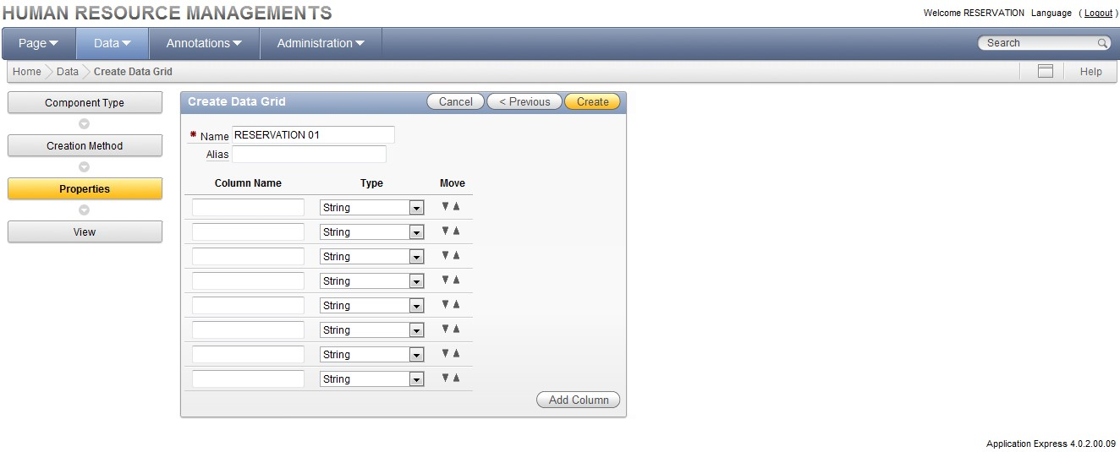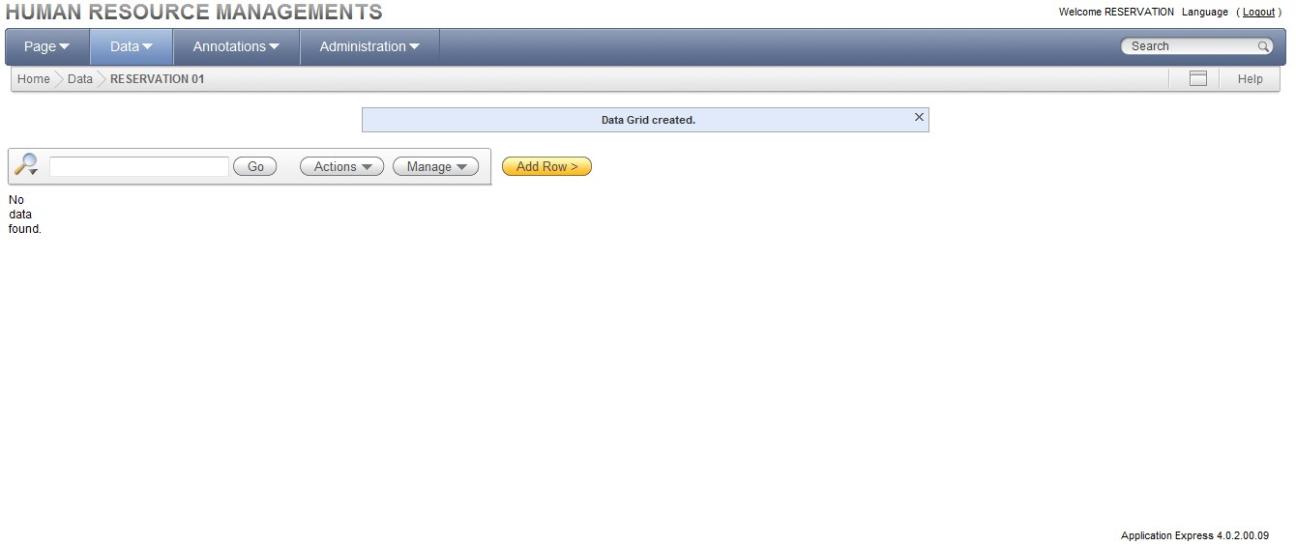

Step 23: Add rows to the table.
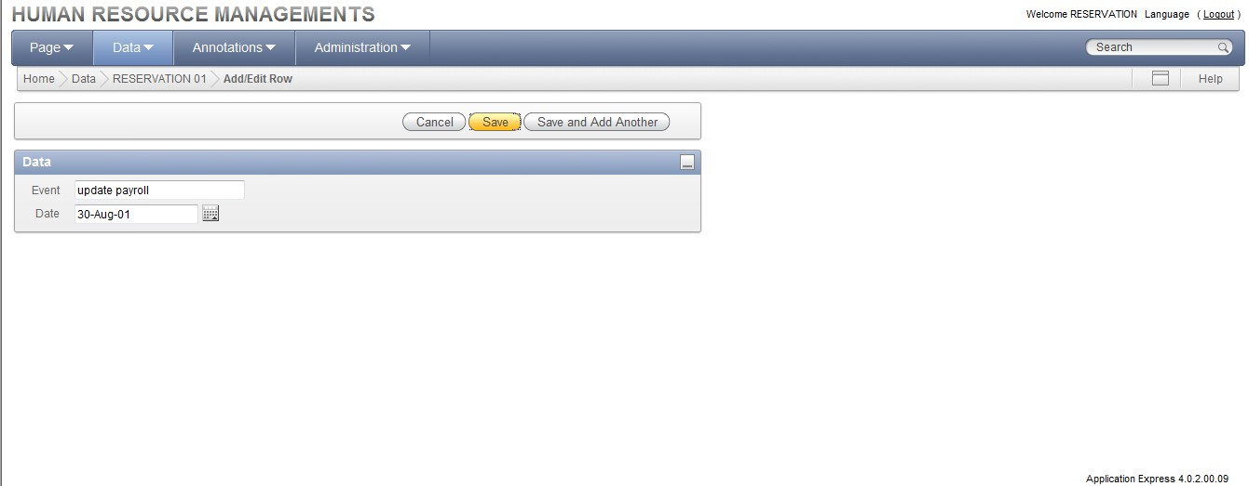
Step 24: Data will be added to the grid.
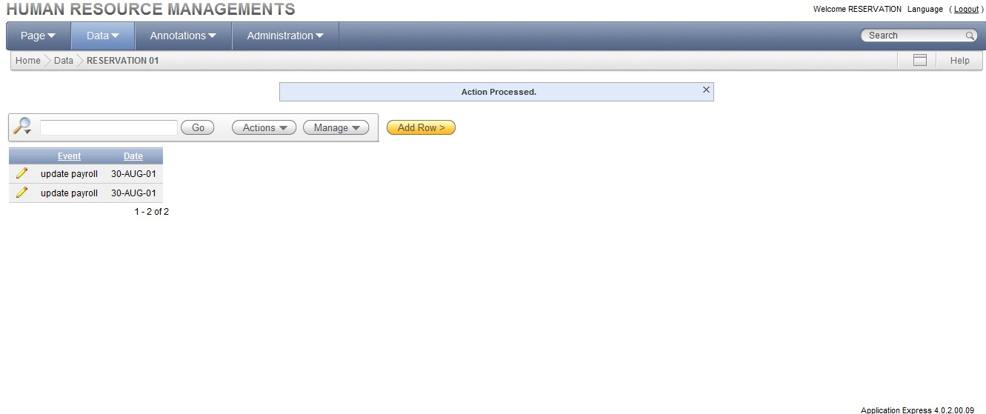

REG NO: 22TD0058 NAME: NASRIN J YEAR/SEM/SEC: Y3/S6/B

PL/SQL PROGRAMS USING ORACLE

CREATING A PROCEDURE:
Step 1: Log in to Database Home Page
Step 2: On the home page, click the sql icon to display the sql page.

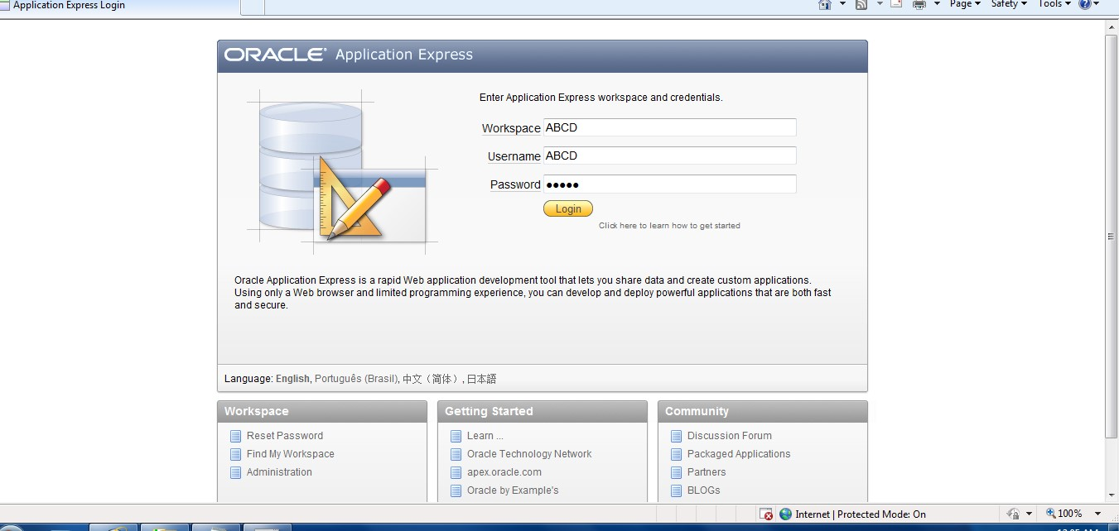

Step 3: Click the SQL Commands icon to display the SQL Command page.
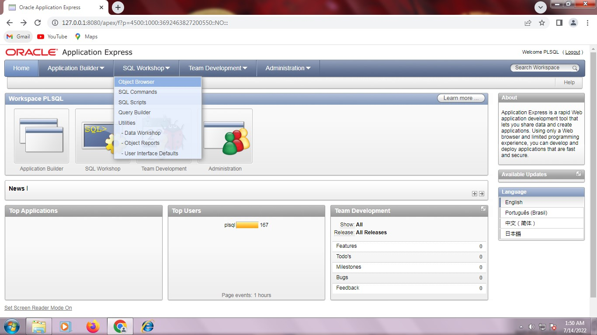

Step 4: On the SQL commands page enter the PL/SQL code for the PL/SQL procedure or function.
Step 5: Select (highlight) the code for creating the procedure or function, then click the Run button create the procedure or function.

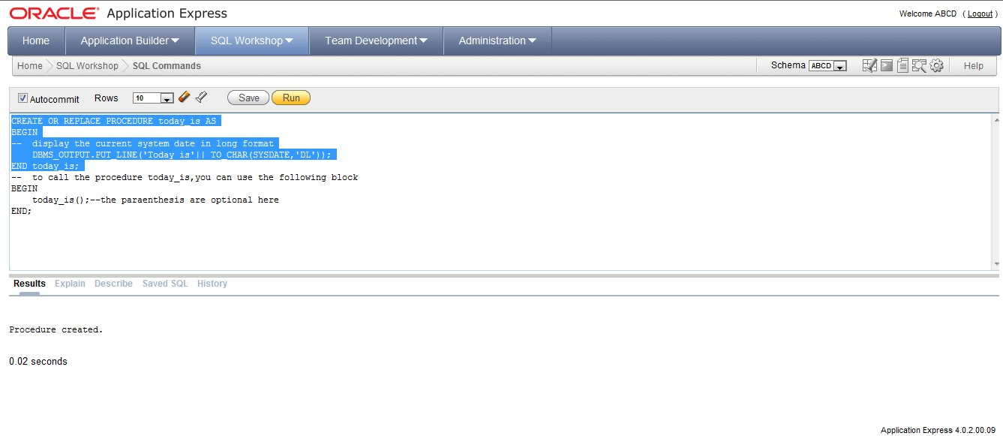
Step 6: Select (highlight) the code for calling the procedure or function, then click the Run button to call the procedure or function.
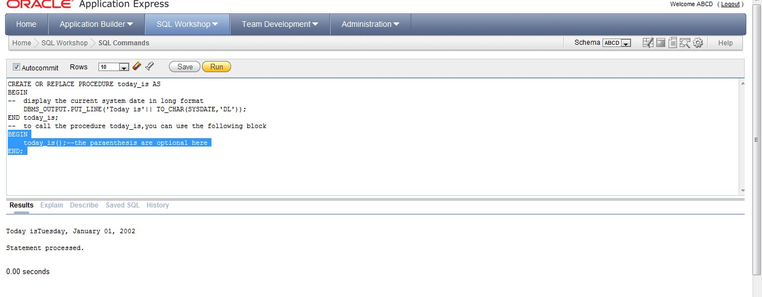
Step 7: If you want to save the PL/SQL code for future use, click the save button.
Step 8: In the Name field, enter a name for the saved PL/SQL code. You can also enter an optional description. Click the Save button to save the code.
Step 9: To access saved PL/SQL code, click the Saved SQL tab and select the name of the saved PL/SQL code that you want to access.
SEQUENCE:
Creating a Sequence:
Step1: On the Workspace home page, click SQL Workshop and then Object Browser. Object Browser appears.
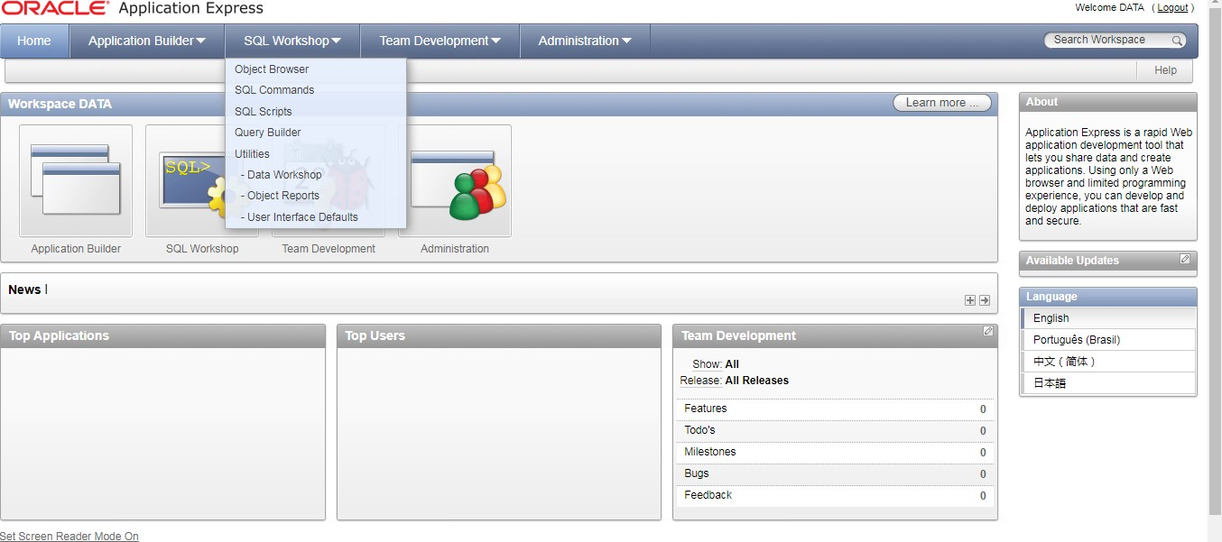
Step 2: Click the Create icon.
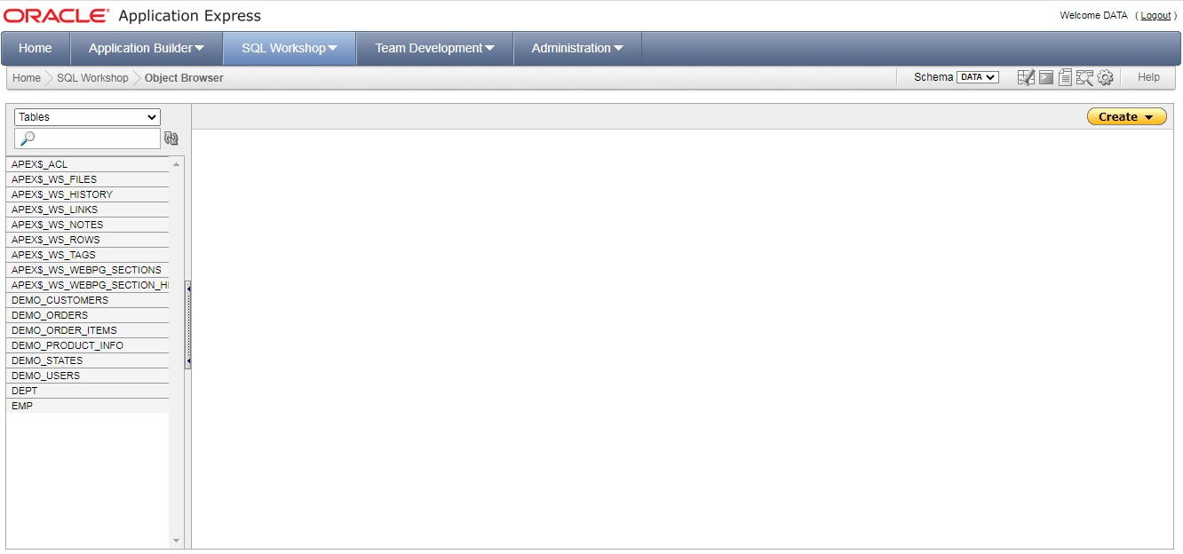

Step 3: From the list of object types, select Sequence.
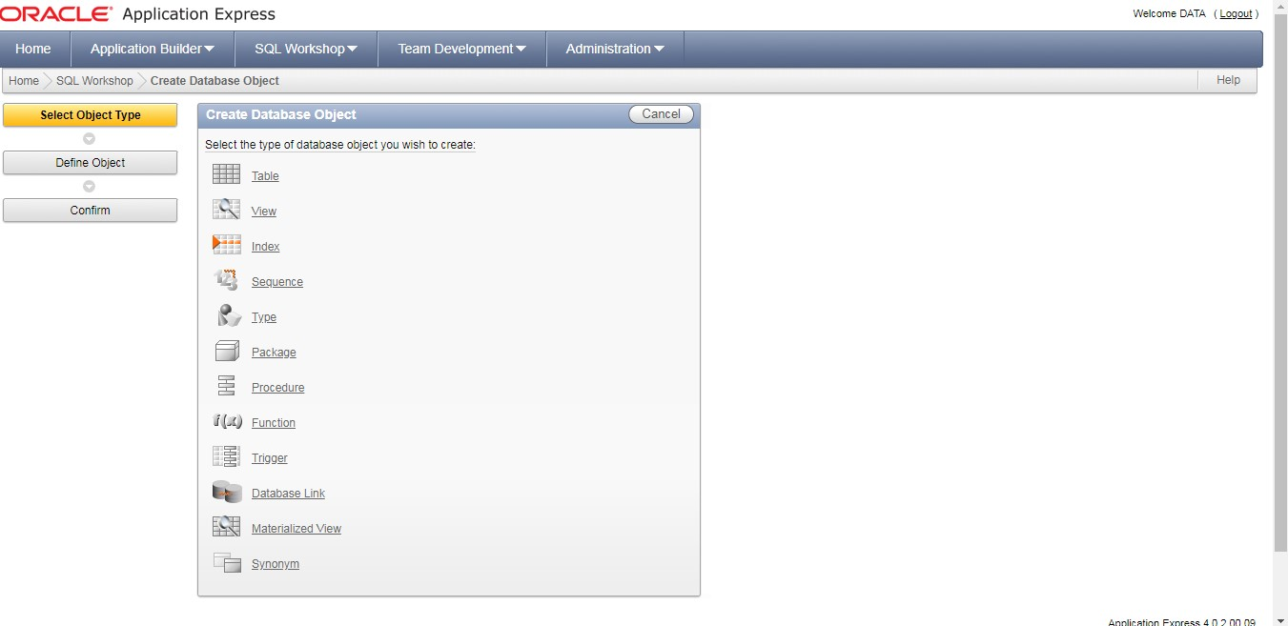
Step 4: For Define:
- Sequence Name – Enter the name of the sequence.
- Preserve Case – To have the final sequence name match the case entered in the Sequence Name field, click Preserve Case.
- Start With – Enter the number of the first sequence, The first reference to sequence_name.nextval returns this number.
- Minimum value – Enter the minimum value this sequence can return.
- Maximum Value – Enter the maximum value this sequence can return.
- Increment By – Each call to sequence_name.nextval returns a value greater than the last, until the maximum value is reached. Enter the value used to increment to the next sequence number.
- Cycle – Select this option to restart the sequence number to the minimum value when the maximum value is reached. Note that this is not recommended if using the sequence for primary key creation.
- Number to Cache – For faster access, specify how many sequence values are stored in memory.
- Order – Specify ORDER to guarantee that sequence numbers are generated in order of request. This option is necessary if using Real Application Clusters (Oracle RAC).
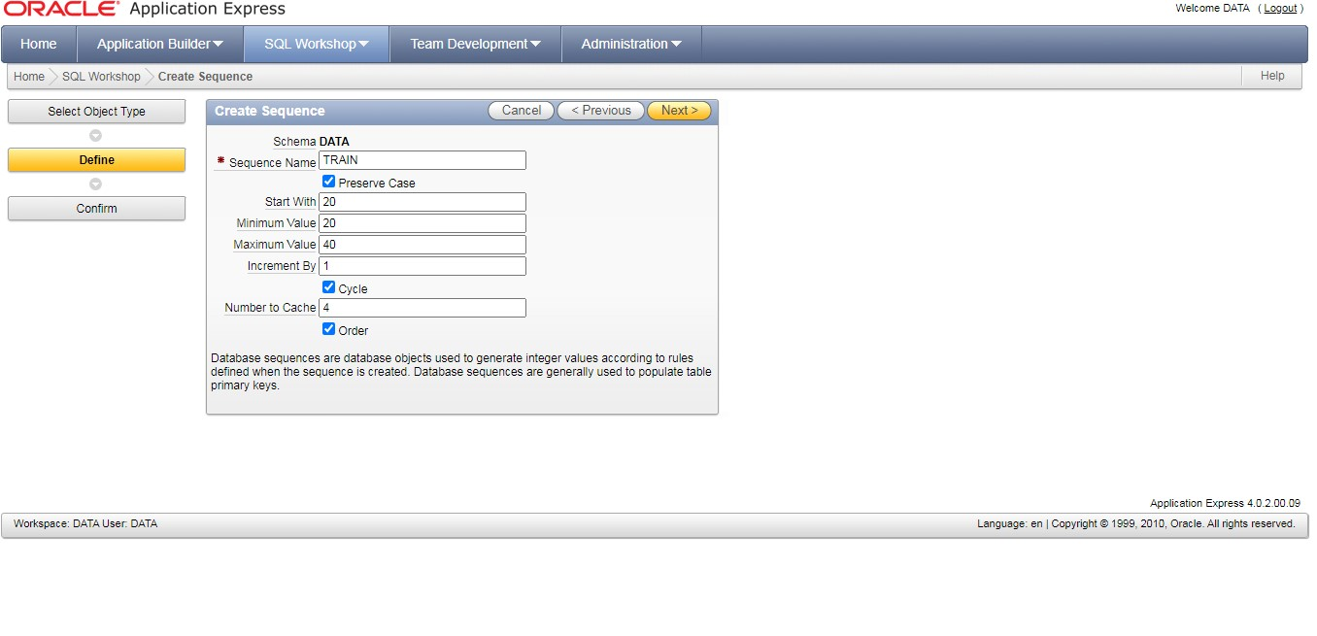
Step 5: Click Next.


Step 6: Click create sequence.
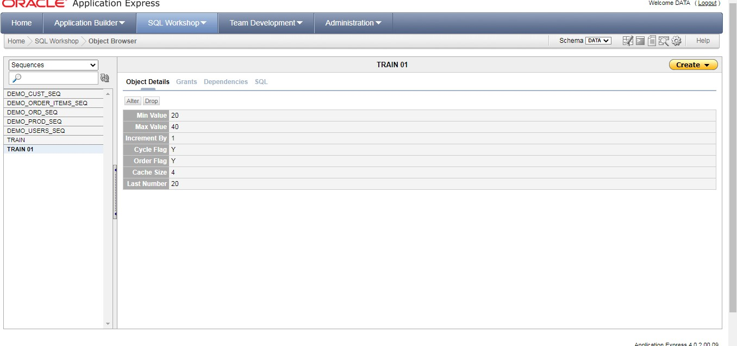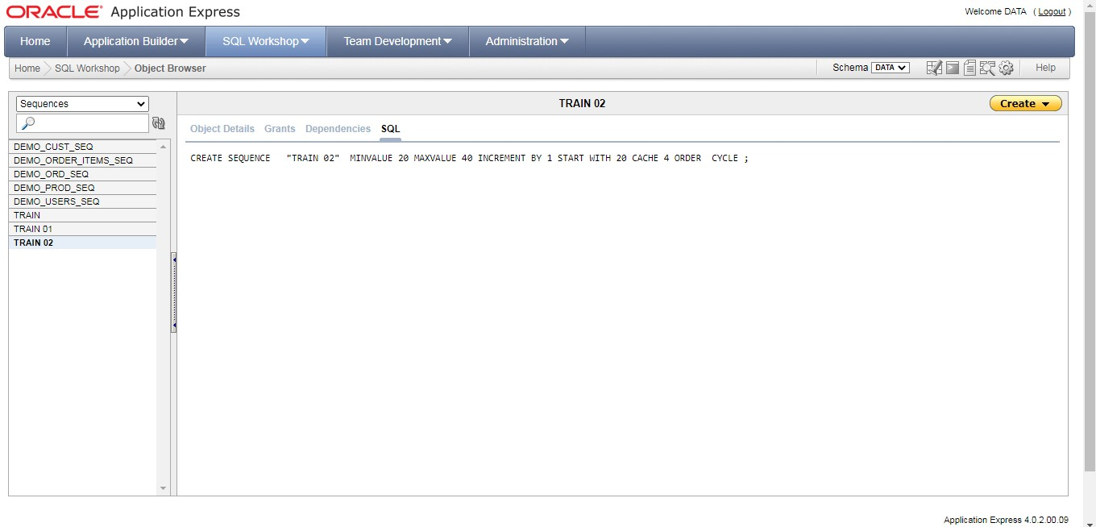
Altering a Sequence:
Step 7: From the Object Selection pane, select a sequence. The Object Details view appears.
Step 8: Click Alter.
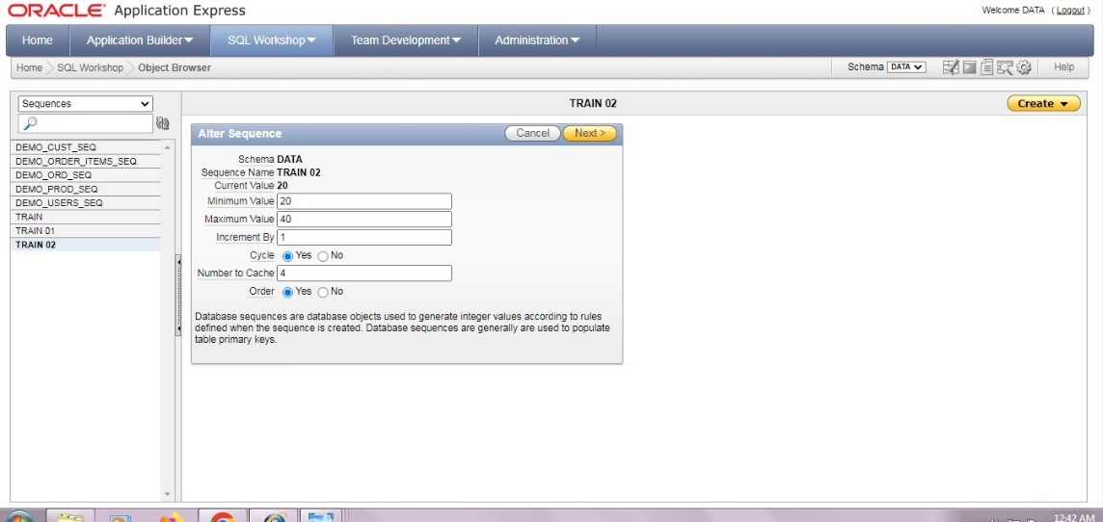
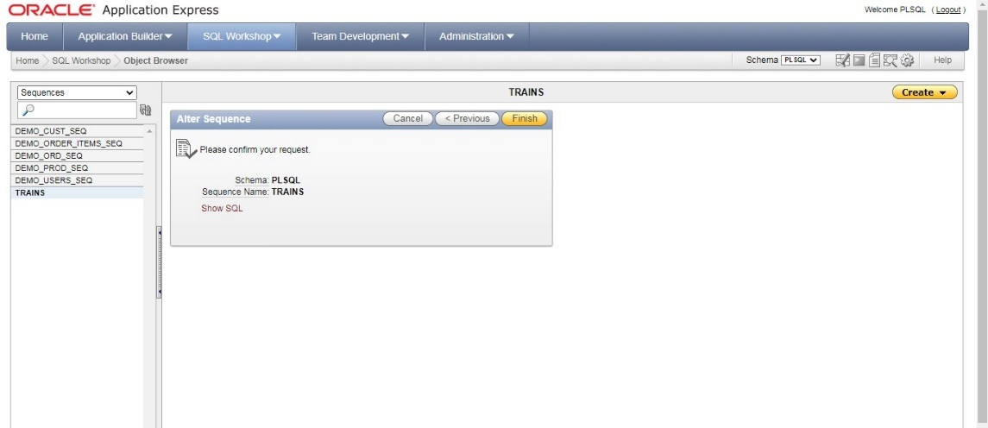
Step 9: Click finish button.
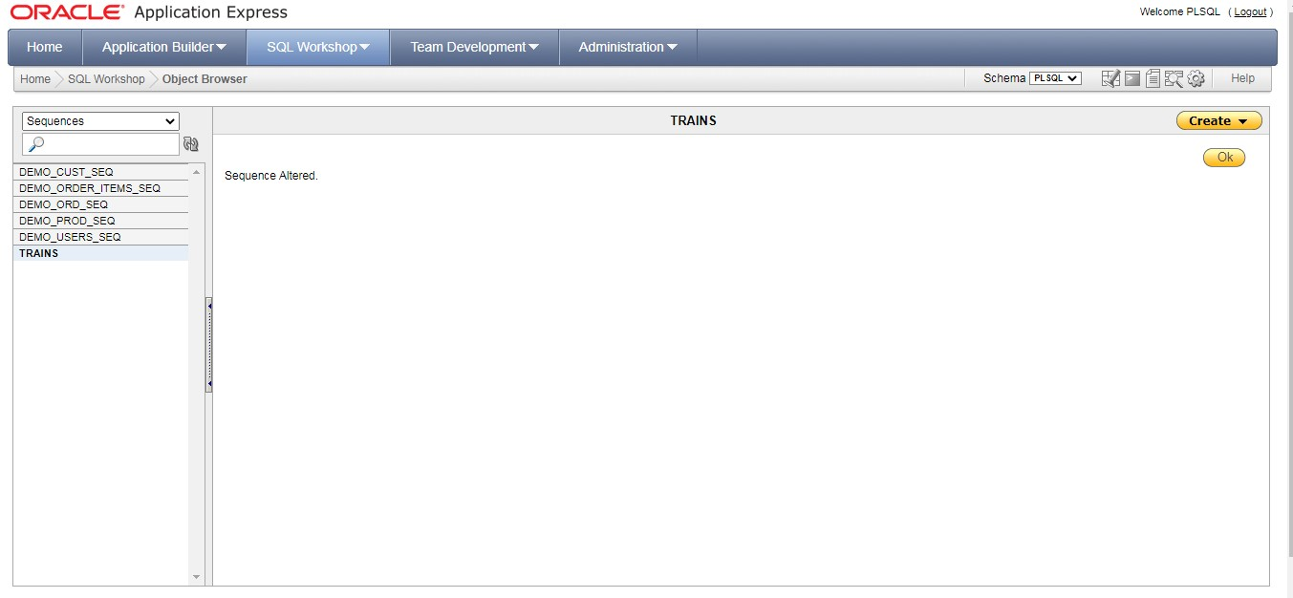
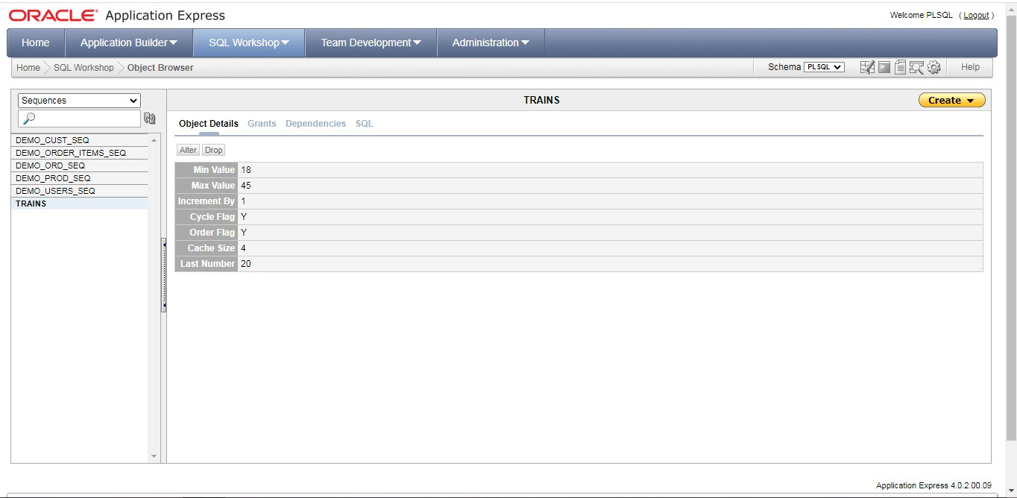

Grant:
Step 10: Grant, privilege and grant options. We can perform Grant and Revoke in this view.

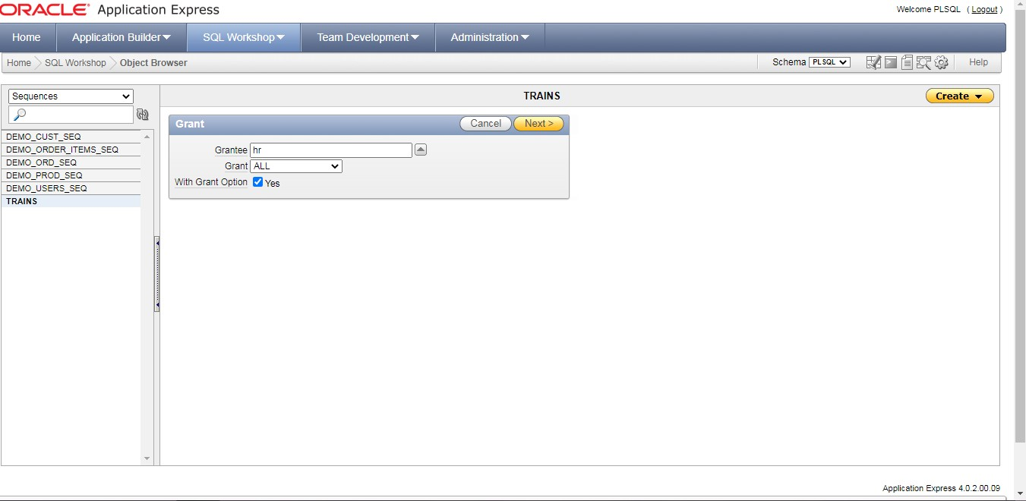

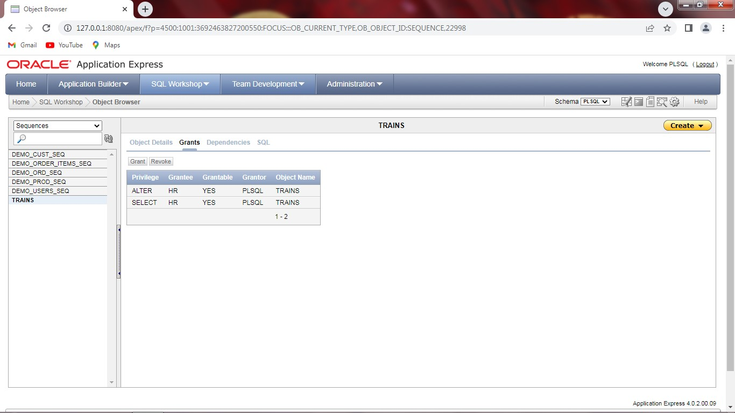
Revoke grant:
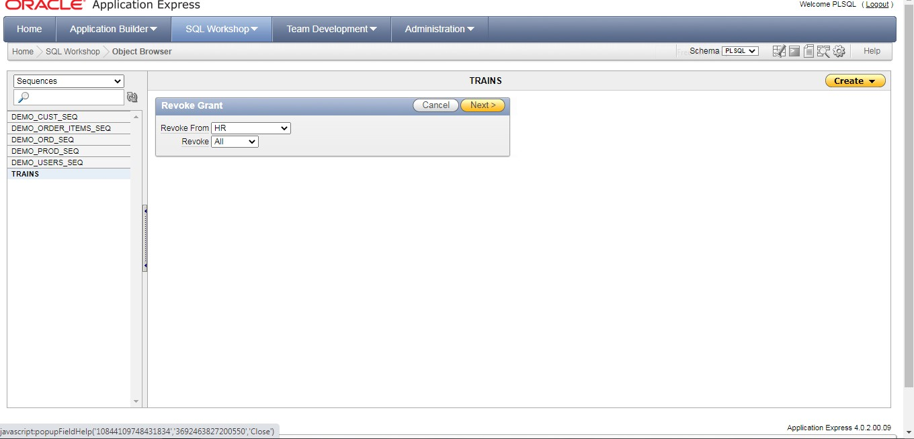
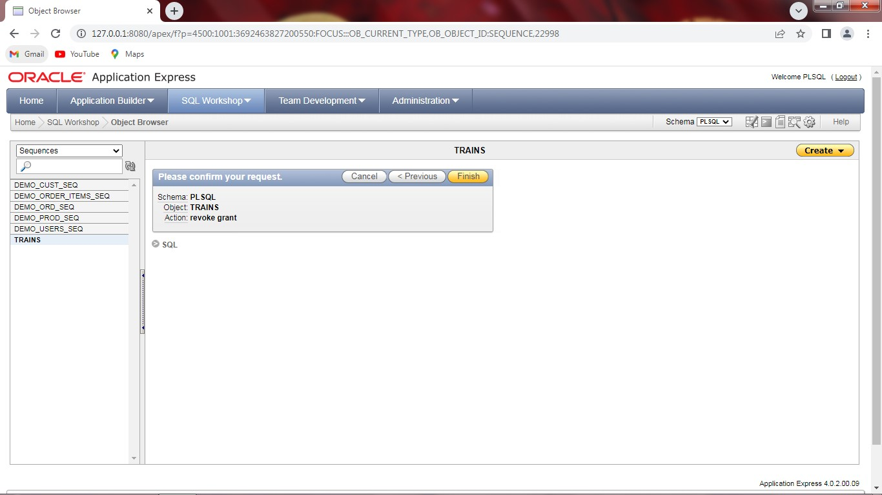

Drop sequence:
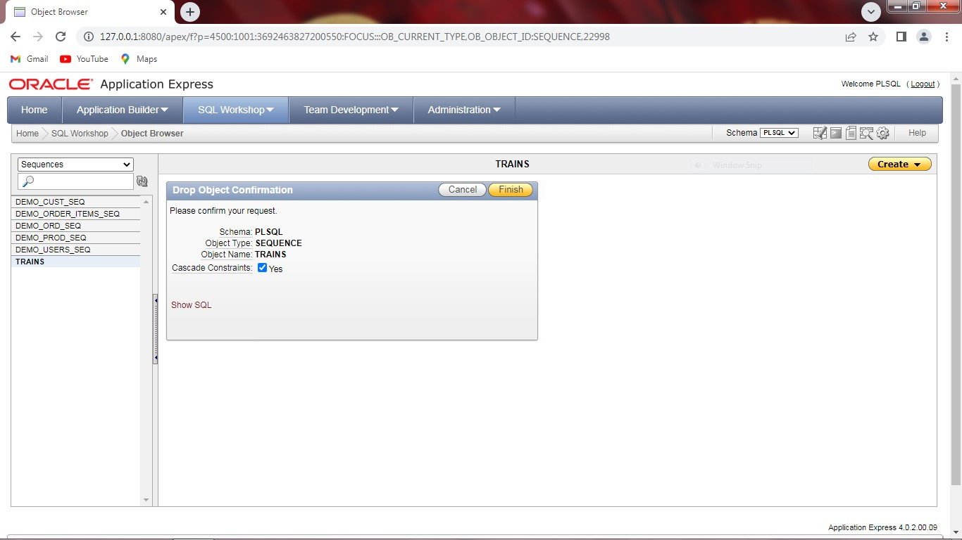

TRIGGER:
Step 1:Go to Database homepage. UnderSql workshop click object browser.

Step 2: Click create and select trigger.

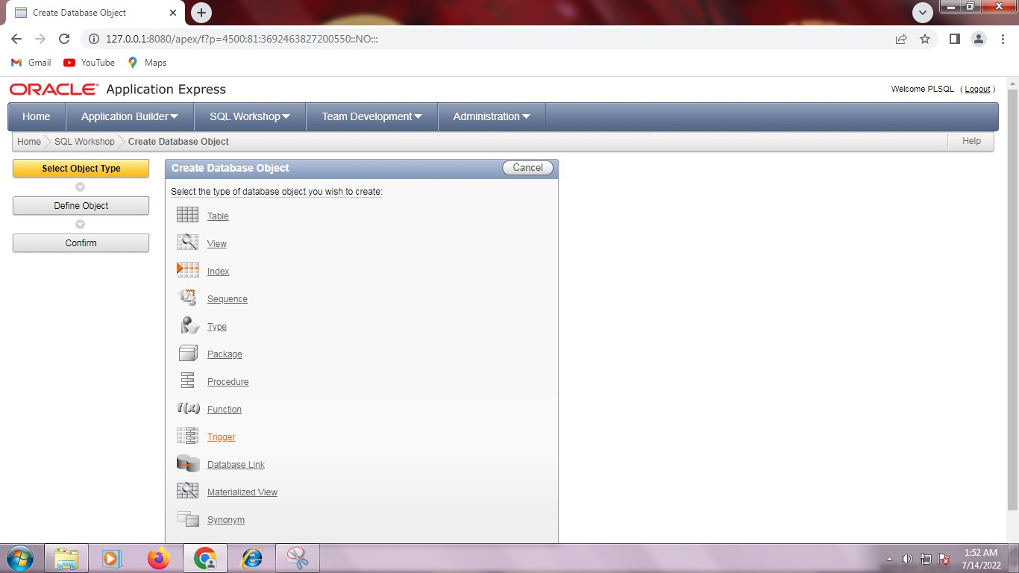

Step 3: Create trigger and enter the trigger body.
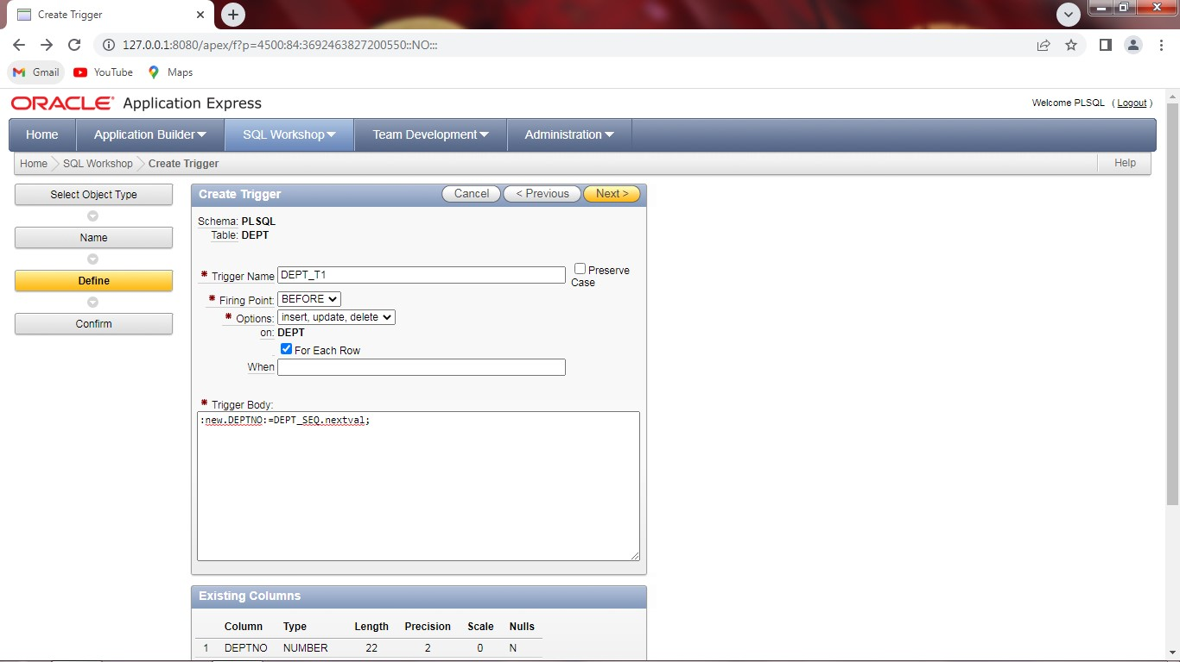
Step 4: Click finish button.

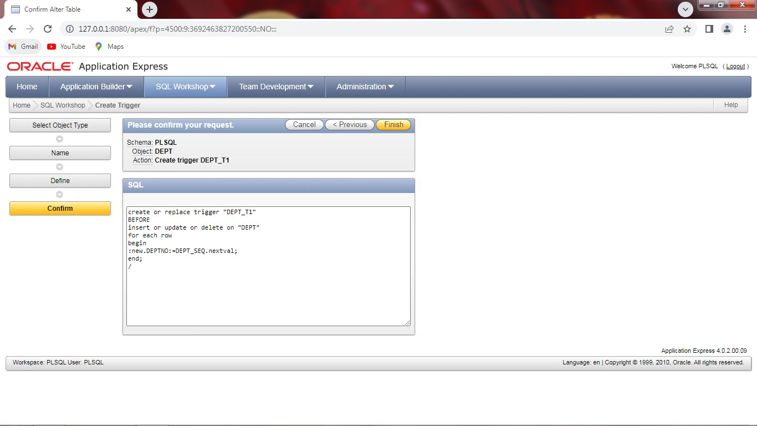

Step 5: Trigger is created.
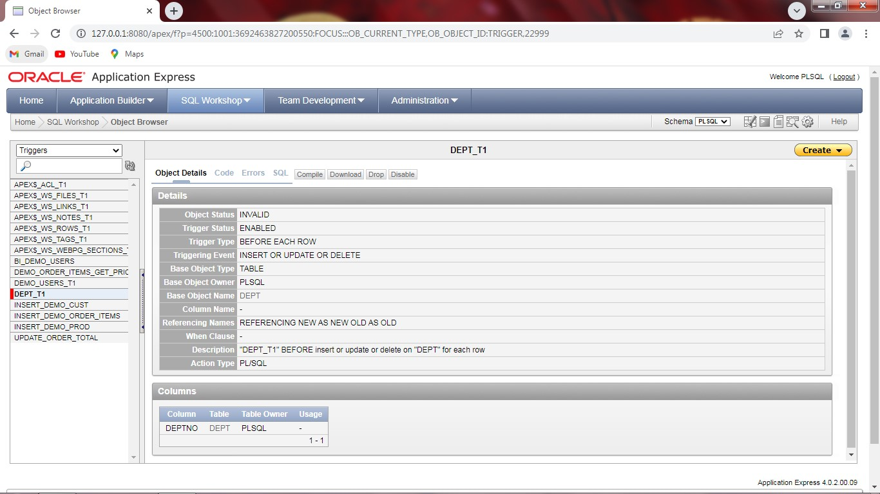
Step 6: Go to Database application.
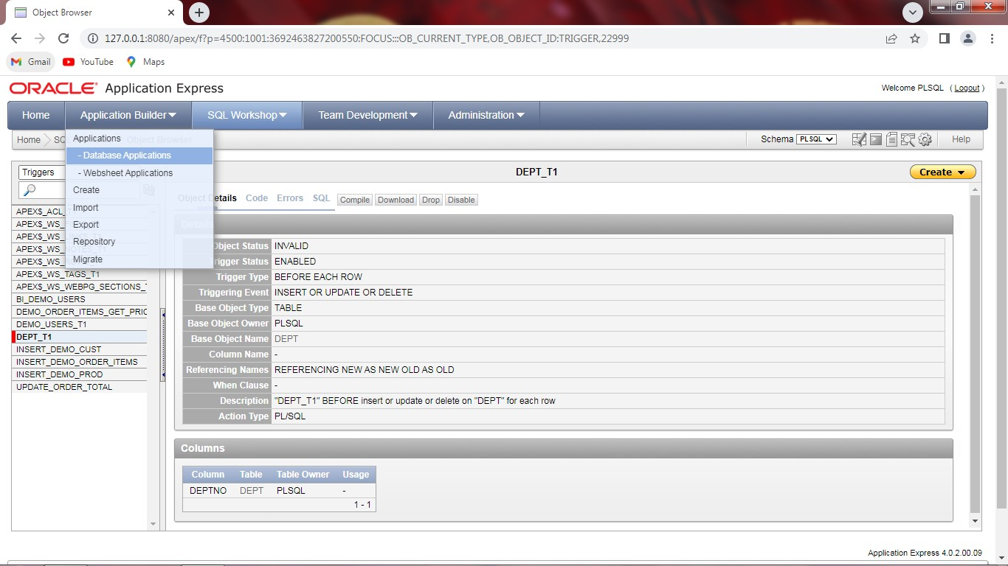

Step 7: Create Database application.
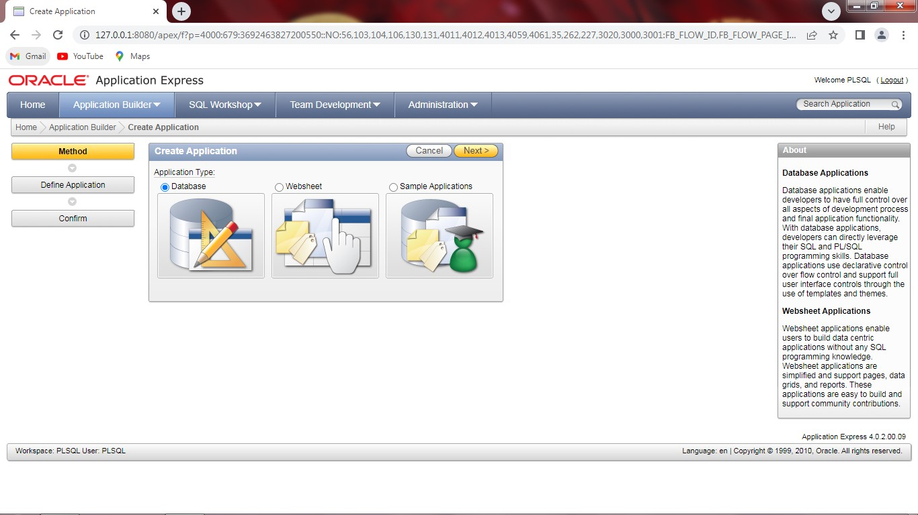
Step 8: Select from scratch and click next.
Step 9: Enter an application name.
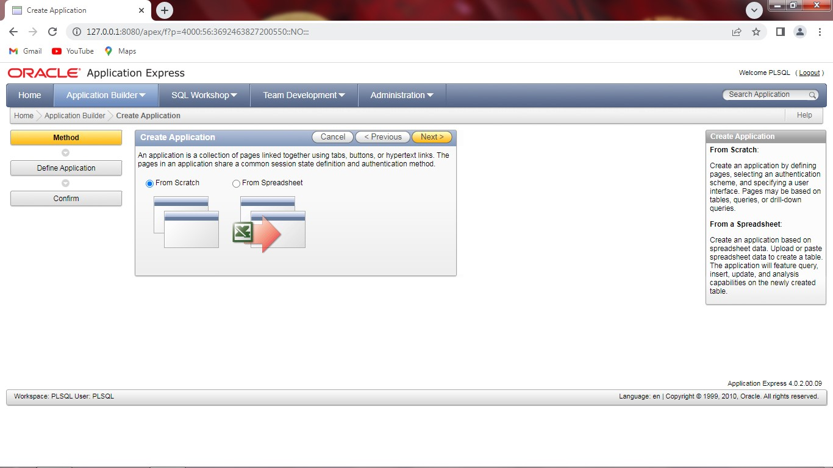
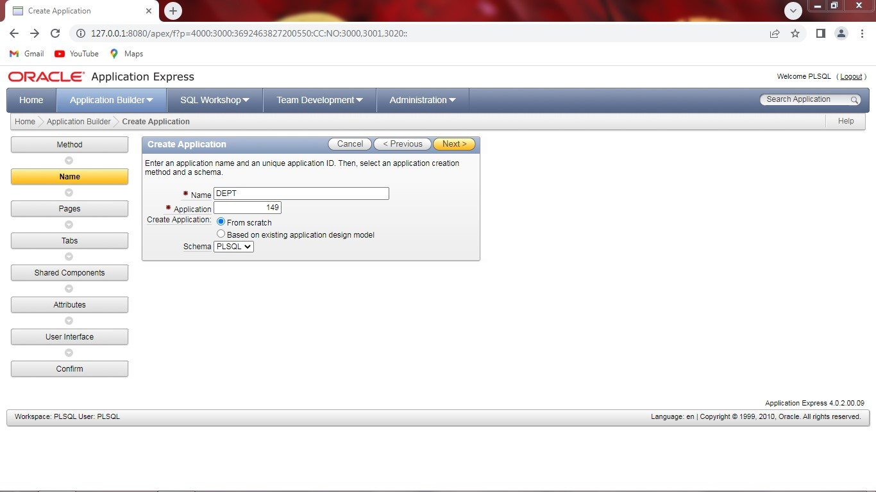
Step 10: Create a tabular form.
Step 11: Create application and run application.
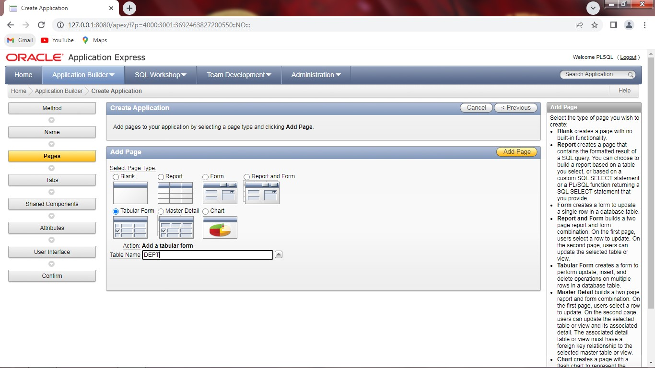
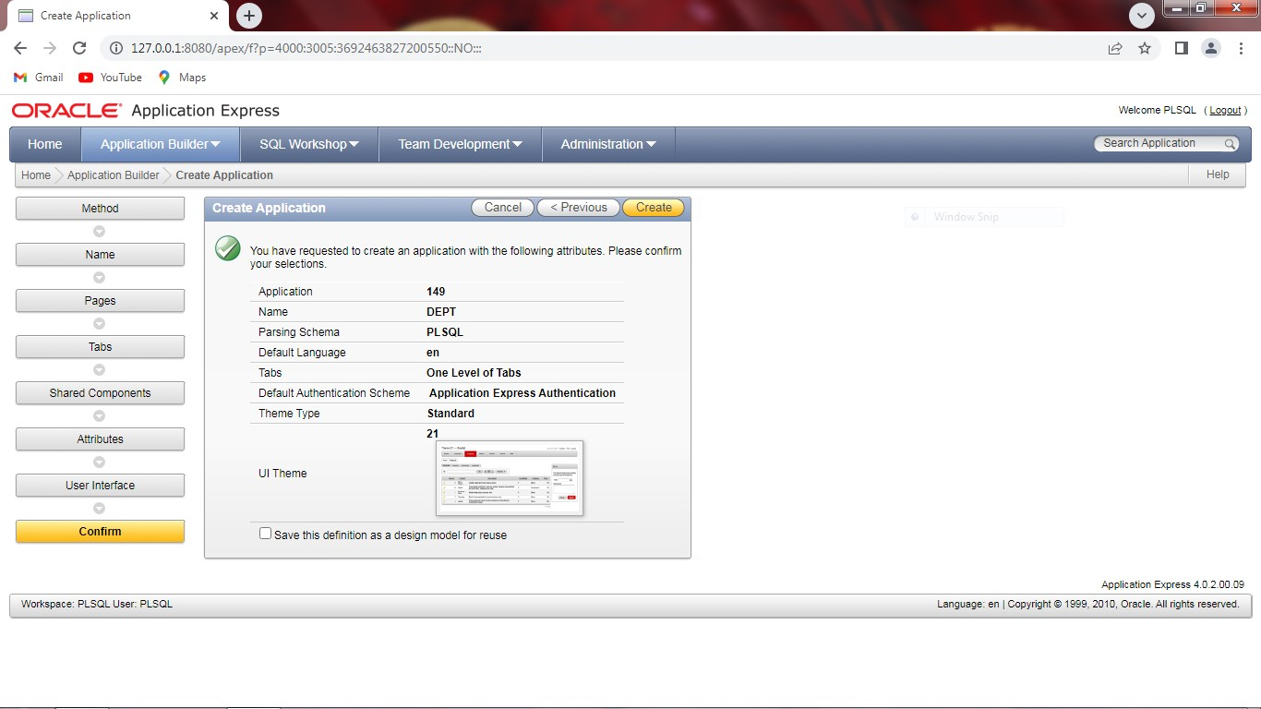

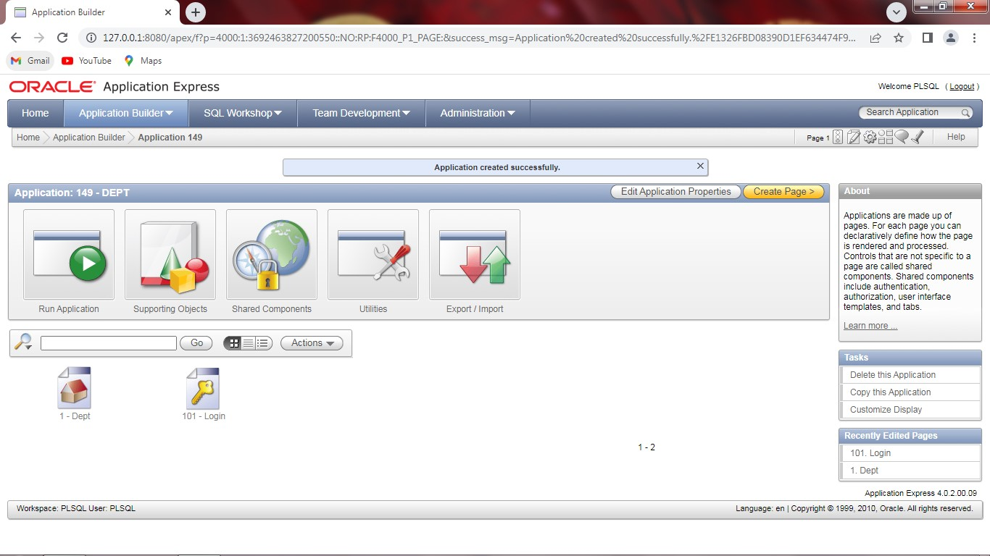

Step 12: Login with username and password.

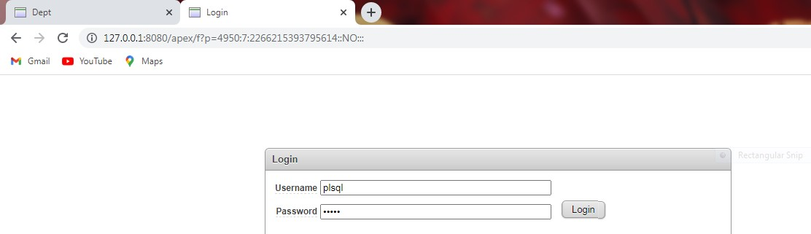
Step 13: Table will be displayed.
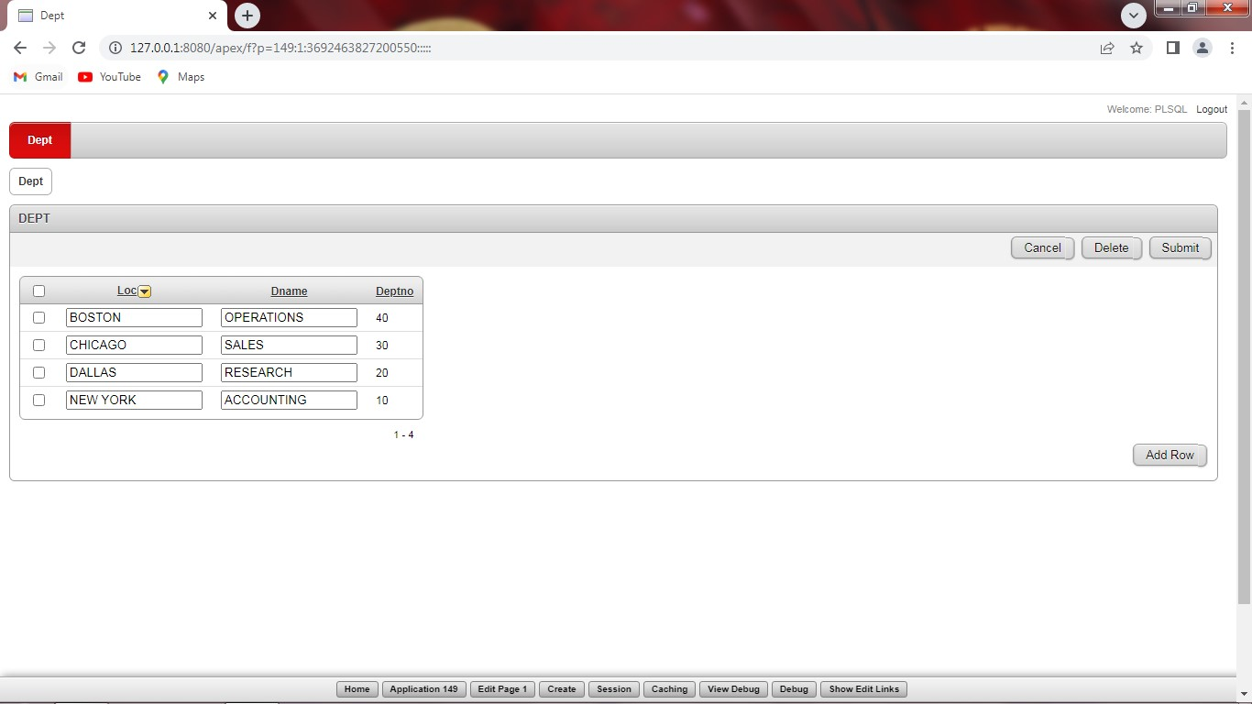

REG NO: 22TD0058 NAME: NASRIN J YEAR/SEM/SEC: Y3/S6/B

SURVEY USING ODOO

INTRODUCTION TO ODOO:
- Odoo is all-in-one management software that offers a range of business application that form a complete suite of enterprise management application targeting companies of all sizes.
- Odoo keeps on modifying due to its licence free features and thus latest source code is available whenever required.
STEPS IN SUREY MANAGEMENT:
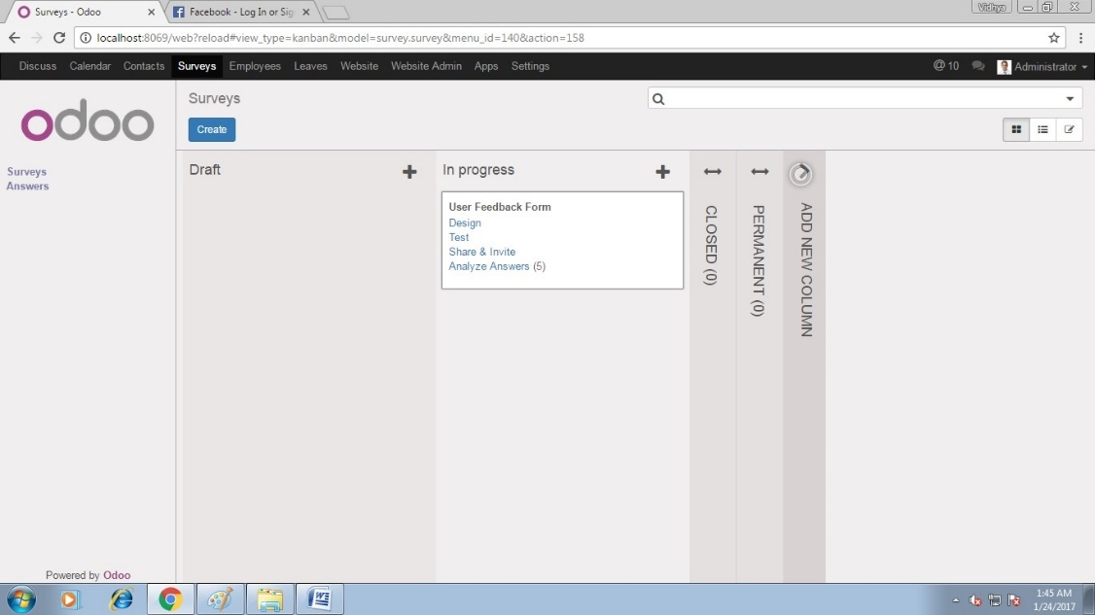
Step1: Visit localhost: 8069 in your web browser, then enter username (admin) and password (admin).

Step2: Click survey option and then click design survey. And give title of the survey.
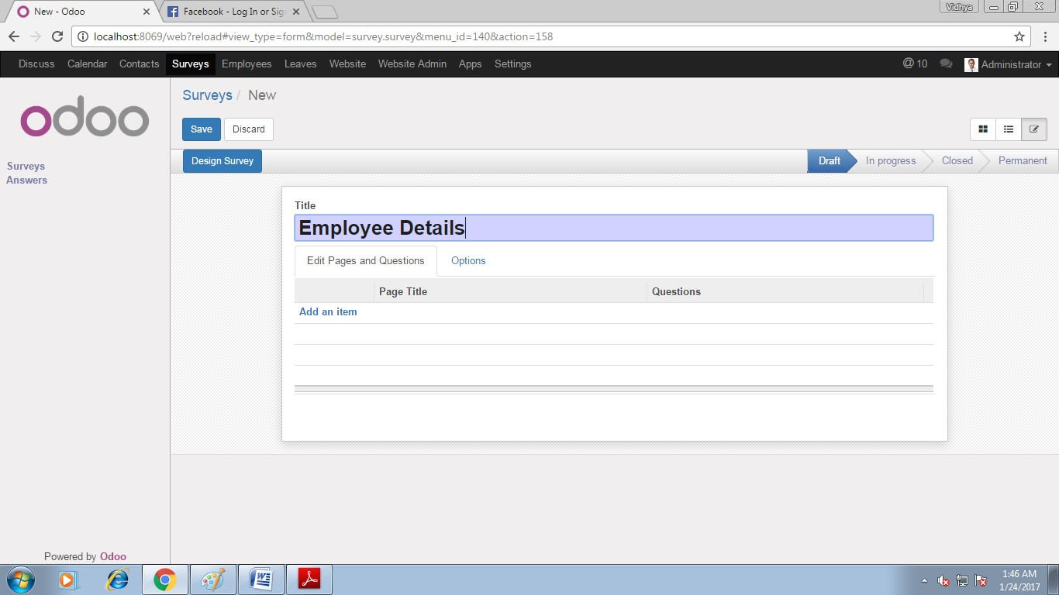
Step3: Give page title.
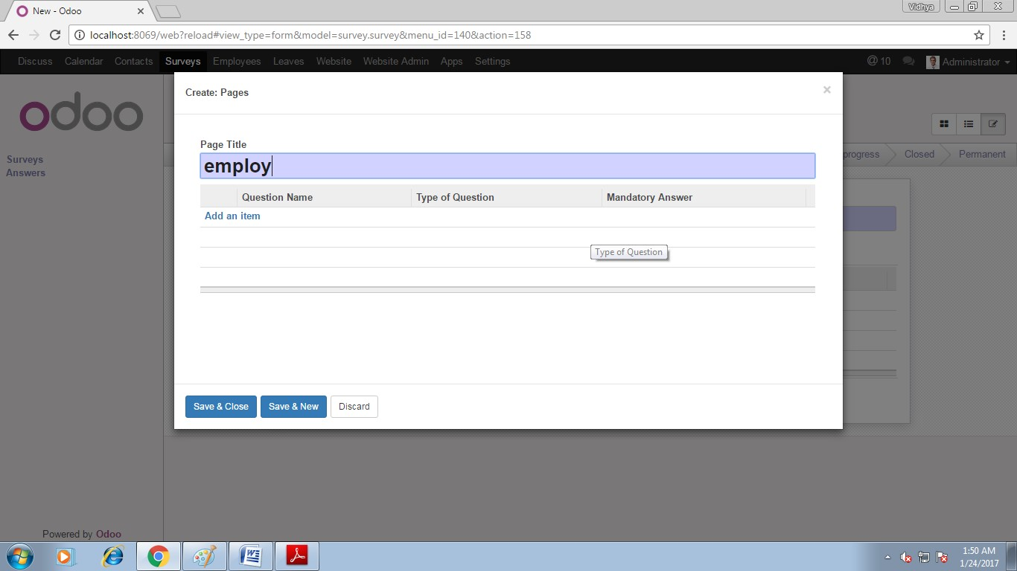

Step 4: Enter your questions and its types.
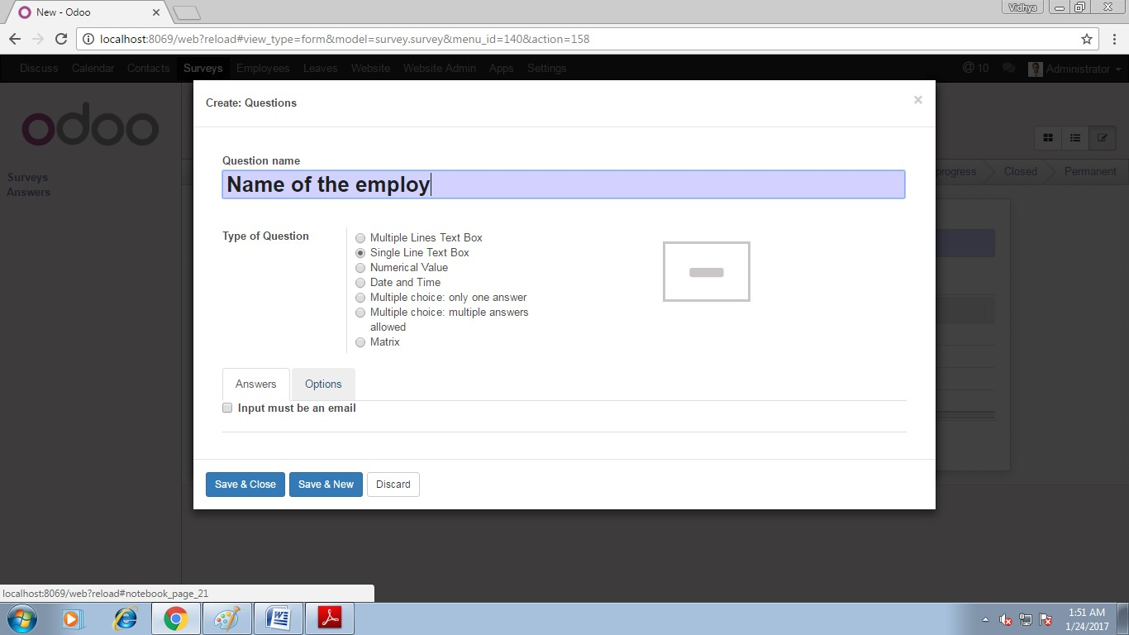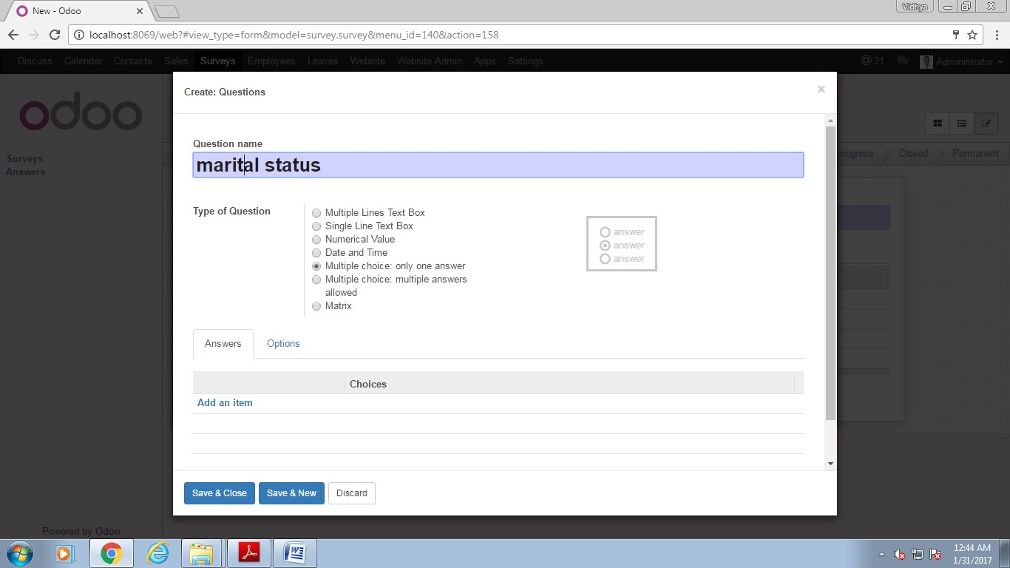
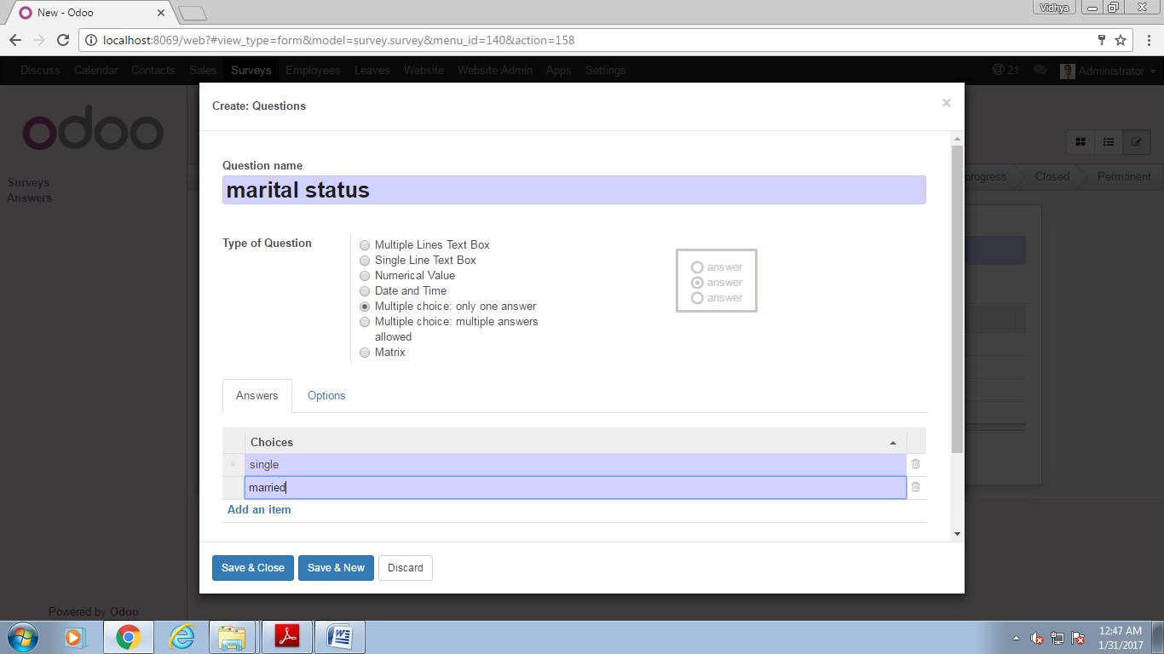

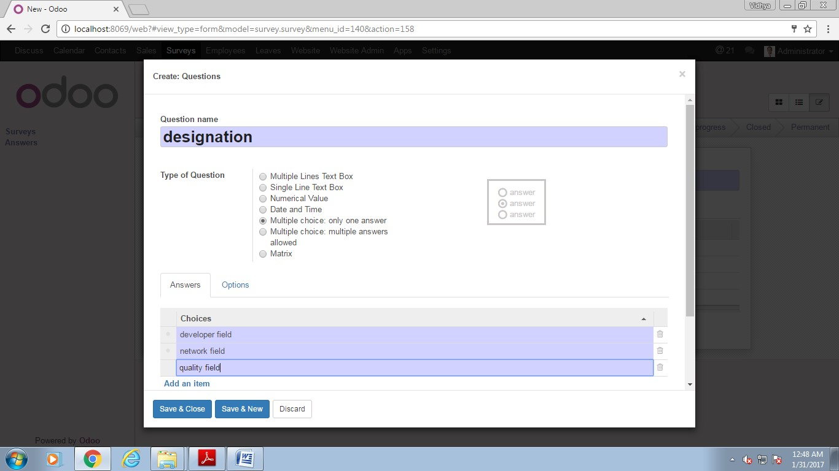
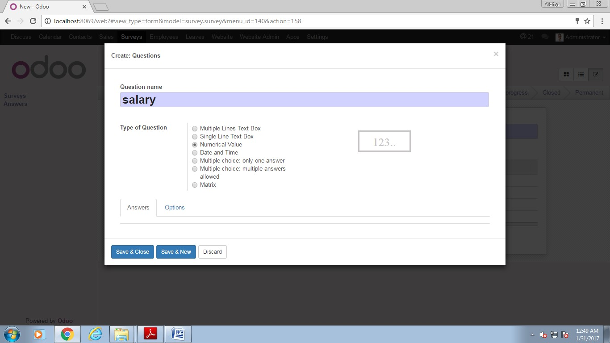

Step5: Review your questionnaires and its types.

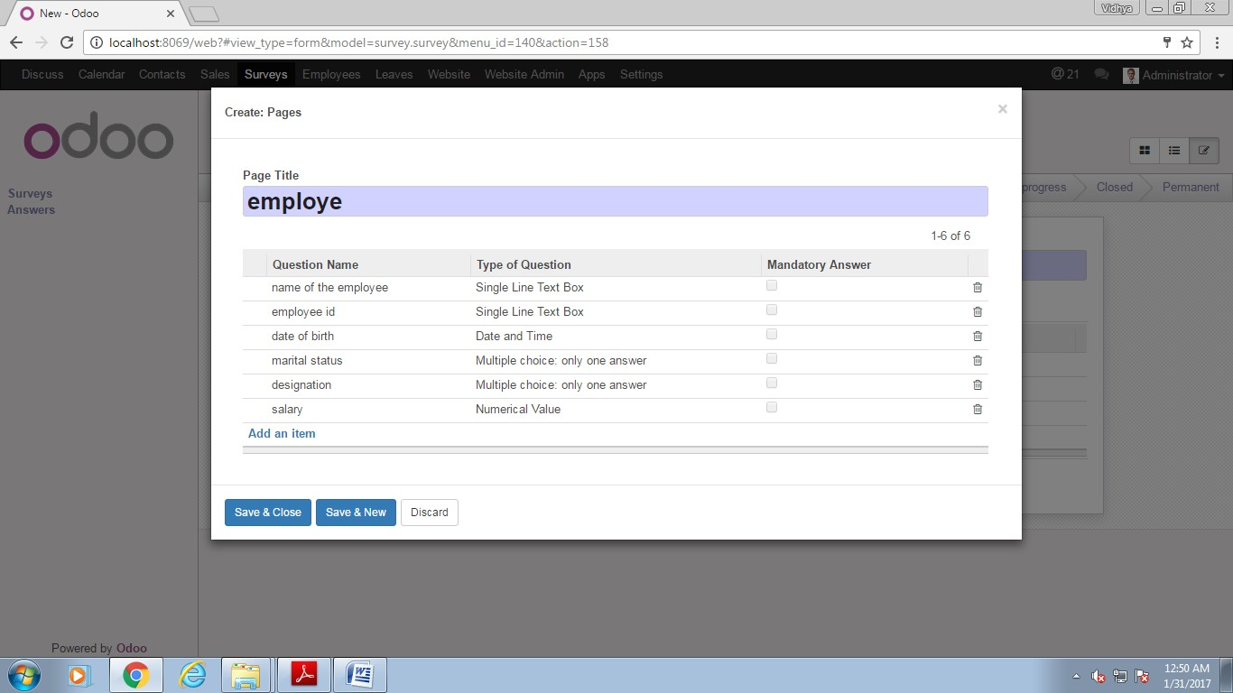
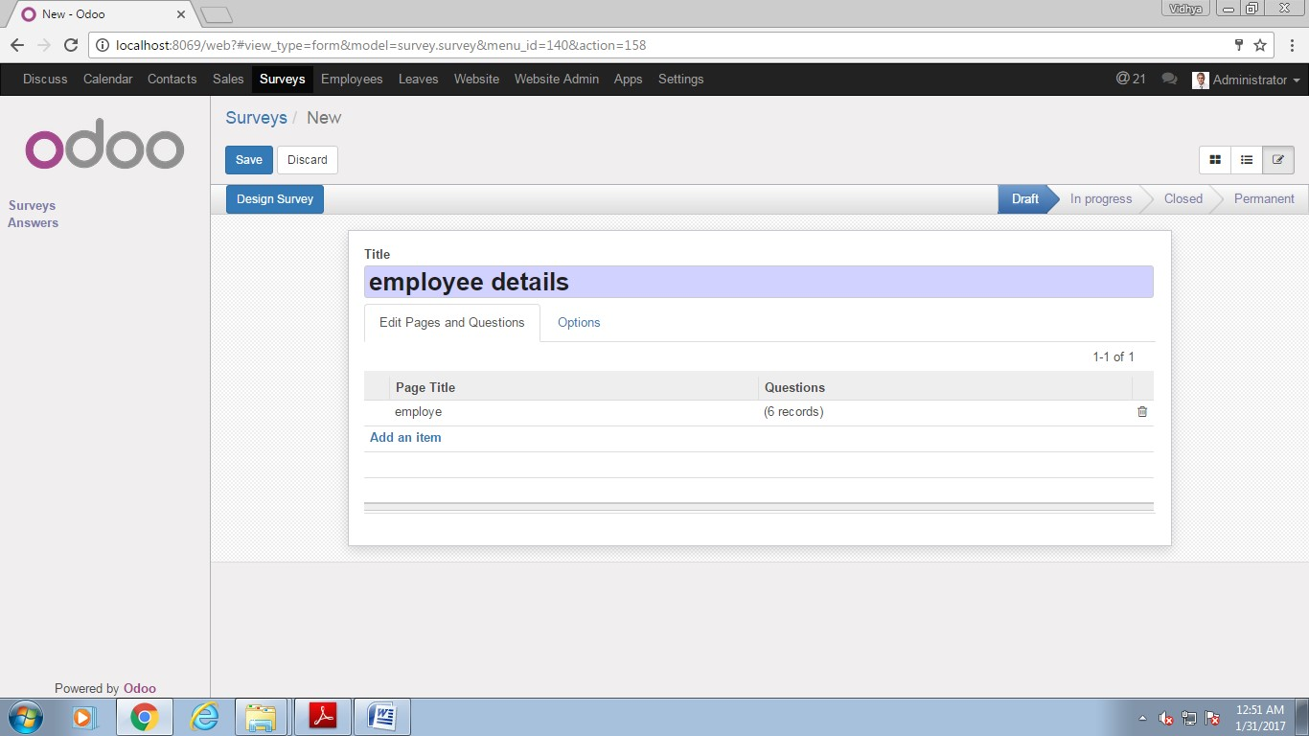

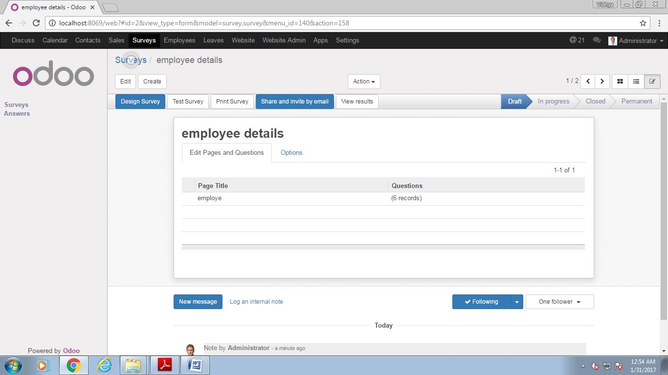

Step 6: Start survey.
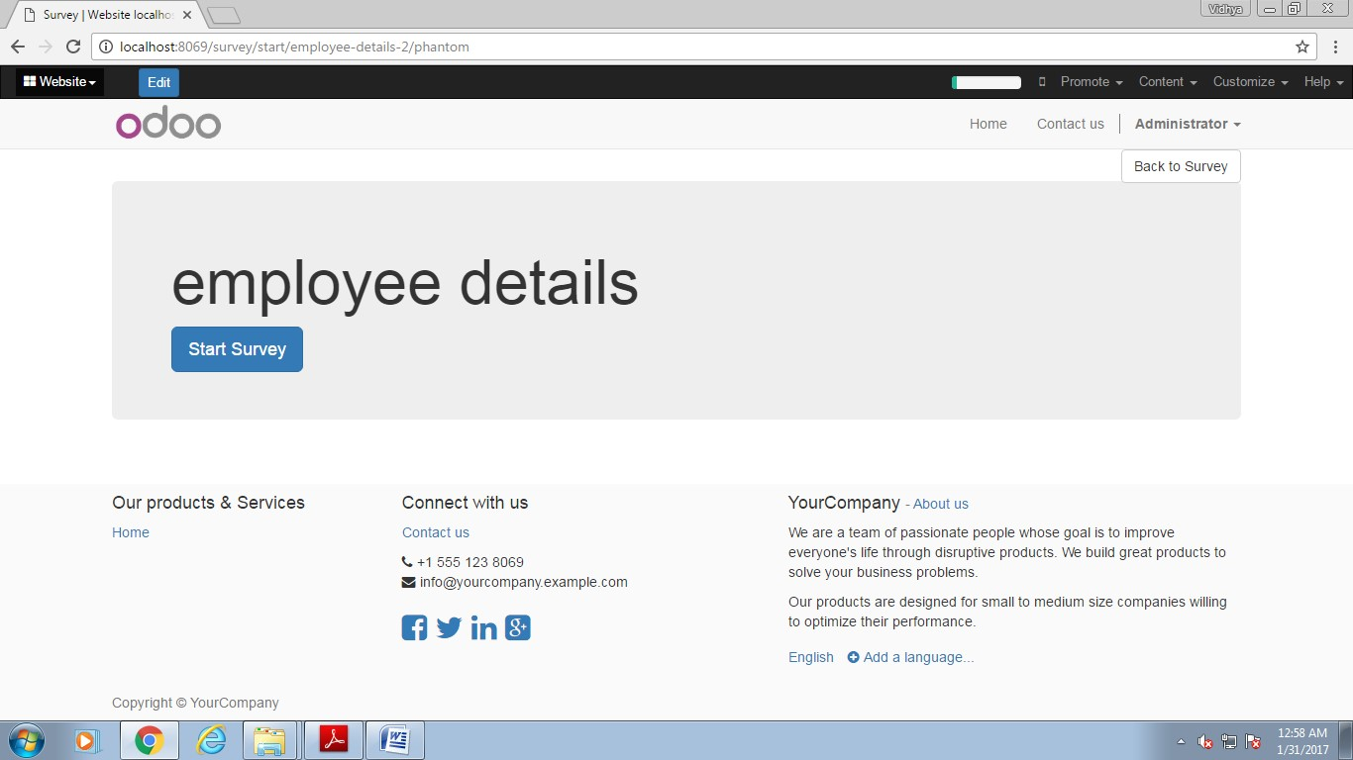

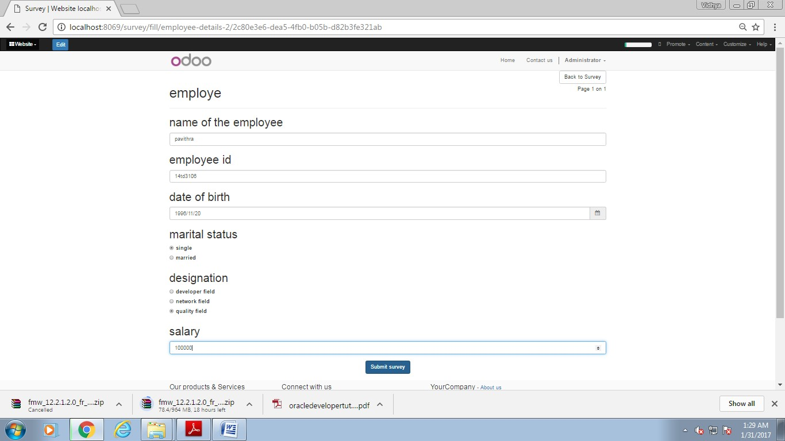
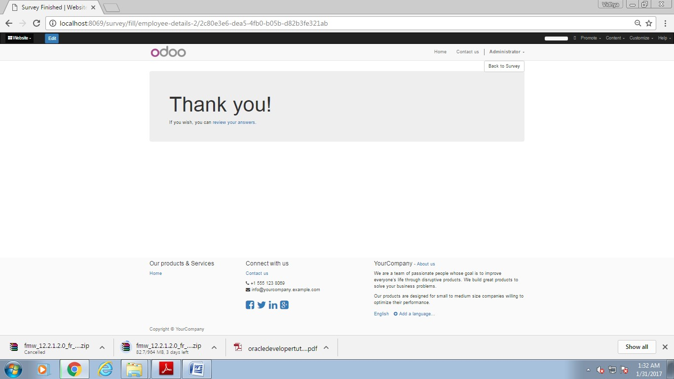
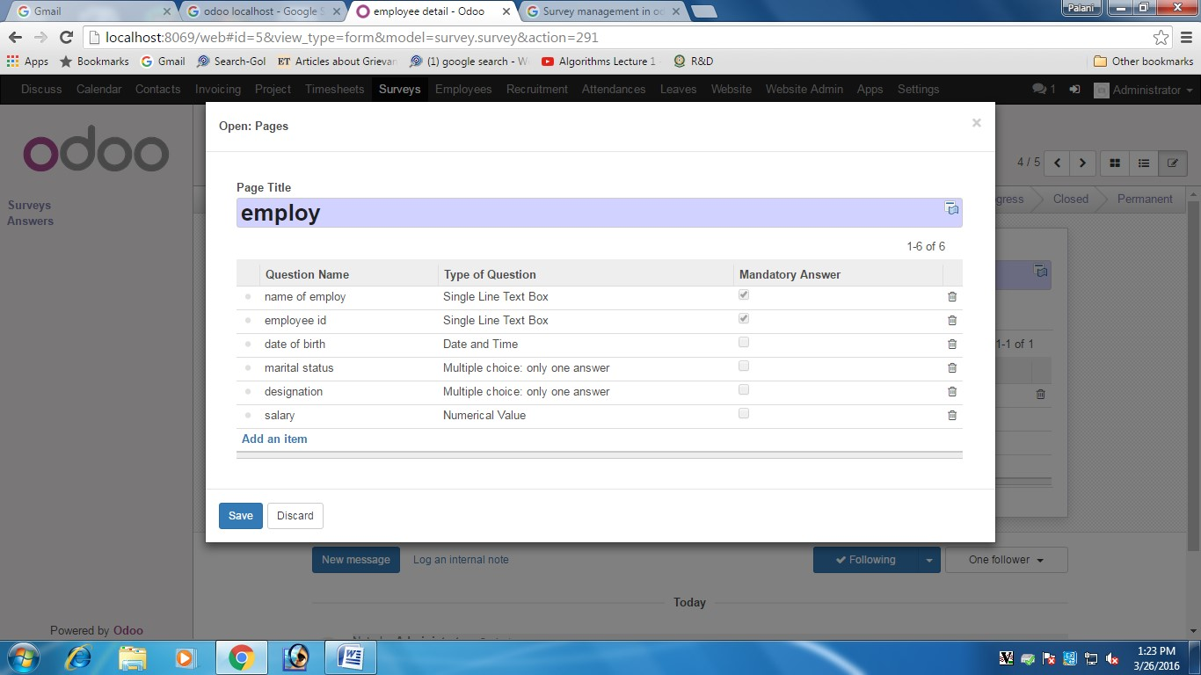

REG NO: 22TD0058 NAME: NASRIN J YEAR/SEM/SEC: Y3/S6/B

LEAVE MANAGEMENT USING ODOO

INTRODUCTION TO ODOO:
- Odoo is all-in-one management software that offers a range of business application that form a complete suite of enterprise management application targeting companies of all sizes.
- Odoo keeps on modifying due to its licence free features and thus latest source code is available whenever required.
STEPS IN LEAVE MANAGEMENT:
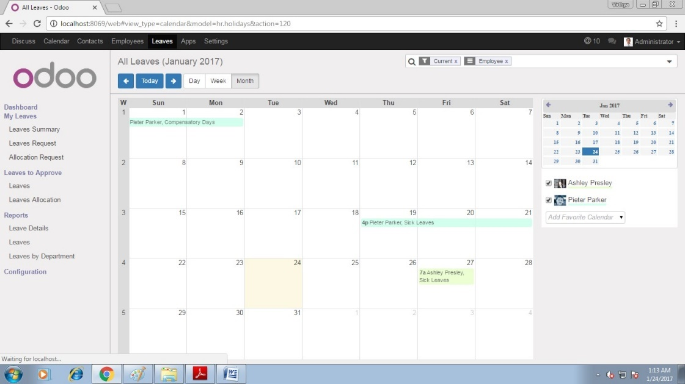
Step 1: Select leaves in the menu bar.
Step2: Give description and select leave type and fill all the requirements.
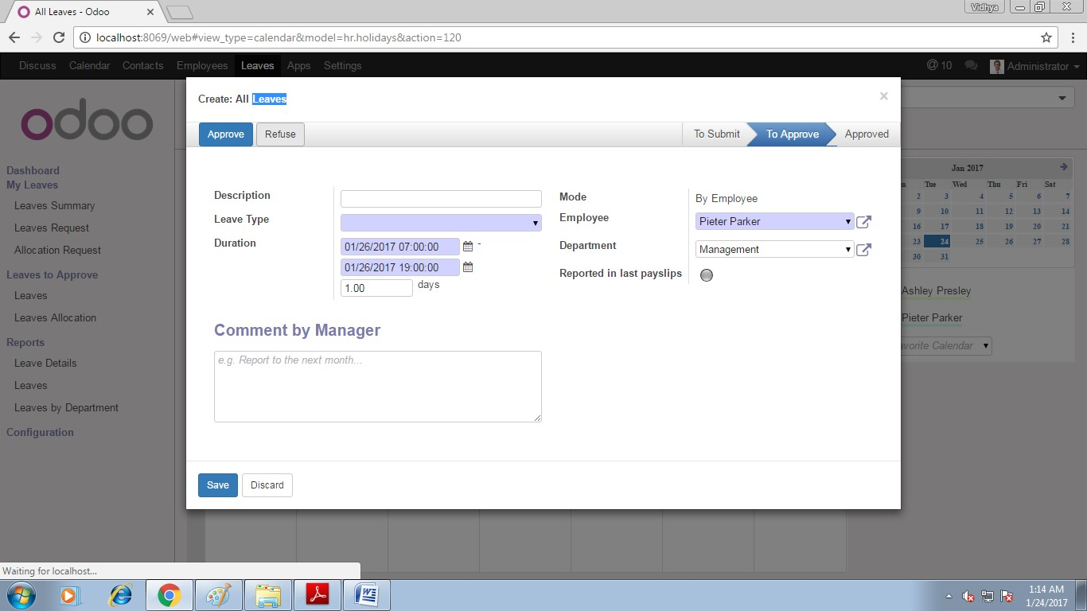

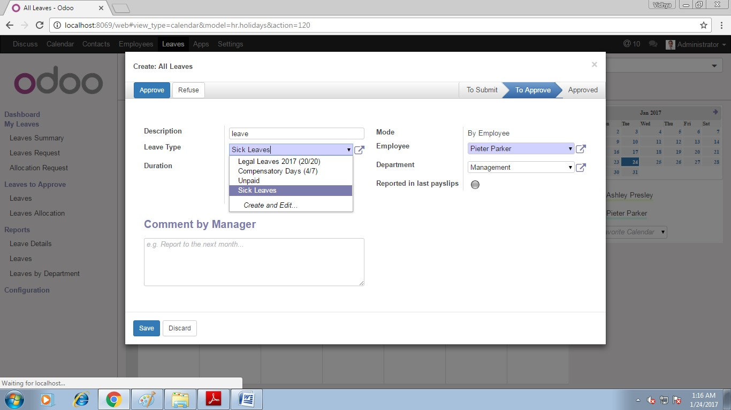
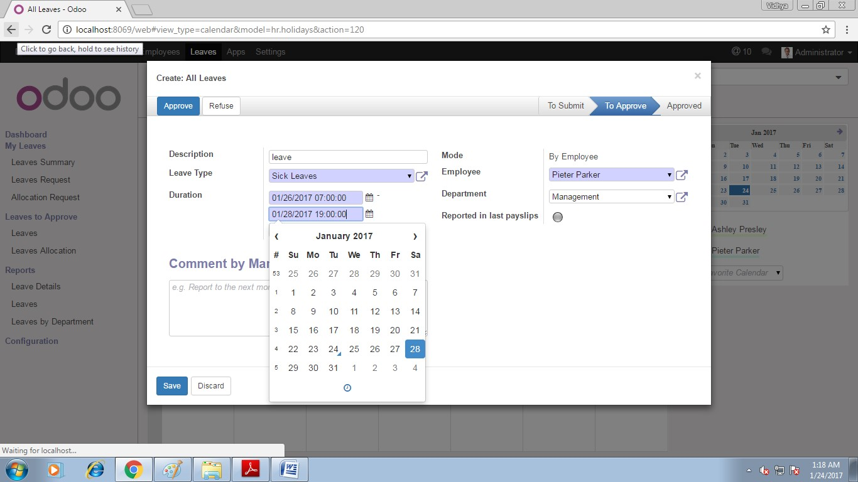

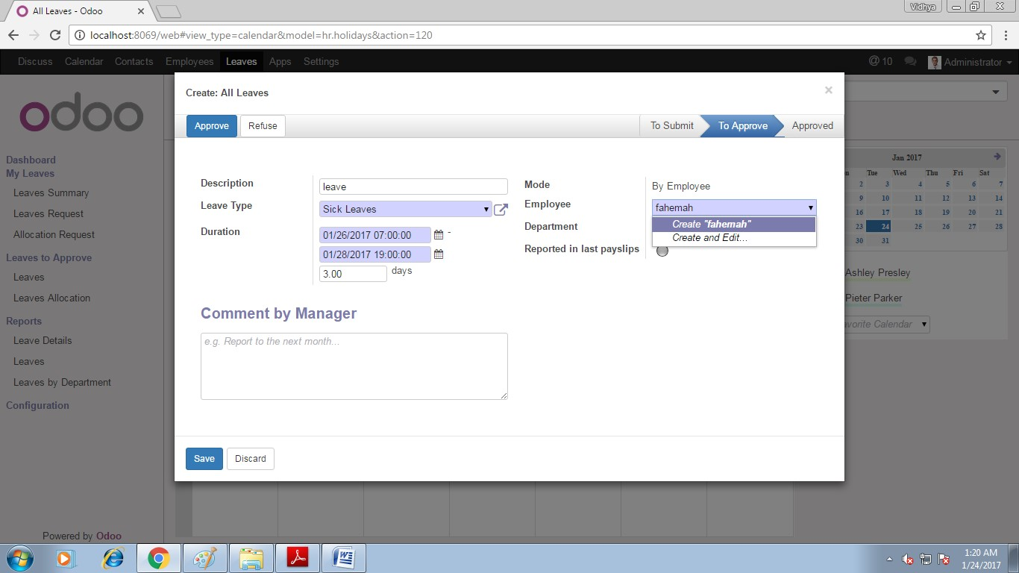
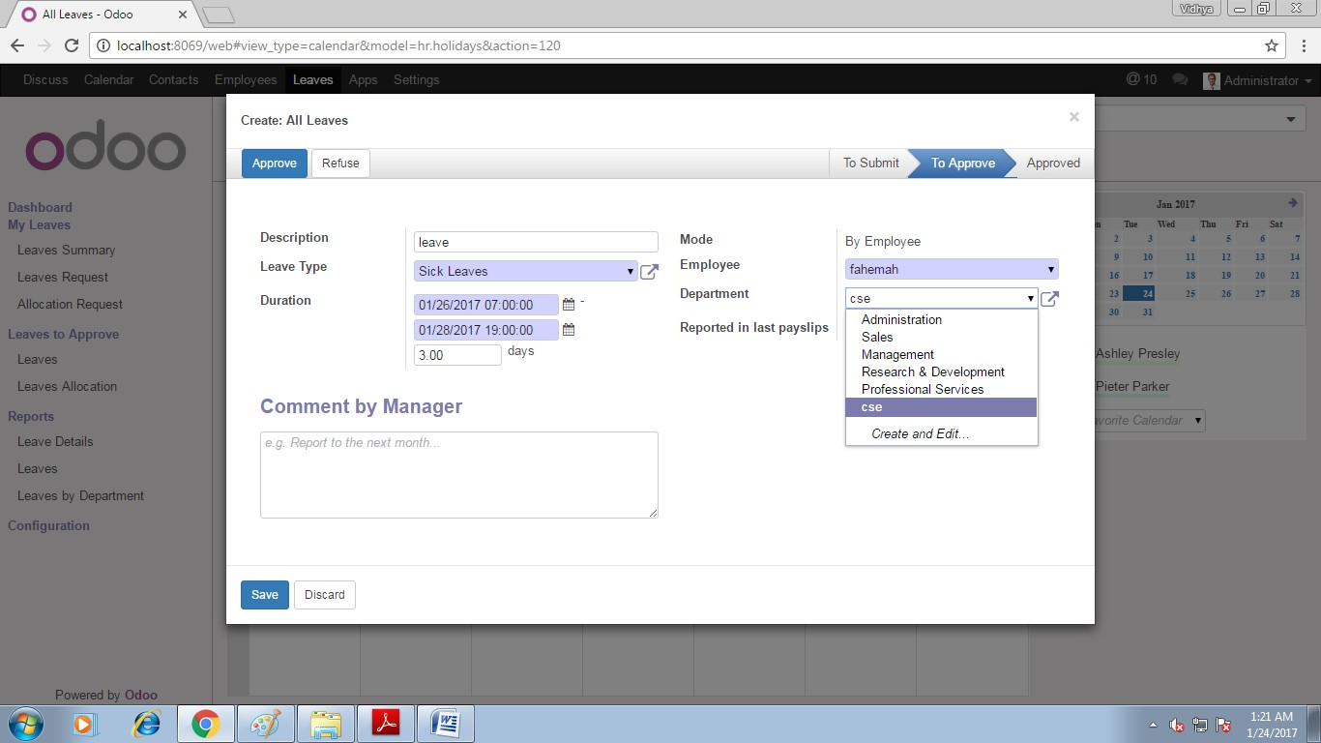
Step3: click reported in last pay slips.
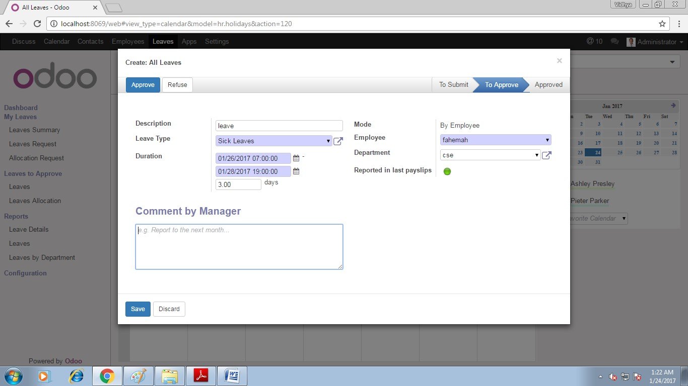

Step4: click save.
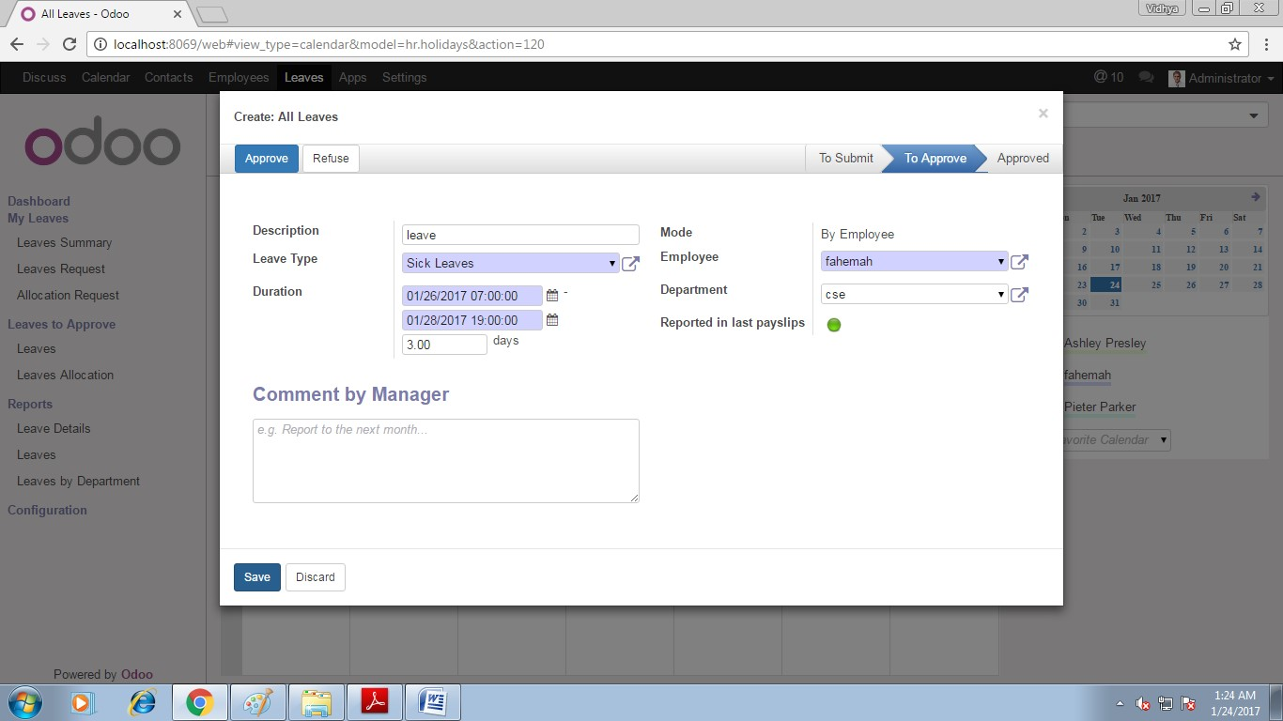
Step5: After clicking save button then your leave list is displayed.
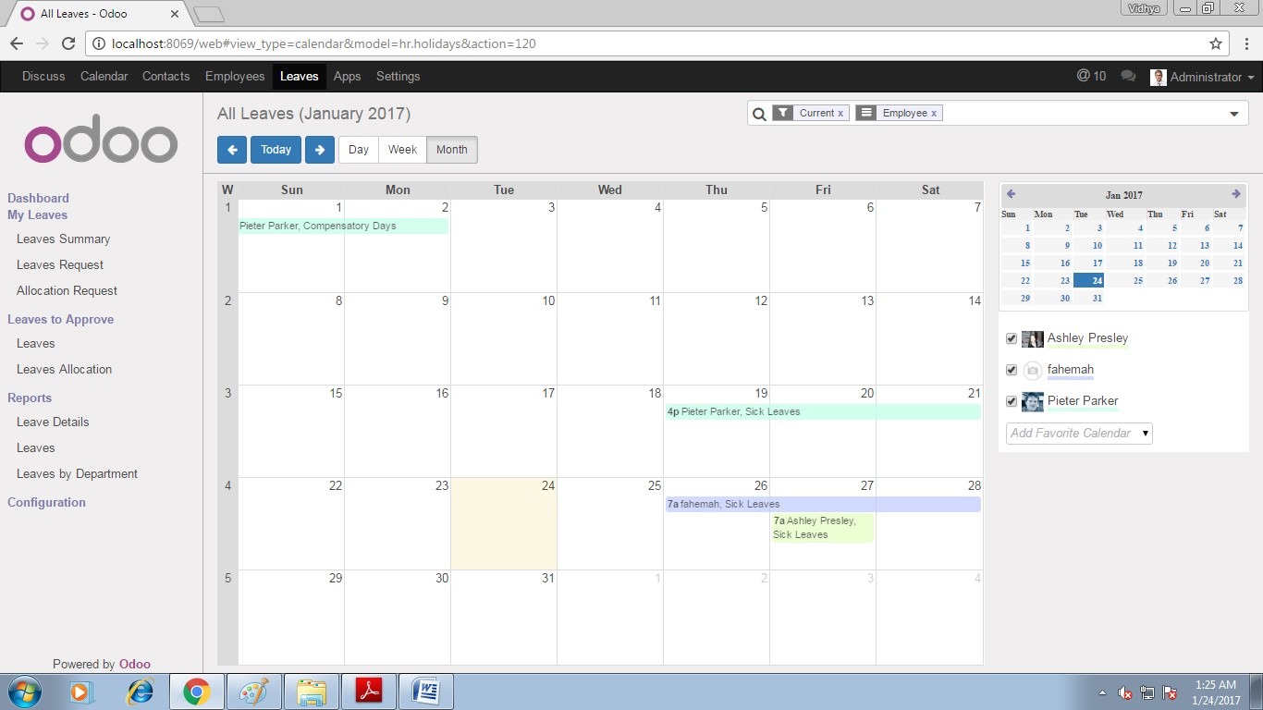

REG NO: 22TD0058 NAME: NASRIN J YEAR/SEM/SEC: Y3/S6/B

HUBSPOT

INTRODUCTION OF HUBSPOT:
- Hubspot is an inound marketing and sales platform that helps companies attract visitors and visitors, convert leads and close customers.
- Its products and services aim to provide tools for social media marketing, content management, web analytics and search engine optimization.

STEPS IN HUBSPOT:

Step 1:Start with the link of www.hubspot.com. Understand sales process and lead ownership. Sign in with your email account then create a new contact.

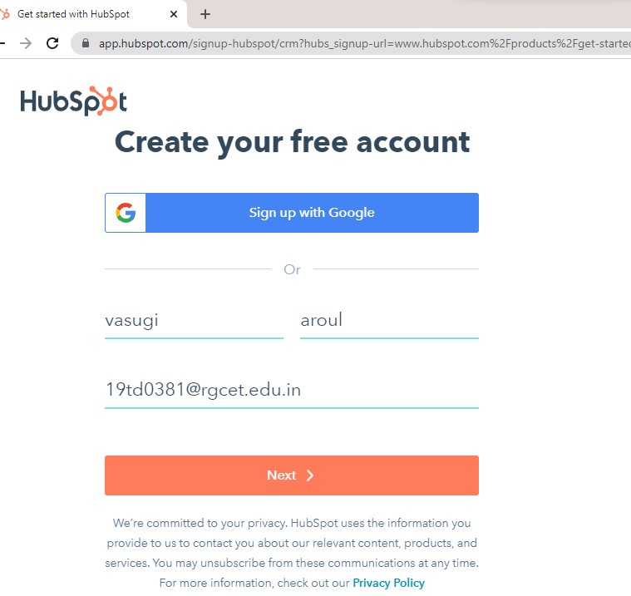

Step 2:Move data Sale sand tell us little about yourself.

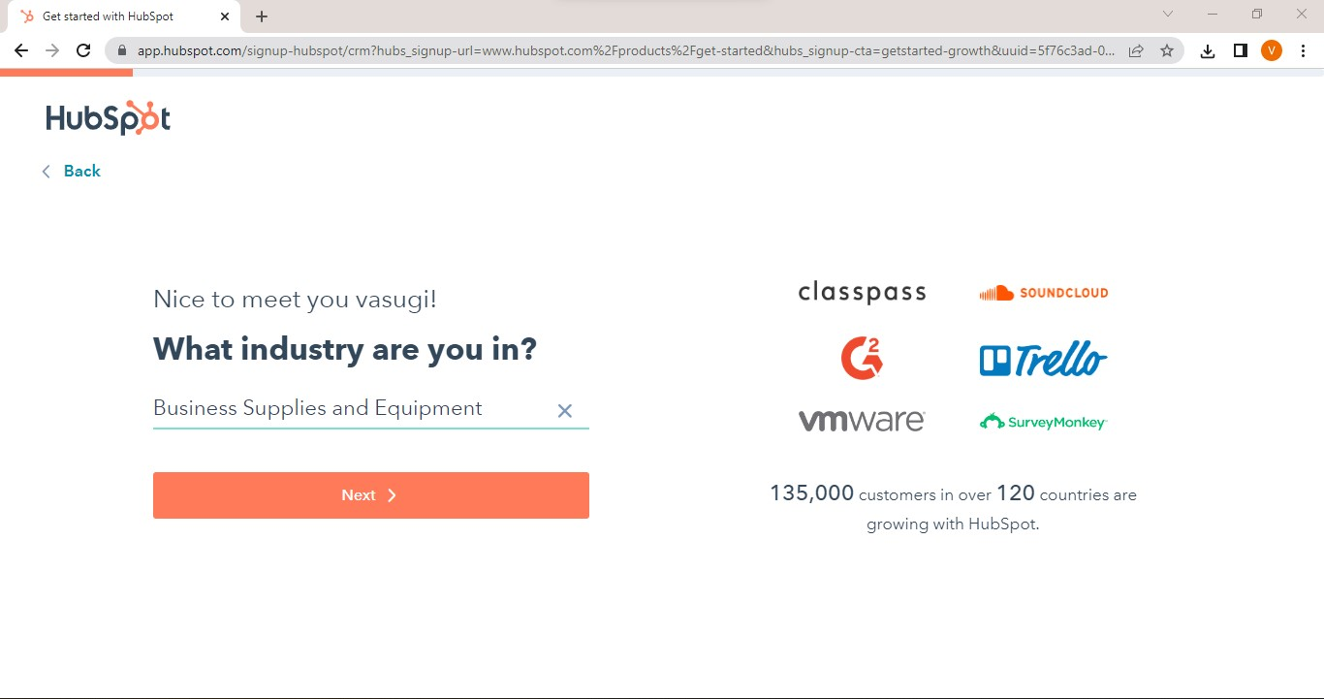

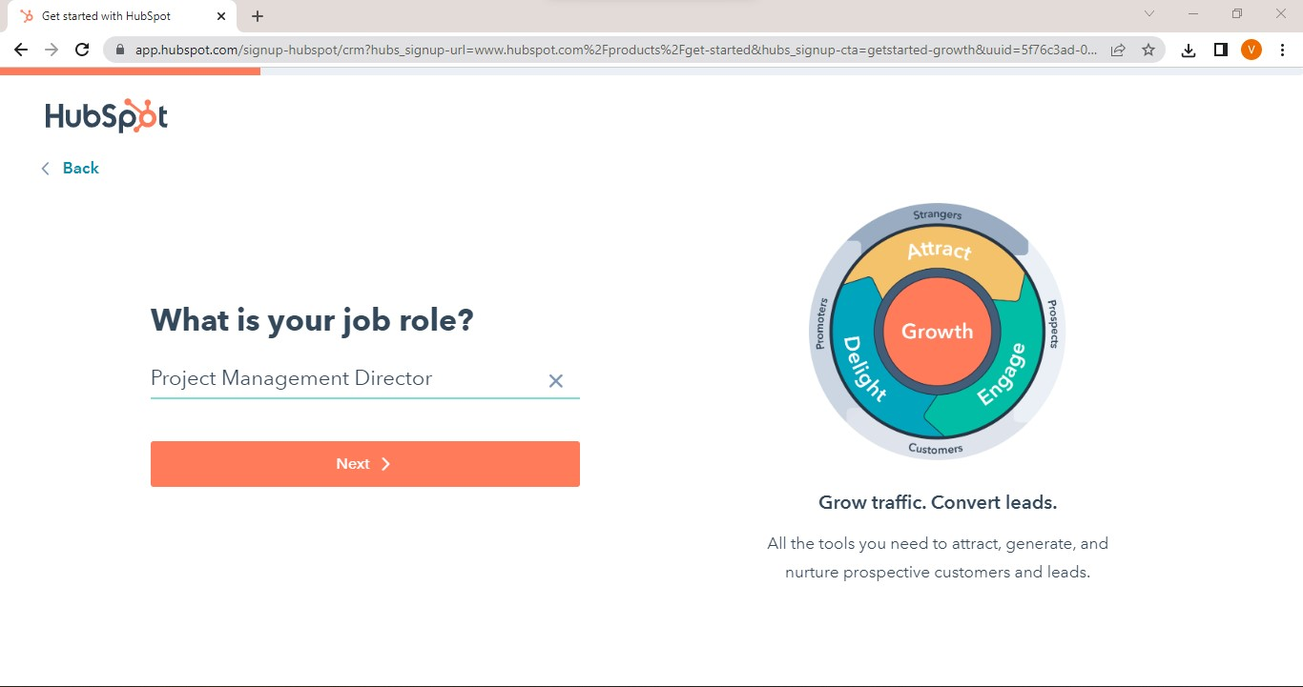

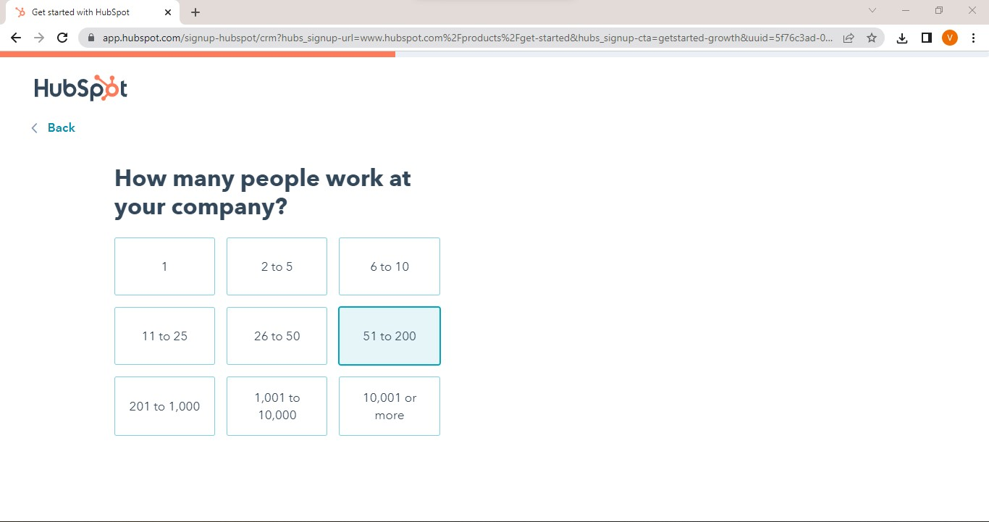

Step3: Create contact with following details.

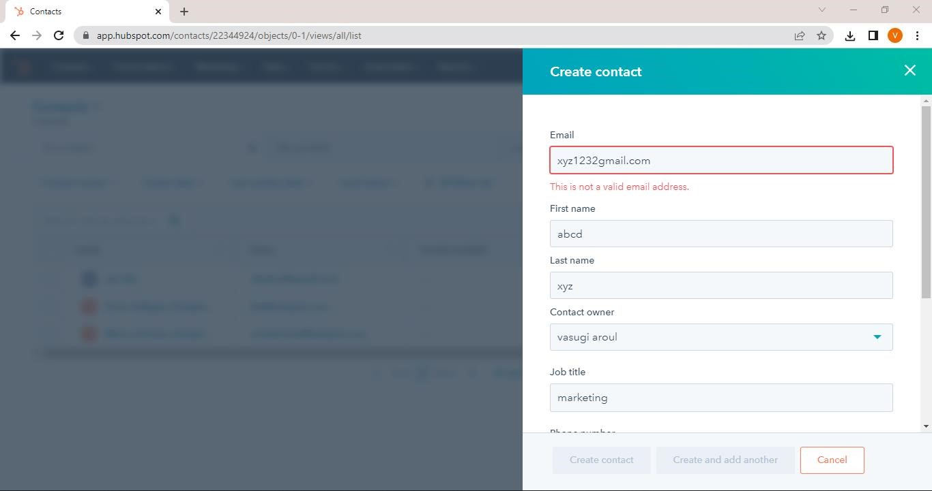

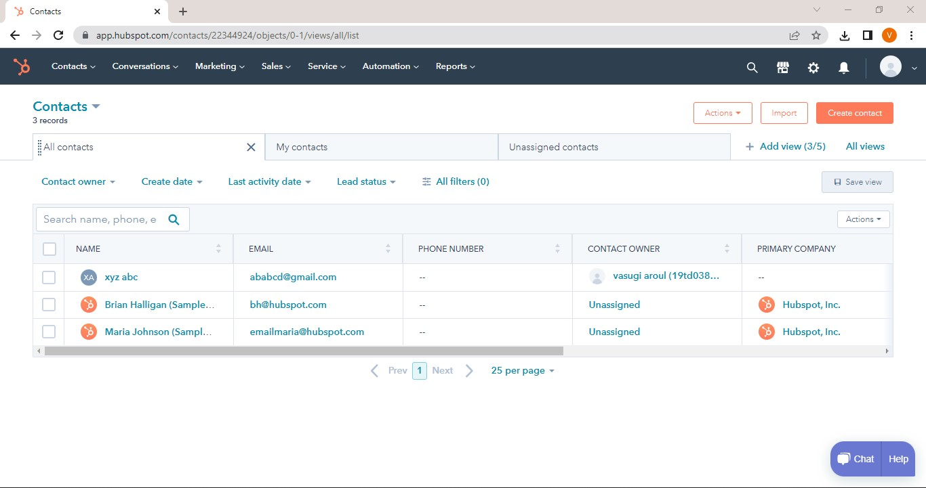

Step4: Create Company.

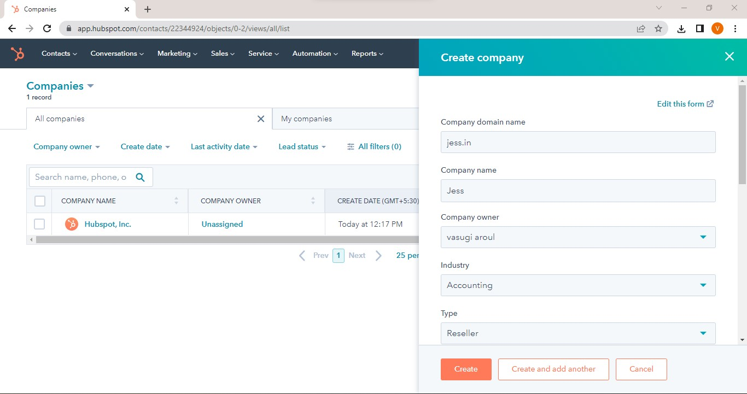
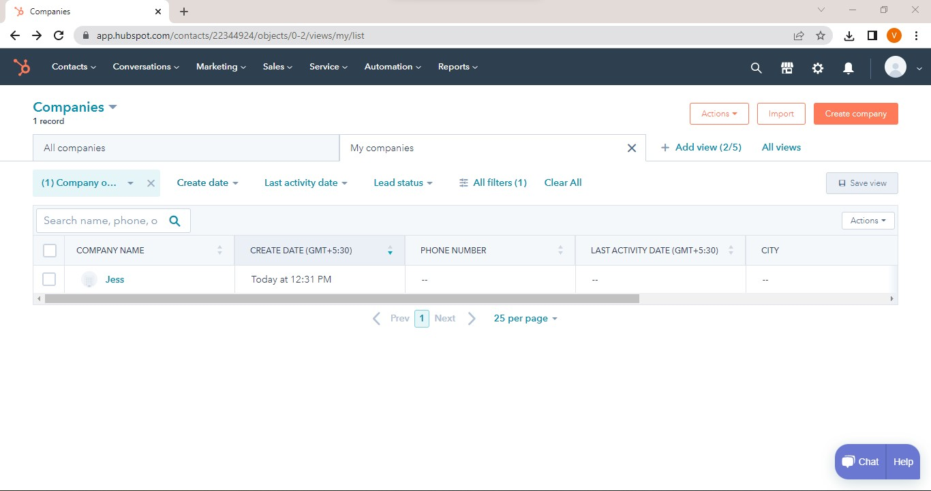

Step 5: Create deal.

